Rural Women’s Social Education Centre [RUWSEC] is a non-governmental women’s organisation started in the year 1981 by a team of 13 women; twelve from the local ‘Dalit’ villages in which we started our community based programmes.RUWSEC is located at Karumarapakkam village, Thirukazukundram, near Chennai, Tamil Nadu, South India.
Achieving women’s wellbeing through women’s empowerment is the mission of RUWSEC since its inception. RUWSEC’s main focus has been on enabling women to gain greater control over their bodies and their lives, and achieving well being through the promotion of gender equality sexual and reproductive rights. Our overall approach has been to motivate, educate and organise women from poor and mariginalsied community to stand up for their rights and become agents of social change. The core values of our work focus on two important themes 1) Empowered and rights based 2) Women centered and participatory. This summary descries the 34th year of RUWSEC’s innovative activities on sexual, reproductive health and rights.
Programmes for the financial year 2014 – 2015 were carried out under four major thematic areas; 1) Promoting general health and well being in the community 2) Promoting sexual and reproductive health and rights (SRHR) of adolescents and young people 3) Promoting sexual and reproductive health rights of adults with a special focus on women 4) Prevention of intimate partner violence against women. In each of the above said themes we work on four strategies namely1) Community capacity building 2) Providing health care services 3) Monitoring research and bringing out popular health education materials 4) Advocacy for wider policy change.
Highlights of the programmes for the year 2014 – 2015 are as follows:
Towards the objective of improving general health and well being in rural areas, community level workshops and awareness sessions were conducted on diabeties, hypertension and anaemia prevention in 25 villages. Community level diabetic screening programme was conducted in 10 villages. House- visits were also made to ensure early diagnosis and follow of treatment services. Centralised training sessions were run for young diabetics (Aged below 40 years).A support group for diabetic patients has been formed and the group meets during the last Saturday of every month. Community level awareness sessions were also run on hypertension in 15 villages.
We provide specialised outpatient care services in our clinic, as a result, patients who need regular services for life style diseases and chronic illness, accessing the our clinical services have increased considerably. Apart from Allopathic services, villagers have also accessed our alternative system of treatment services (Homeopathy and Siddha). During the reporting period of April 2014- March 2015; 10757 patients have accessed our clinical services (Allopathy 6320 persons; Siddha 3134 and Homeopathy 1303 persons).We provide specialized diabetic out- patient care services (allopathy and siddha treatment) on Saturday and on an average 80 patients accessed the service on the day. Specialized Gynecological out-patient services are provided on Mondays.
Gender and SRHR education workshops were conducted for adolescents (8th grade) in 15 Government middle schools. A total of 1389 students benefitted out of this session. Another 763 students studying in 9th grade four Government high schools were also given four day sessions on SRHR education. In addition we run a two day workshops for young boys and girls in four colleges; 324 students actively took part in these sessions. A summer camp was organized for the school students who attended our SRHR education sessions; wherein 19 girls and 32 boys attended the camps. SRHR awareness sessions were conducted for young girls working Mahle Company. The topics discussed in the camp included sexuality, contraception and substance abuse. In order to promote youth leadership among young people 1) Six days trainers training workshops were organized for college NSS students 2) Ten days intensive TOT for young people in rural areas were also conducted. The youth leadership programme received good appreciation and support from the youth. An annual day celebration was organized for the school students who attended the SRHR sessions wherein they exhibited their talents and special prizes were given for them. More than 150 students participated in the event. With the support of ARROW, Malaysia, we have started a research on effect of religious fundamentalism on the implementation of sexuality education programme for young people in India. The secondary data review work is completed and formation of field research team and tools for the survey have been finalized.
Under the programme to improve sexual and reproductive health of women, we planned to conduct two refresher trainings for newly married couples. This year 16 – 20 persons took active part in the sessions. The main focus of the community awareness programme is to provide the right information to the right people at the right time. This was done through house visits by trained health workers. Awareness creation and one on one counseling services are provided to pregnant women, lactating women, women with single child through trained health workers in the community. This year two such workshops were conducted in 25 villages; one on contraception and another one on safe abortion. , 1326 women attended these workshops. A special camp was organized for pregnant women and 14 women took part in this camp. Women who had single children had two trainings in this year and 15 women benefitted out of this event. Cervical cancer screening camps were organsied for rural women and about 60 women got benefited out of the programme and three women were referred for advance check-up to a cancer hospital in Adayar and Kancheepuram. The Cancer support group meeting are run in every month on a fixed day. 10 – 13 persons attend these meetings regularly, we have developed a research report on India’s country profile on sexual and reproductive health rights, after thorough review the report was printed and started disseminating widely among different stakeholders. A national level consultation cum dissemination meeting was organized in during Dec 7-8 2014. The copy of the publication is available at http://www.ruwsec.org/wp-content/uploads/2016/02/RP-1-India-s-Country-Profile-_-SRR-20122015.pdf. Another research publication which is in the pipeline of publication was titled “India’s country profile of sexual and reproductive health services".
An innovative programme for documenting the experiences of grassroots voices, our organization president wrote her experience on working with rural women on SRHR in the diary of a ‘Travel Journal’ and a video documentation was also carried out. This short video was uploaded on the Asian rural women’s coalition website. A talk show about rural women’s rights was conducted in the television channel ‘Puthuyugam’ for 30 minutes as part of international rural women’s day celebration. Two of our coordinators participated in the show.
We translated two important SRHR publications from English to Tamil 1) Linking Poverty, Food Sovereignty and Security, and Sexual and Reproductive Health and Rights. Available at: http://arrow.org.my/publication/afc-vol-20-no-1-2014-food-security/and http://www.ruwsec.org/wp-content/uploads/2016/02/TS-4-AFC-on-Povery-food-security-and-SRHR-Tamil-2014.pdf. 2) Sexual and Reproductive Health and Rights in the Post-2015 Agenda: Taking Their Rightful Place. Available at: http://www.arrow.org.my/publications and http://www.ruwsec.org/wp-content/uploads/2016/02/TS-5-Advocacy-Brief-on-post-2015-development-agend-Tamil.pdf. The books were printed in 1000 copies each and we have started disseminating them with various stakeholders.
On social media site; Facebook (srhrindia) and Twitter we have created a page in the name of SRHR India. We share information on gender, women’s issues SRHR to various like-minded groups through this social media page.
Under the theme on prevention of gender based violence against women, community level workshops on GBV for self help group women are run in 25 villages. We have formed 70 community committees (Women’s protection committees) to combat gender violence committees in the villages over these years. Members who are active and continue to support the women in the villages had training this year. Additionally in the reporting period nine new committees have been formed and introductory meetings were conducted in the villages. These committee members have been explained about their role. Victims of domestic violence are provided constant support and guidance. An International Women’s Day was also celebrated on march 8th.
Contributions and donations to support our activities are welcome. If you would like to support us, please write us : ruwsec@vsnl.com and ruwsec.tn@gmail.com
---------------------------------------------------------------------------------------------------------------------Rural Women’s Social Education Centre- RUWSEC
61 Karumarapakkam Village, Veerapuaram PO
Thirukazhukundrum Via, Kancheepuram District
Tamil Nadu – South India 603109. Phone: 91- 44-27491254
www.ruwsec.org ; www.facebook.com/ruwsec.india

Travel Journal Video
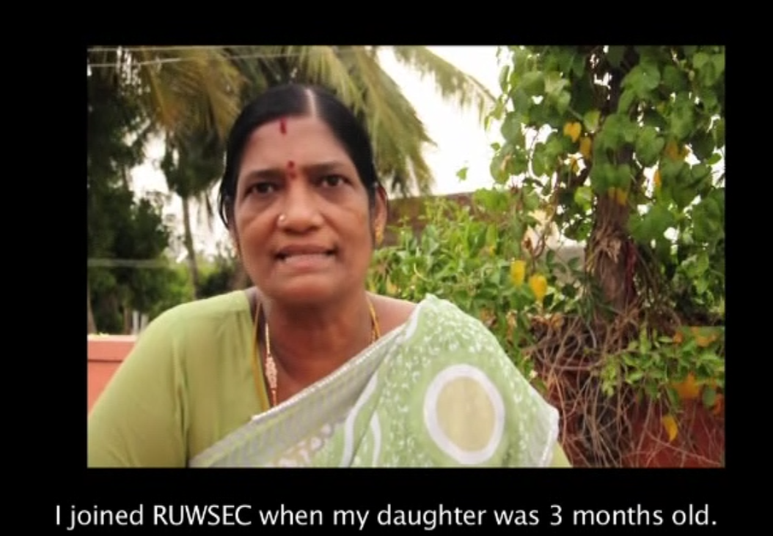
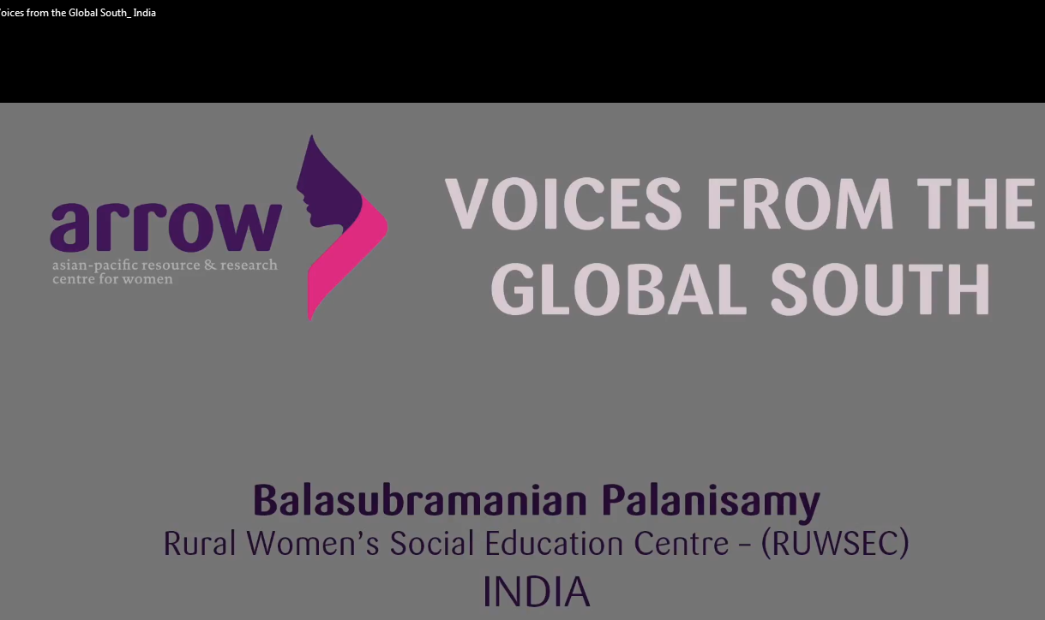
You tube video on SRHR
Publication release
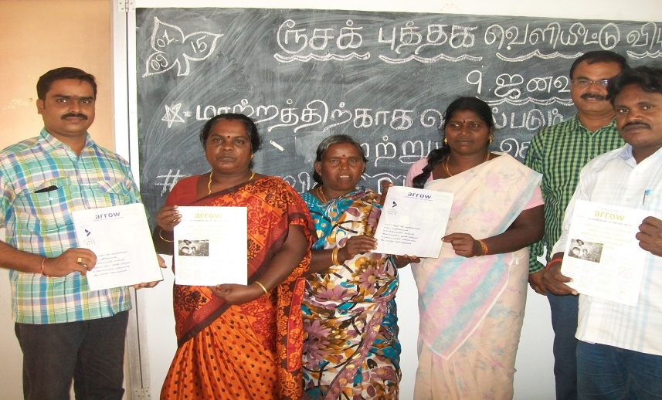
Clinic Outpatient care

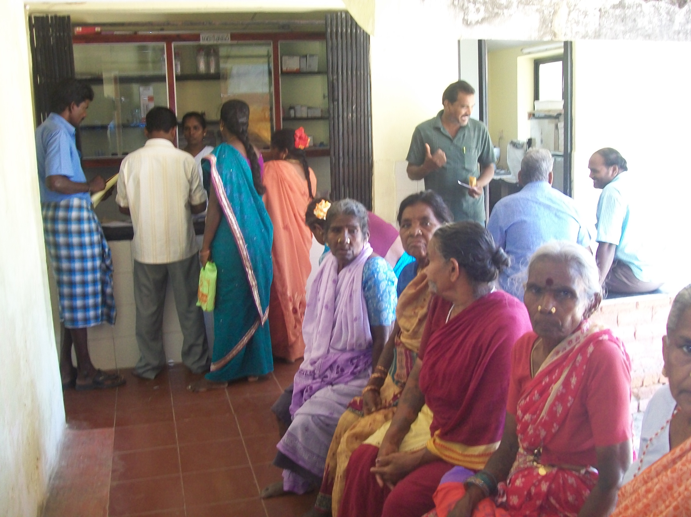
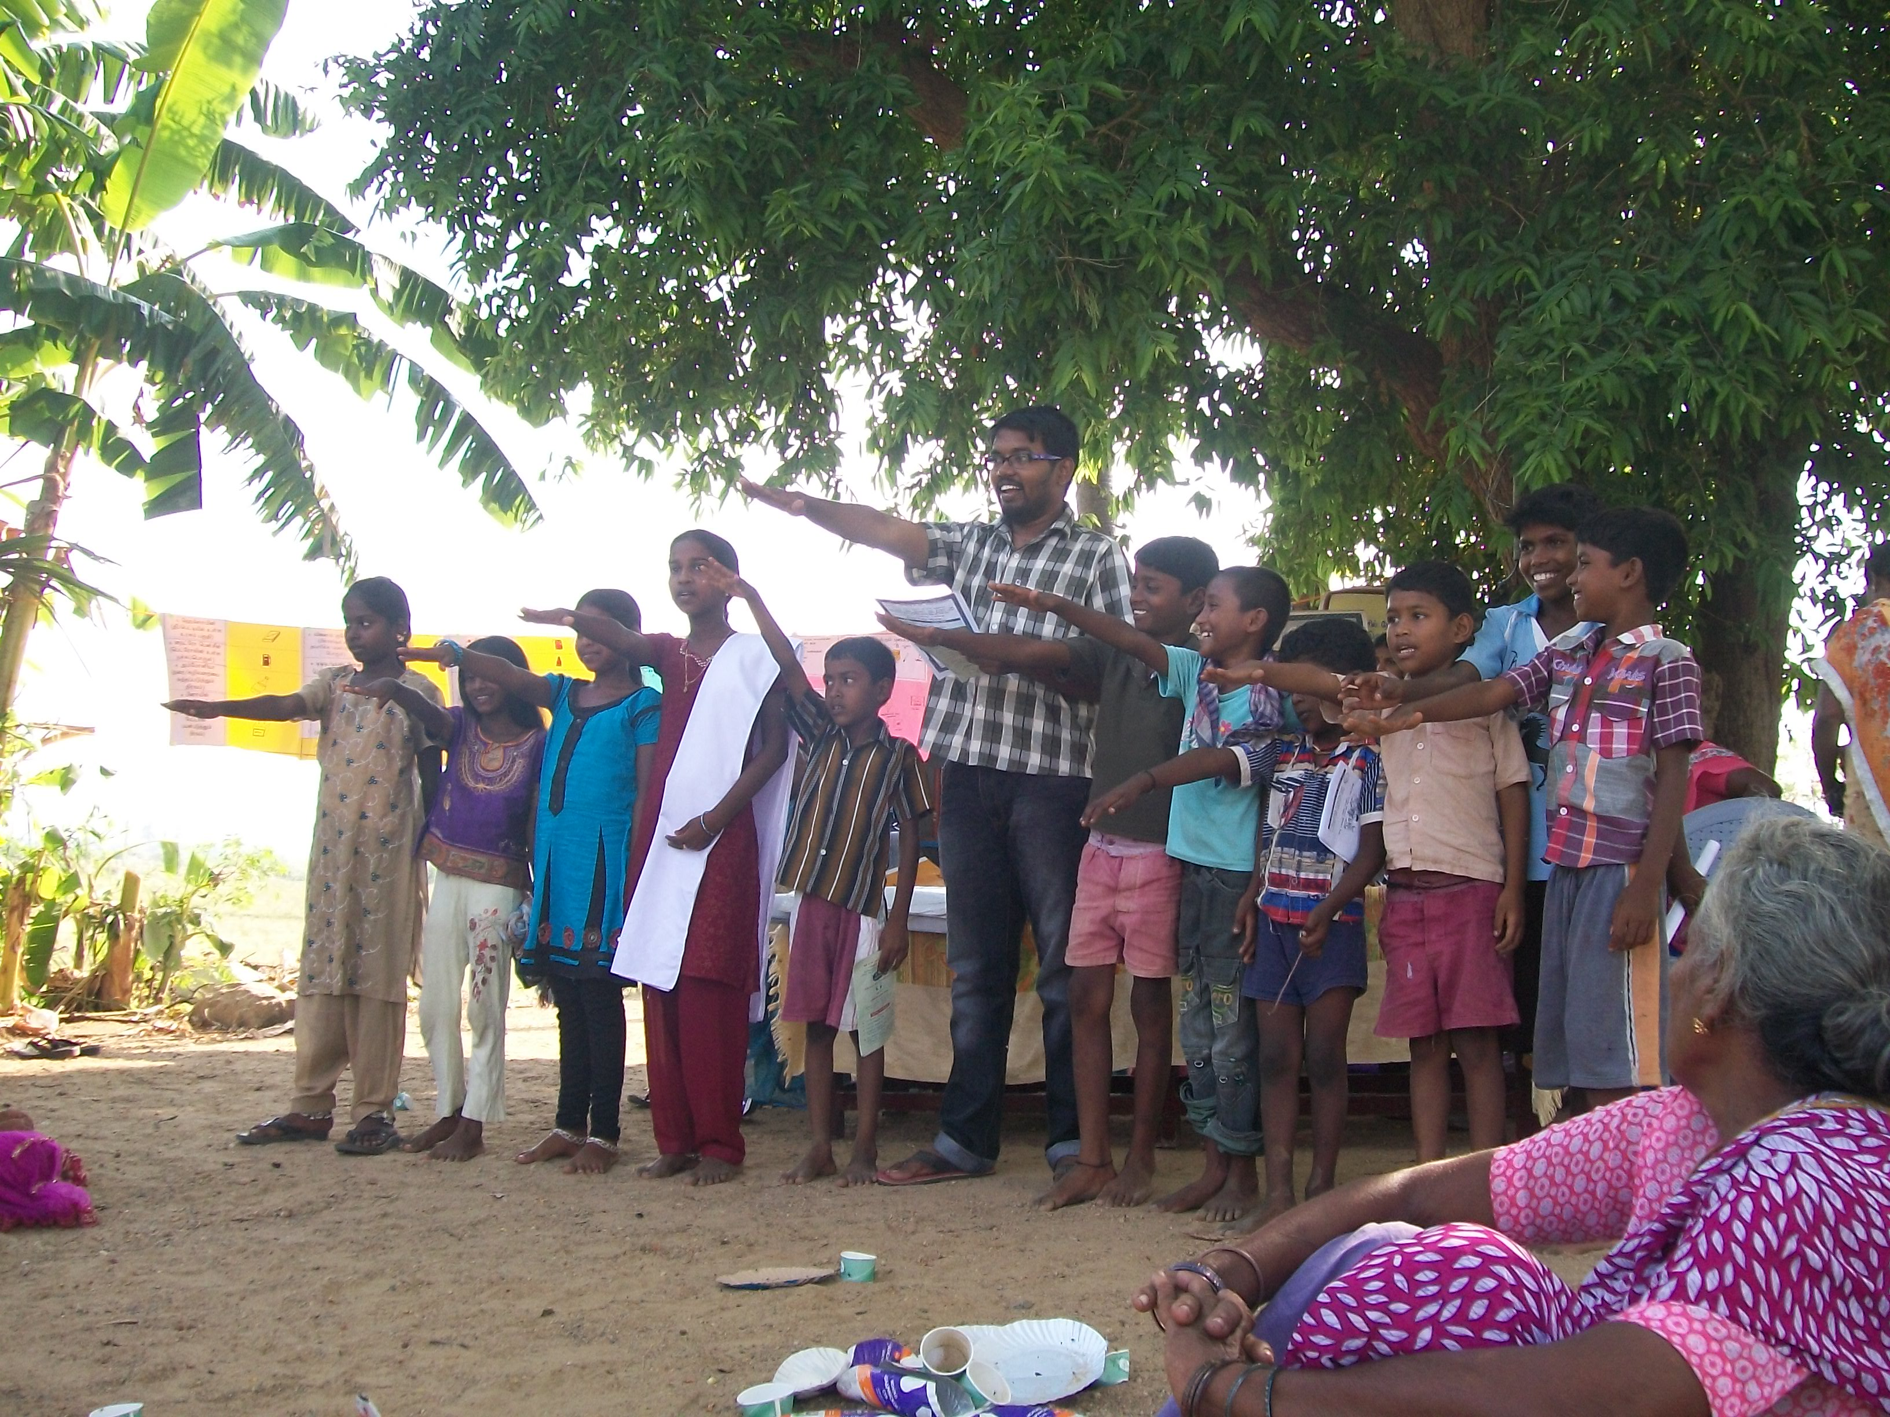
Tobacco Cessation Campaign
SRHR workshop for College students

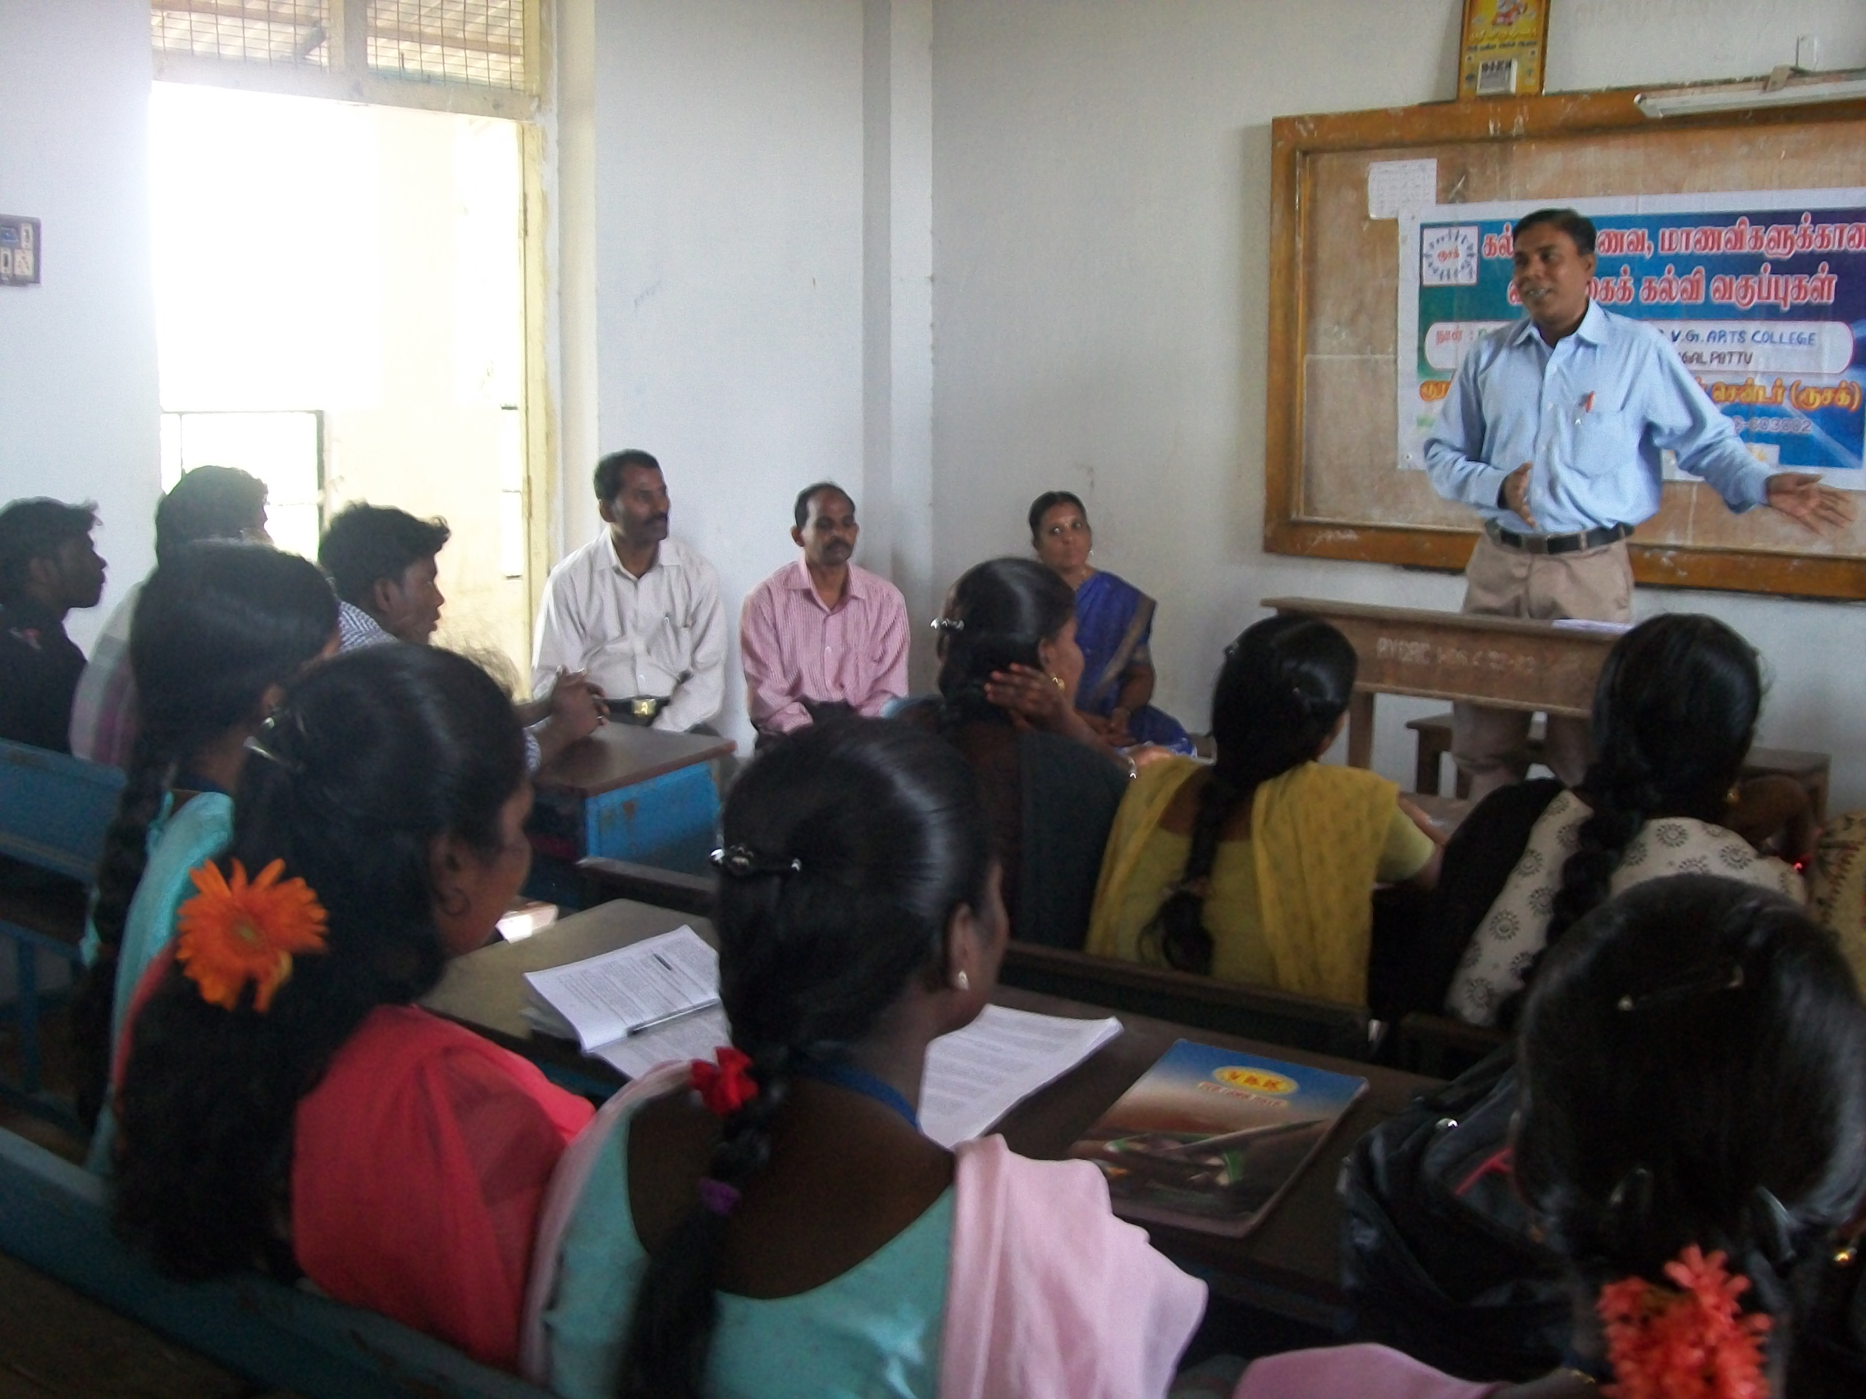

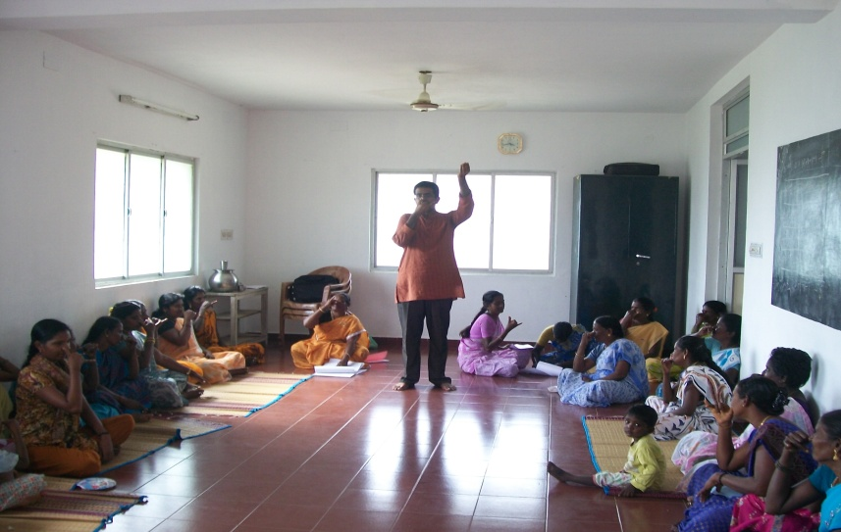
Diabetic awareness session

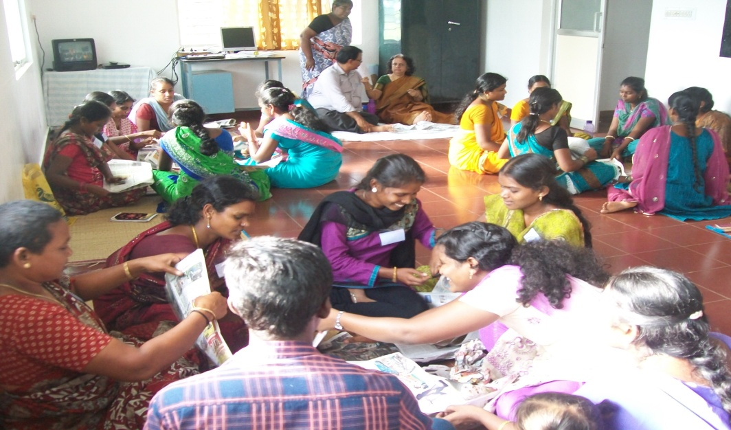
Young leadership training programme

