Rural Women’s Social Education Centre [RUWSEC] is a women’s organisation working for sexual and reproductive health and rights. The organisation was founded by 13 women in 1981, and it is located at Karumarapakkam village Thirukazhukundram, near Chennai, Tamil Nadu, South India. Achieving women’s wellbeing through women’s empowerment is the mission of RUWSEC. Our primary focus has been on enabling women to gain greater control over their bodies and lives and achieve well-being by promoting gender equality and sexual and reproductive rights.
RUWSEC’s overall approach has been to motivate, educate and organise women from poor and marginalised communities to stand up for their rights and become agents of social change. Over the years, our work has included women and men, adolescents, and young people towards promoting well-being and sexual and reproductive health and rights. The core values of our organisation’s work focus on two important themes 1) Empowerment and rights-based 2) Women centred and participatory. The strategies of our work are to
  - Bringing forth the voices of women (and men) from the most marginalised sections of society, especially Dalit and rural poor communities;
  - Promoting leadership skills of the above groups to effectively participate in this strategy's existing governance and accountability structures and other spaces for community participation.
  - Developing critical thinking and alternative models in health care provision, research and planning for social action.
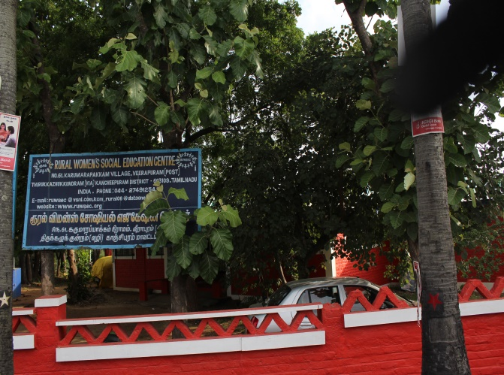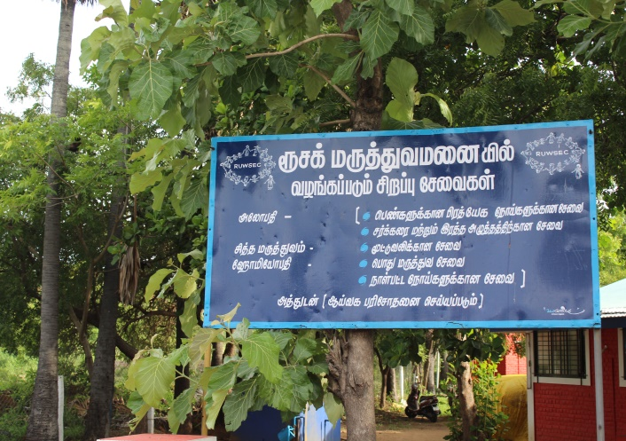

During the three and a half decades of its existence, RUWSEC has implemented a broad spectrum of activities ranging from comprehensive community based reproductive health education and health promotion, community-based interventions to prevent domestic violence against women; and, innovative work with young women and men on gender and sexual and reproductive health and rights. Providing women and patient-centred quality health care services is also a significant component of RUWSEC’s services.
We have been working at different levels; community, schools, colleges and health systems. We have school-based life skill education for adolescent students, young women working in factories and youth groups in the villages; we work with the public health system towards improving the quality of reproductive health care services. Currently, our intensive field programme activities focus on the following four significant aspects:
- Promoting general health and wellbeing in the community,
- Promoting sexual and reproductive health and rights (SRHR) of adolescents and young people,
- Promoting sexual and reproductive health rights of adults with a particular focus on women and
- Prevention of intimate partner violence against women.
In each of the above, we adopt four strategies, namely, 1) Community capacity building, 2) Providing health care services, 3) Monitoring, research and bringing out popular health education materials 4) Advocating broader policy change.
Summary report of activities for the year 2017 – 2018
Prevention and treatment for non-Communicable Diseases: The programme on promoting general health and wellbeing in the village gives importance to creating awareness on non-communicable diseases that are associated with lifestyle changes like diabetes, blood pressure, cancer and anaemia, this programme is carried out in 25 projects villages. Community-level meetings were organised for self-help women on Diabetes, Hypertension and Anaemia. Diabetes and hypertension patients in the project villages were followed up with RUWSEC staff and volunteers. They made fortnightly visits in the villages and provided counselling services on food practices, the importance of exercises and physical activities, follow-up treatment and the importance of taking regular tablets. We have developed counselling cards to counsel diabetic patients, and it is used by the staff at the community level and health centre-based counselling. Three sets of cards were created; basic information about diabetes, dos and don’ts, food items to be avoided etc.

Specialists also provide medical intervention for these lifestyle diseases in our clinic. A support group for diabetic patients have been formed in two villages where the diabetic patients are more in number. This year seven support group meetings were conducted in Kamarajar Nagar, and four support group meetings were conducted in Amanambakkam village. In these meetings, support and guidance are provided for all the diabetic patients in the village. In these meetings, 25- 30 persons attend the diabetes support group meeting. Likewise, support group meetings are conducted for the cancer patients in the office, and one kg of Nutri mix power is given to the cancer patients. These meetings have provided them with an opportunity to share their issues and clarify their doubts, and it is also a forum to learn cross-learning from their fellow members on the best practices to handle their problems. 10-15 cancer patients attend the meeting regularly.
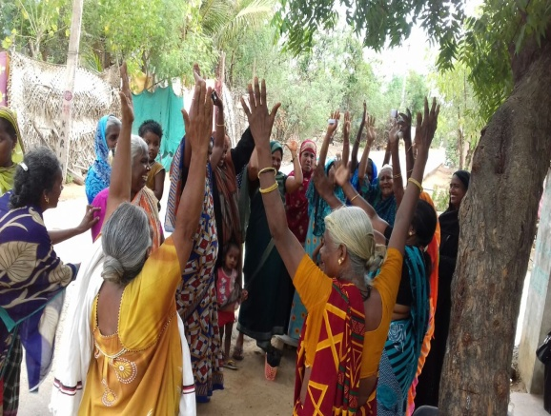
Diabetes Support Group Meeting at the Community; Support group meeting for Cancer patients at RUWSEC
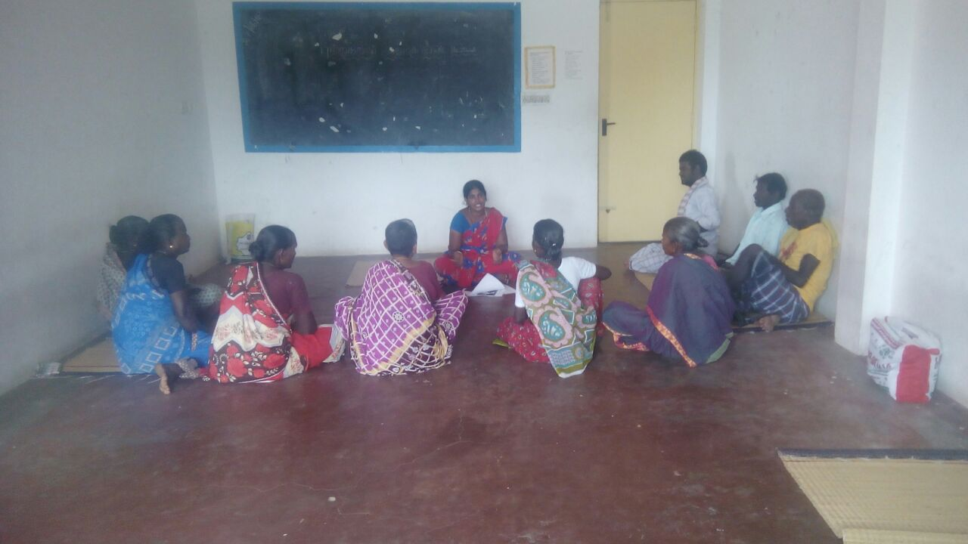
Special workshops were organised for the youth Diabetes patients @ the RUWSEC office; the world diabetes day event was organised in two villages on 14th November. The students from ESI medical college performed various awareness sessions in the form of songs, puppet shows and dramas in one village.
Workshop for Young men and women on prevention of blood pressure and Community level meeting for SHG women on Diabetes and sexual health

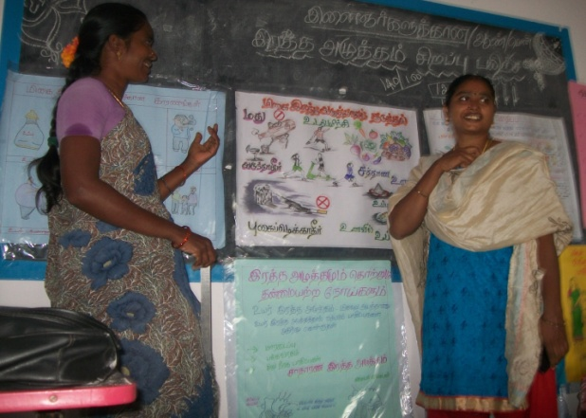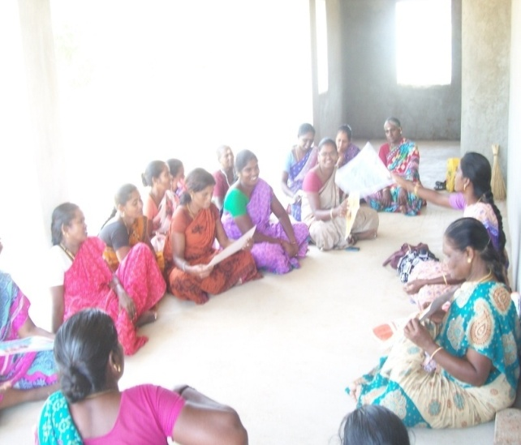
This year counselling services were provided for health problems in the project villages; among them, diabetic patients were 580. In them, 300 are men and 280 are women, patients with blood pressure were 322 among them 166 are men and 156 are women. One hundred forty women and adolescent girls are under follow-up treatment for anaemia. We also provide counselling services in Nerumbur PHC two days a week (Tuesday for Pregnant women and Friday for Diabetes patients). On average, 30-45 persons were counselled per day.
Staff members have a periodic schedule for field visits to the entire project villages; the diabetic patients are classified into three group’s people who are currently/pre-diabetic stage, diabetic for long years and taking treatment and people who have diabetes, have other health problems also, and based on their health ailments counselling services are provided. While providing counselling services, it is stressed for follow-up treatment, periodic laboratory tests, and healthy food practices, like what a diabetic patient should eat? What should they not eat? Why is follow-up treatment necessary? How does the health gets affected if diabetes is not treated, and the importance of timely medical intervention are explained during the counselling process? With specialists' help, counselling cards are prepared, and staff members use these cards to provide counselling services during house visits in the project villages.
People from the nearby villages access our clinical services to meet the special needs of the people from the marginalised sections, especially for the diabetic patients in the community a special camp for heart-related problems was conducted. In the centre, 29 people participated. Among them, 3 had heart problems, 11 were diabetic with high blood pressure, 1 had a kidney problem, and one had a higher cholesterol level. People diagnosed with difficulties were referred to private and public hospitals for follow-up treatment; the staff also followed them up during the field visits.

In our clinic, outpatient services are provided for the unique health care needs of the community; people access allopathic and other forms of medical practices, where there are no contra effects. It could be noted that people accessing alternative medical systems are gradually increasing over these years.
During this reporting period, 17,064 people have used the clinical services. Among them, 7,425 have accessed the allopathic services, 7,622 accessed Siddha services and 2,017 accessed homoeopathic services. We could observe that the number of elderly persons and people with long term ailments is accessing our clinical services more in number.
Number of Beneficiaries by System of treatment in RUWSEC healthcare services 2017-18
Month | Allopathy |  |  |  |  | Siddha |  |  |  | Homoeopathy |  |  | Overall  Total
 | Male | Female | Children | Pregnant | Total | Male | Female | Children | Total | Male | Female | Total
April 2017 | 288 | 232 | 21 | 2 | 543 | 189 | 193 | 19 | 401 | 65 | 65 | 4 | 134
May | 249 | 439 | 25 | 3 | 516 | 197 | 180 | 21 | 198 | 82 | 74 | 4 | 160
June | 224 | 374 | 16 | - | 614 | 226 | 304 | 12 | 542 | 49 | 83 | 11 | 143
July | 233 | 479 | 28 | 9 | 749 | 278 | 385 | 21 | 684 | 77 | 112 | 15 | 204
August | 213 | 407 | 31 | 7 | 658 | 254 | 400 | 28 | 682 | 62 | 111 | 27 | 200
September | 224 | 533 | 50 | 11 | 818 | 202 | 361 | 28 | 591 | 76 | 109 | 11 | 196
October | 206 | 469 | 10 | 9 | 694 | 297 | 417 | 6 | 720 | 61 | 114 | 3 | 178
November | 195 | 387 | 15 | 3 | 600 | 253 | 451 | 7 | 711 | 67 | 126 | - | 193
December | 157 | 385 | 5 | 2 | 549 | 242 | 555 | 14 | 811 | 29 | 112 | 5 | 146
January 2018 | 199 | 386 | 27 | 2 | 614 | 251 | 391 | 25 | 667 | 47 | 84 | 12 | 143
February | 167 | 367 | 5 | 3 | 542 | 296 | 553 | 9 | 858 | 56 | 90 | 2 | 148
March  2018 | 182 | 334 | 8 | 4 | 528 | 304 | 451 | 2 | 757 | 55 | 106 | 11 | 172
Total | 2537 | 4792 | 241 | 55 | 7425 | 2989 | 4641 | 192 | 7622 | 726 | 1186 | 105 | 2017
Allopathy = 7,425, Siddha = 7,622; Homeopathy= 2,017,
Overall total 17,064 persons

The speciality care services available on Sunday’s for diabetes has received wide recognition in the community. Specialised counselling services are provided for patients with reproductive health problems and gender-based violence, chronic illness. Diabetic specialists advise people to have millets and pulses in their regular diet, but these food items are a bit expensive, and people from the
Marginalised sections could not have it in their regular diet; only a few could afford it. During field visits, staff members stress the importance of follow-up treatment for health problems.

An annual health camp for Diabetes and BP patients was organised in March 2017, and poor patients who have been taking treatment at RUWSEC and PHC’s from our project villages were listed. From the list, 120 patients were invited based on specific criteria. Laboratory tests and eye tests were done a week before the camp, and then consultations with doctors were arranged. Patients who needed further investigation and follow up services were referred to Chengalpattu government medical college and followed up by the RUWSEC staff.
Life skills and SRHR Programme for adolescents and young people: Life skills education sessions are conducted for school students on imparting gender sexual and reproductive health among adolescents. As we could not get permission from the district high school authorities, we approached the respective school head master’s in our project villages and conducted the session for 9th standard students. This year five sessions on life skills education were conducted in three high schools in Nerumbur, Veerapuram and Natham Kariyacheri. About 100 students participated in the sessions.
As we got permission from the BEO to conduct life skills education sessions for high school students, five sessions were conducted for 8th standard students in 15 government middle schools in Thirukazhukundram block. Over 300 adolescent boys and girls benefited from the programme.
The session on ascertaining one’s strengths and weaknesses were beneficial for me; it allowed me to think about my strengths and develop them further.
I learned about what menstruation is scientifical, the myths and misconceptions surrounding it, and how it affects women. Also, know the toll-free number 1098 for children.
Gender and SRHR workshops were conducted for students in the Chengalpattu region; Government Arts and Science College, Chengalpattu, Vidhya Sager women’s college - Chengalpattu and Pattammal Azagesan Arts college- Athur. This was done in two days on their respective college campus, and 267 boys and girls participated in the sessions. Similar sessions were conducted for college students and a trainer’s training programme for NSS volunteers in colleges; 25 students attended the training programme conducted in the RUWSEC office. The students gave feedback on each of the sessions covered; some of the reflections are,
Life skills education programme annual day was also conducted for middle school students on the RUWSEC campus. Two hundred students and twenty-two teachers participated in the event. Many events exhibited their talents and skills, what they learnt in the life skills class in cultural shows.

Life skills education programme annual day on 9th March 2018
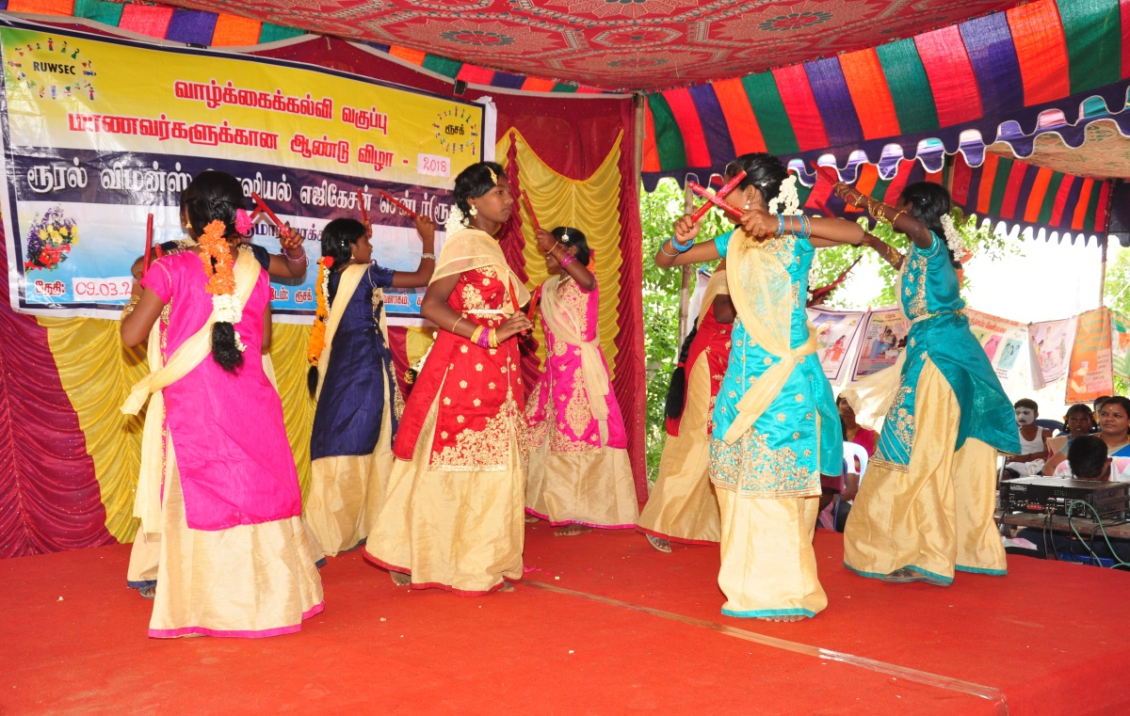

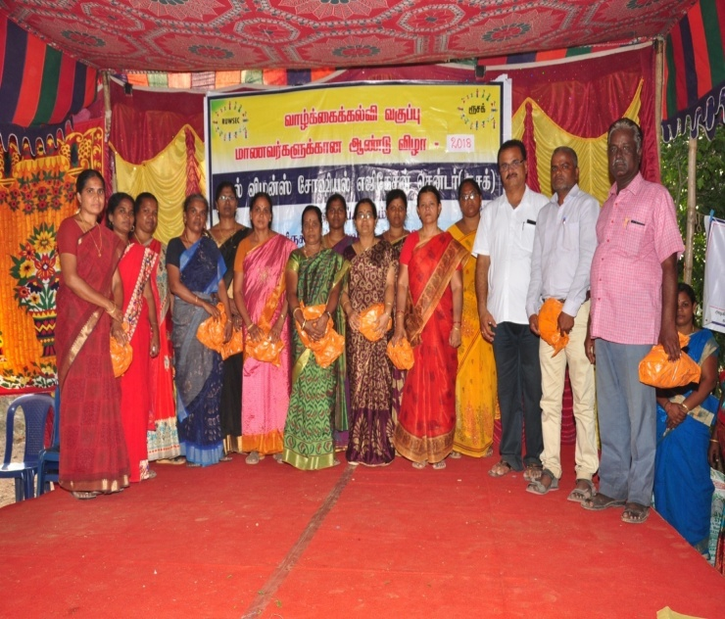
A middle school teacher who attended the annual day celebration says
When I was a student in the year 1998, I had participated RUWSEC life skills annual day function and got a few prizes; plates and books. Even today I kept it in my home, today I brought ten students from my schools, and they got similar prizes, it is a proud moment for me

Young leadership training programme: In 2013, we conducted a training programme for young men and women aged below 30 years as young leaders in the community. With an objective that the trained people would contribute to social change in the community, take up leadership initiative in their villages and act as change agents and serve the community. The fourth batch training was conducted for the young people in the financial year, and it is a certificate course, 28 persons, including four men, enrolled in the class, and 20 people completed the ten days training.
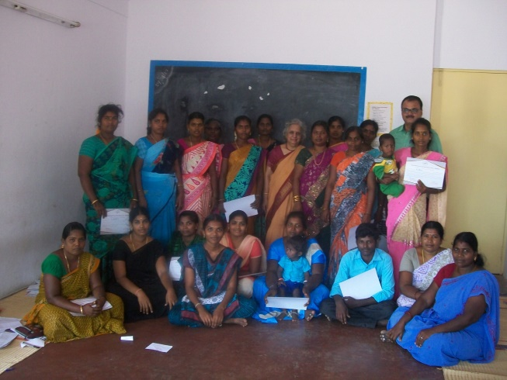
The participants shared that all the information transmitted in training was very relevant to their personal life, especially the reproductive health part, which was much needed for their age group. Moreover, the training methodology was very participatory and would remain evergreen in their minds.
A girl who had undergone a nursing course said, I got only medical information in the nursing diploma course. Still, I got more information about social determinants of health and reproduction, which would be highly useful for my work.

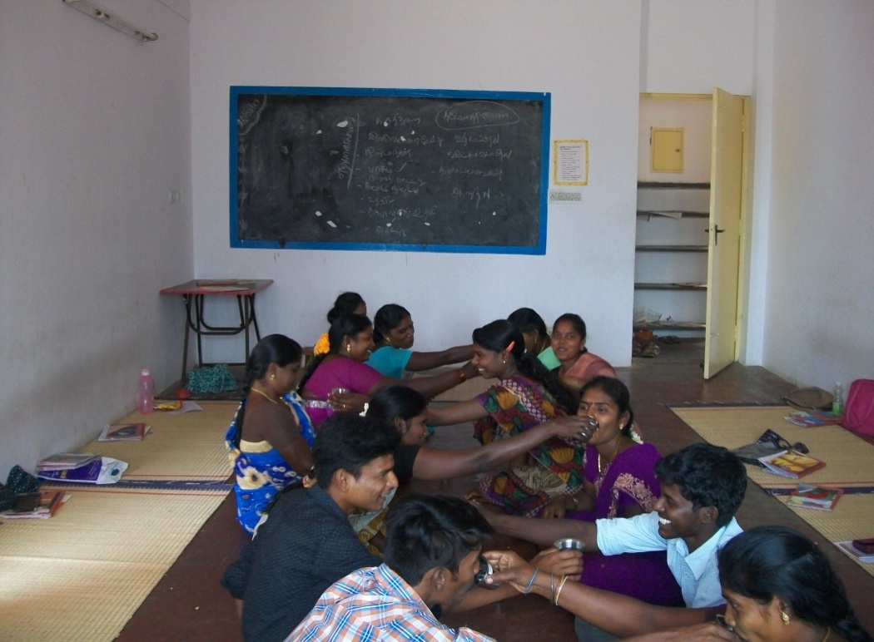
A session on gender equality for youth leaders
Community-level workshops for young unmarried girls were organised in five villages (Suradimangalam, Padoor, Pakkam, Naduvakkarai and Andimadam) on Nutritional anaemia and reproductive health, 17- 25 girls, attended the sessions
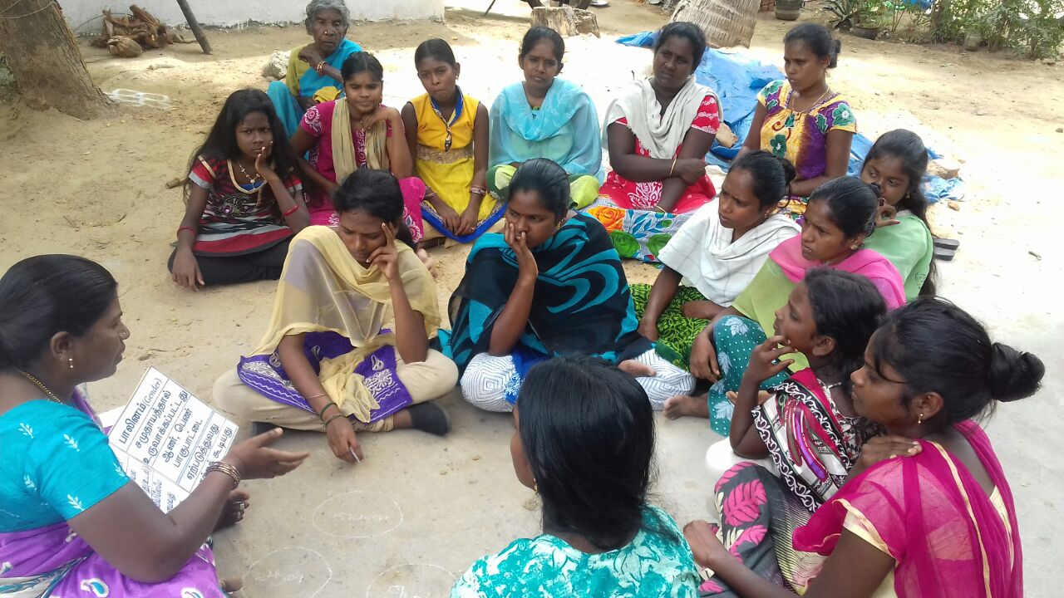
Creative ideas of the young people should be encouraged, and they should be given a chance and forum to express them; with this plan, on the 24th October, the Founder’s Day of RUWSEC, young people were asked to present poetry, essay and painting with a theme on women’s health and rights.

Forty-four participants took an active part in this competition, and we are in the process of uploading the best entries on our social media page. It was organised according to age group; the first one for school-going adolescents and another for college and youth volunteers.
RUWSEC founder day celebration was held on 24th October 2017. On occasion, to motivate rural poor students’ creative ideas and skills, we invited students from government middle schools to submit a short poems, drawings and essays on gender and women’s education and empowerment. The best three entries of each competition are selected and shared on our social media platforms. Prizes were distributed to the best students on occasion.

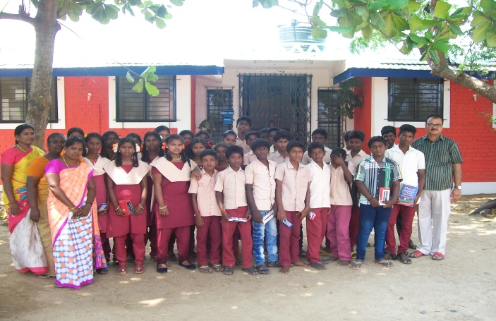
Group photo of government school students who got prizes on the RUWSEC founders day competition

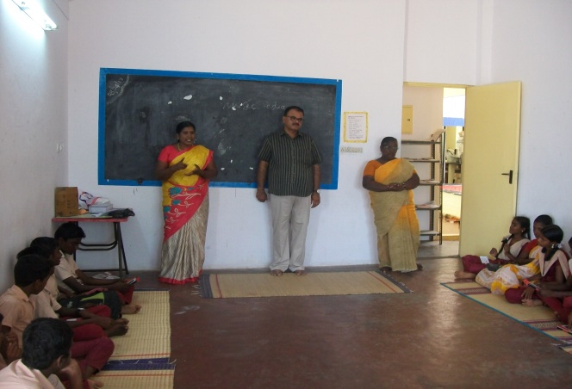
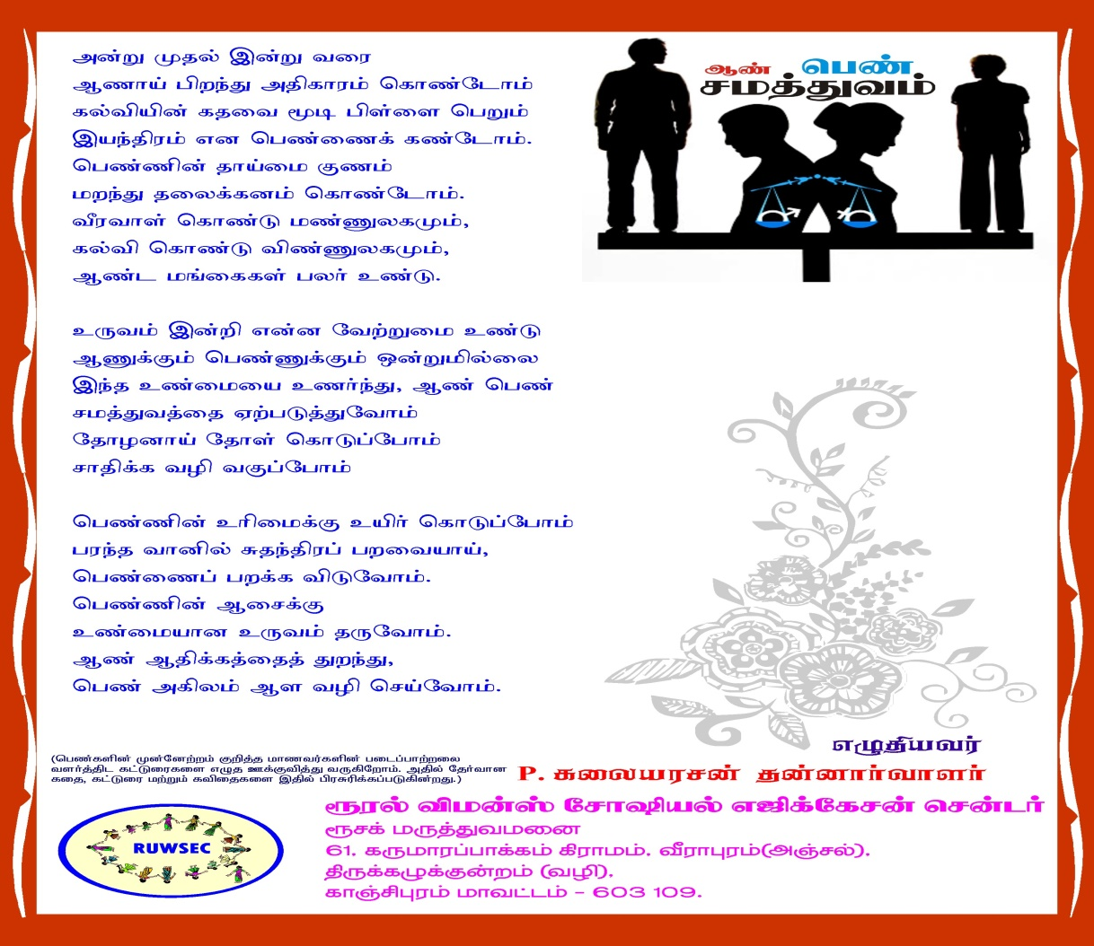

Programme for promoting SRHR of adults: With the long-term vision of promoting gender equality, improving and stressing the importance of sexual and reproductive health rights, a training session was organised for the newly married couples, 18 members took part in this training. Special training, constant guidance and counselling are provided for pregnant women.
During the field visits, the staff members visited all the 25 project villages and provided counselling for pregnant women, single children, and six-month-old babies.
During pregnancy, if the woman has mental health problems, it would affect both mother and the baby with focus this, special training was organised during July 2017. A mental health specialist Dr Kannan from Chennai was invited to address a session on the Effects of mental health problems during pregnancy. In the session, three pregnant women and seven couples from the project villages and 11 staff members totalling 28 members, took an active part. In five of the project villages, community-based workshops on mental health and well-being during pregnancy, and in another five villages, reproductive health problems were conducted 301 women took part in these workshops. Support group meetings are conducted for cancer patients every month 11 women and five men attend these meetings regularly; guidance and counselling are provided during these meetings.
Gender and SRHR workshop for Newly Married Couples
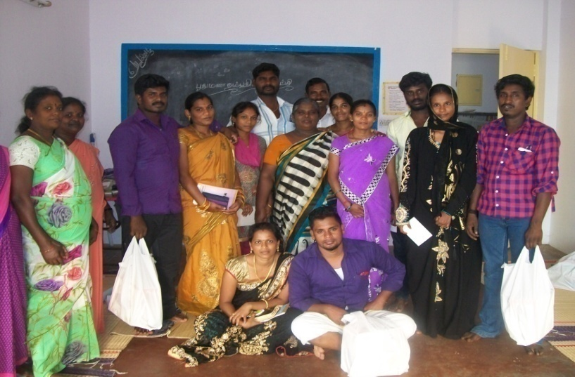
Reproductive Health Training for Women with Single Child

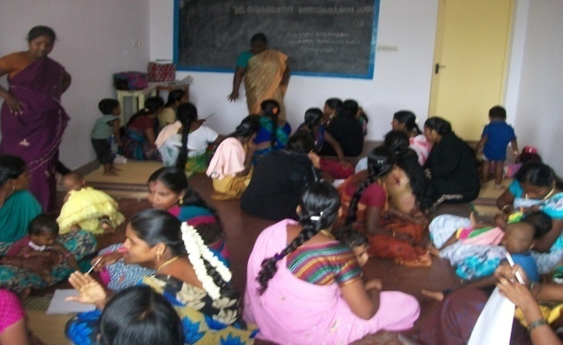
In August 2017, the ARROW partner’s group meeting was held in Kuala Lumpur, Malaysia. The Executive Director and one volunteer from RUWSEC took part in the conference. The research studies were planned in the forum and were also involved in planning for Monitoring Strategic Developmental Goals. During the meeting, preparing for advocacy strategies based on our research studies was also carried out.
An article on Sexual and Reproductive Health was prepared, and it was planned to upload on the web page and social media site on SRHR. The article was sent to three reviewers for review in the process, and after incorporating the suggestion, the report was uploaded to the website.
Research Reports sharing with International audiences and groups;
Based on the two research reports that we prepared on India’s country profile of sexual and reproductive health and another on young people’s sexuality, we were invited to share our findings with the international meetings and forums. Our director presented the conclusions of the two international conferences.

ARROW Partners meeting in Malaysia - Young People’s SRHR – 8-11 August 2017
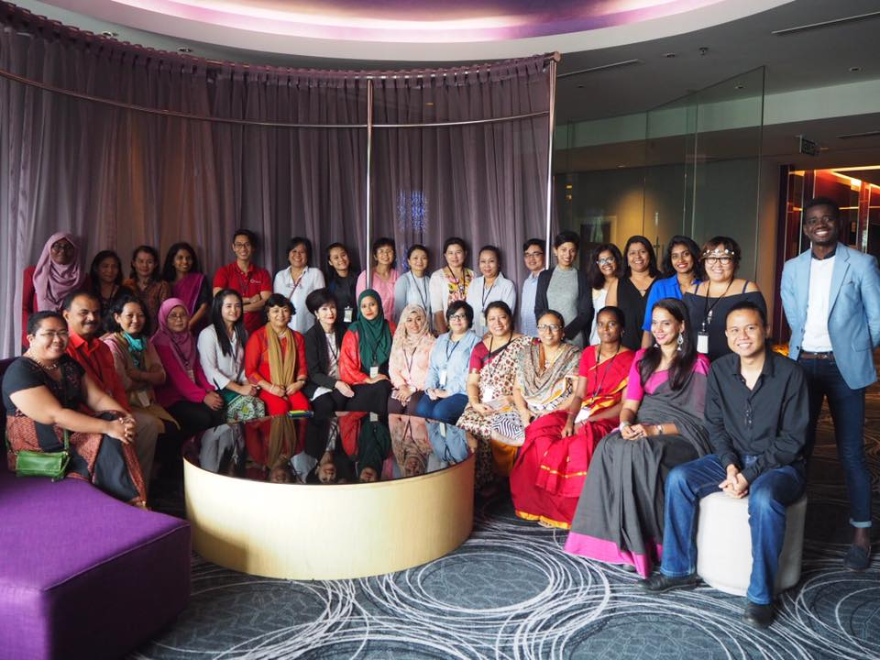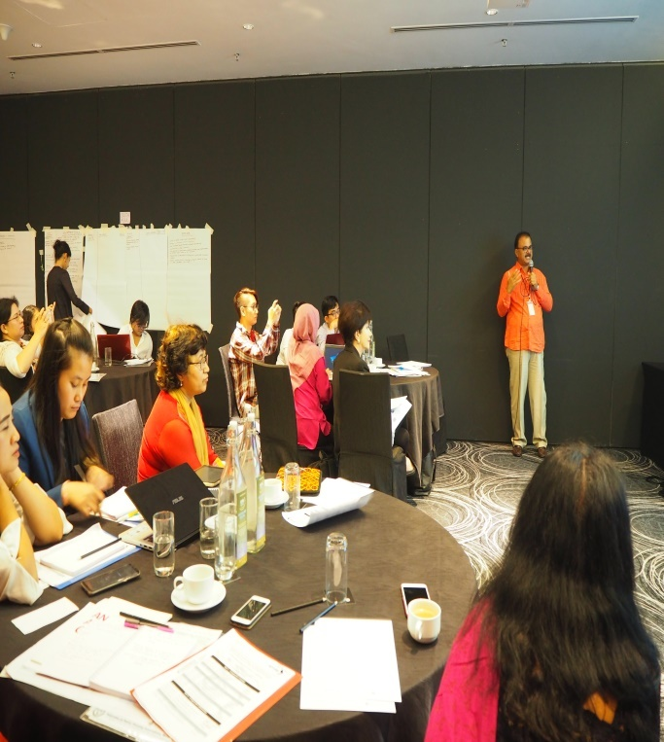

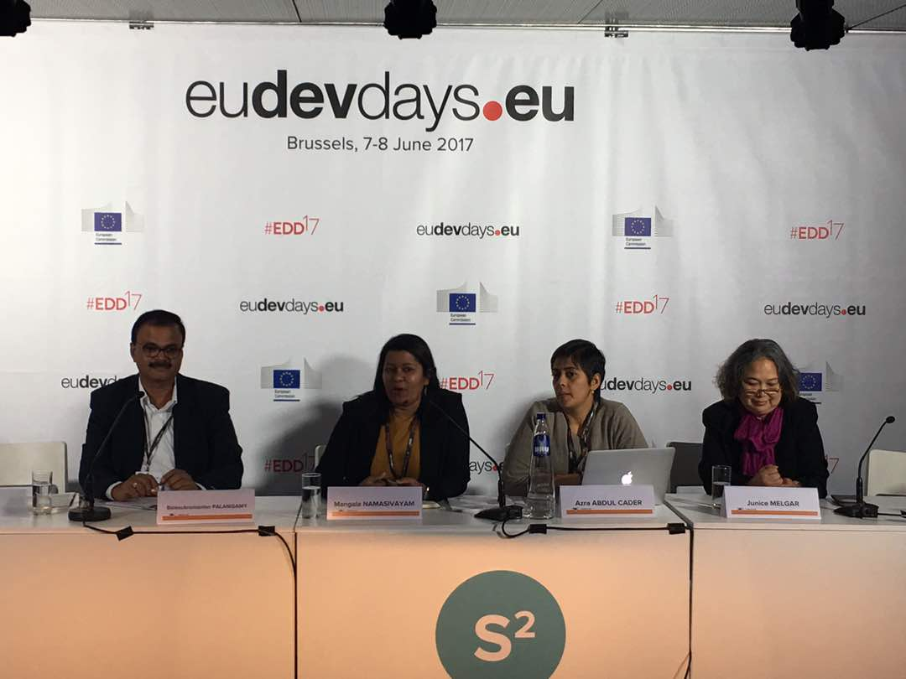
European Development Days in Brussels, Belgium (7-8 June 2017).
Dissemination of research reports in the local community: One of the organisation's strengths is to disseminate our research results to the local community in which we have collected the information. We have produced books marks and stickers to share the critical advocacy messages that emerged from the study in this process.
The travel journal ‘we and our stories’ depict the ‘sexual and reproductive health problems faced by women and how they came out of it’ in this process, case studies of two women were collected, translated, and sent to ARROW for review. Based on this real-life incident, an audiotape for a campaign was released. Three research studies conducted in the previous years with the support of ARROW was also disseminated this year; in this process, the findings were translated into the local language Tamil and presented among staff members and volunteers. The main results were printed as stickers and bookmarkers and distributed to school and college students. In the dissemination meeting, 42 people participated, 18 short messages were also printed based on the research study’s findings and distributed to school and college students with broader dissemination. This was widely recognised, and the initiative was appreciated among all cohorts
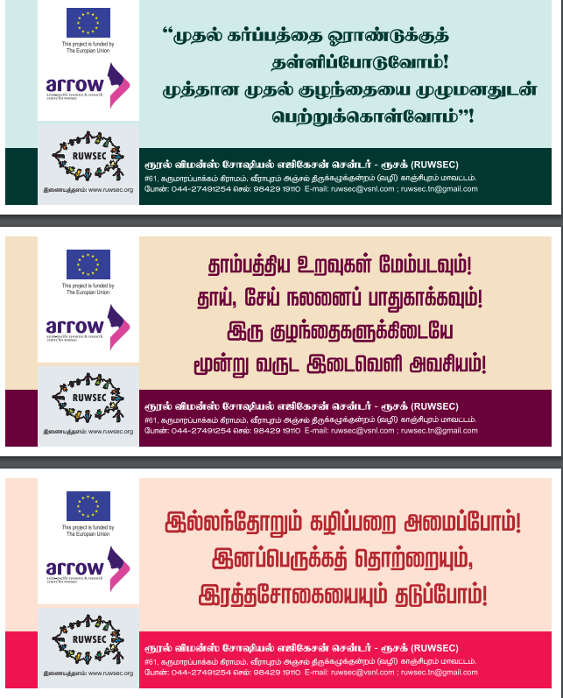

A meeting was organised among the staff members and the documentary crew members about making short films to upload on the website. The members suggested a theme for the short films on early marriages and dowry and contraceptive methods among married couples. Five interviews among staff members were also planned. For the first time, with the participation of the staff members, the short films were picturised. All the short films are ready with English subtitles for getting uploaded to the organisation’s website.
A consultant from ARROW visited the organisation to learn about the activities of EU partners. In the process, few staff members were interviewed, and the organisation’s actions were video coverage.
In the programme on Combating gender-based violence against women, we have been in constant touch with the community committee (CC) members (people called it as women’s protection committees), formed by us all these years. There are 95 committees in the Thiruporur, Thirukazhukundram, Madurandagam and Kattangulathur bocks of Kancheepuram District. The committees update us about the incidences of domestic violence in the community and seek guidance as and when required. One day refresher training was conducted for the CC members by block level, and in total, 127 members participated. The committee members provide ongoing counselling, support and guidance to 42 women who are the victims of domestic violence.
Special workshops were organised for ICDS workers in the Thirukazhukundram block on SRH and gender-based violence against women. Likewise, self-defence training for adolescent girls was conducted in four villages, and 89 participants benefited. An exceptional trainer from Gravma Foundation was invited to facilitate the session.

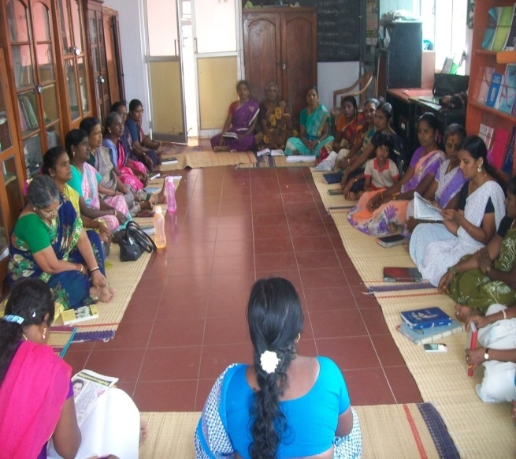

Mass Awareness Generation: International women’s day was celebrated in RUWSEC Campus on 8th March 2018; more than two hundred rural women participated in the various events.
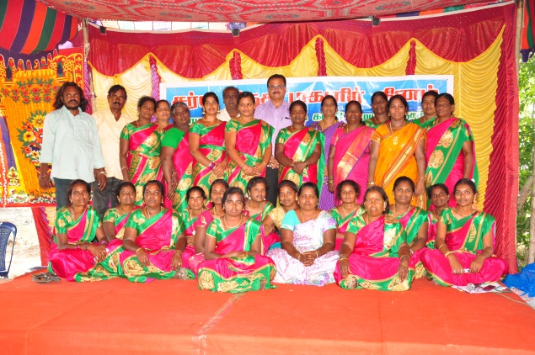

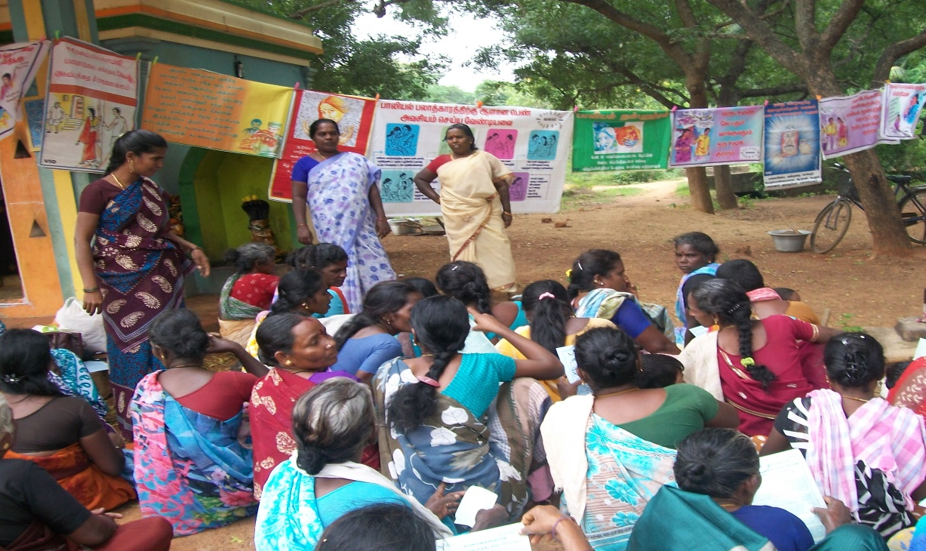
Community-level campaign on gender-based violence against women

Publications: RUWSEC has produced over 60 publications on various themes on sexual, reproductive health. This year we have created two books on SRHR
RUWSEC Publications Two new publications were released on March 8th

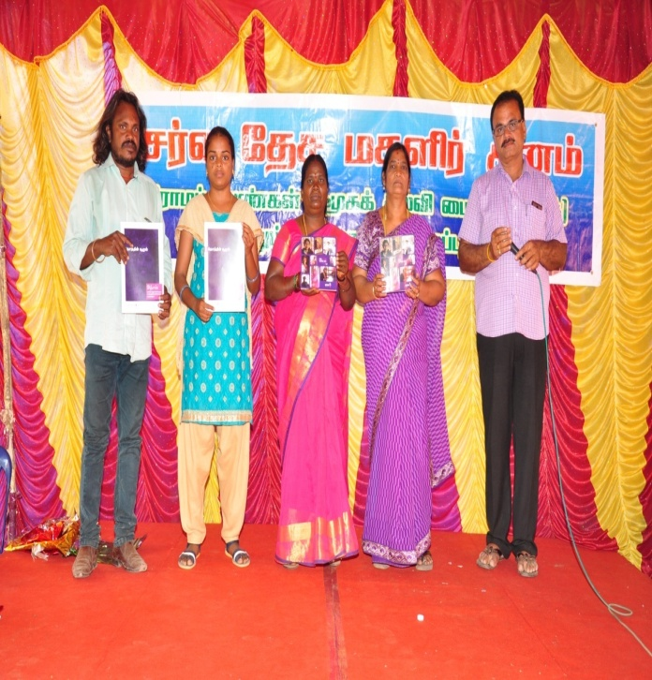
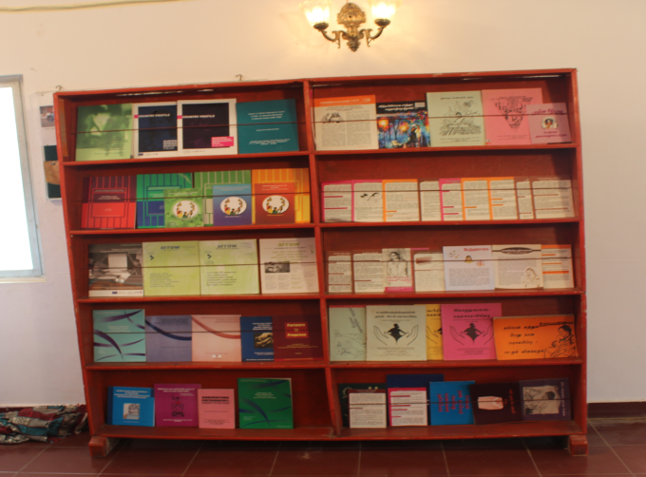

Executive Committee EC meeting and Programme Advisory Committee - PAC meetings at RUWSEC office: EC and PAC of RUWSEC reviews the RUWSEC activities for the year 2016-17 and proposed activities for the year 2017-18

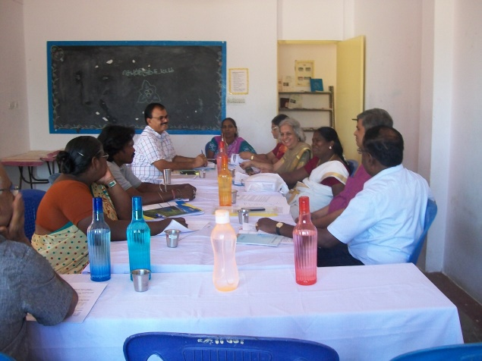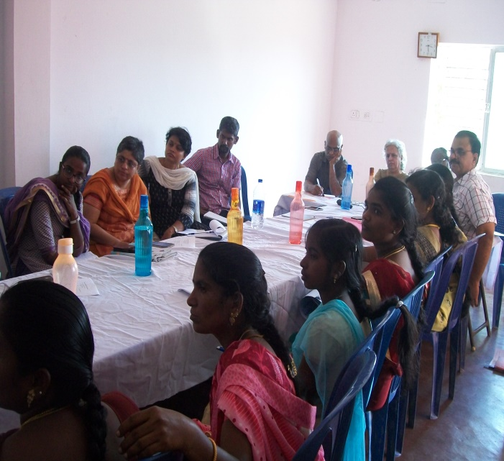

Karunya Trust, Chennai, supported us in conducting a camp for diabetic patients with heart problems. International Women’s Day and Annual Day for life skills education programmes were born with local contributions. ARROW, Malaysia, supported the research and publication activities. All the major field activities were carried out with the help of the corpus fund received from the Ford Foundation.
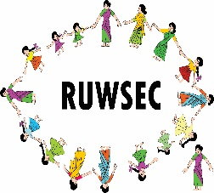 Rural Women’s Social Education Centre (RUWSEC)
61 Karumarapakkam Village, Veerapuram Post, Thirukazhukundrum Via Kancheepuram District, Tamil Nadu, India 60109
Phone: 044- 29542751, E-mail: ruwsec.tn@gmail.com
Website: www.ruwsec.org

