Rural Women’s Social Education Centre (RUWSEC) is a women’s organisation founded in 1981. It is based in Karumarappakkam village near Thirukazhukundrum town in Chengalpattu District of Tamil Nadu. Achieving women's wellbeing through women's empowerment is our organisation’s vision. Our focus has been on enabling women to gain greater control over their bodies and lives and achieve well-being by promoting gender equality and sexual and reproductive rights. Developing leadership among ‘Dalit’ women has been a significant achievement over the past three decades.
Since its inception, RUWSEC has been a grassroots organisation with community-based workers drawn from the local villages. Our approach was to motivate, educate and organise women from poor and marginalised communities to stand up for their rights and become change agents. We wanted rural poor women to analyse the socio-economic and political factors underlying their lack of good health and control over their sexuality and fertility and to have the knowledge and skills to alter their situations.
Our strategy was to start with a series of community meetings and workshops, from which we identified a core group of young community leaders – primarily women and men. On-going training and learning opportunities were provided, and those with potential were encouraged to develop their project ideas, which they then led. Training in project management and implementation enabled innovators to become project leaders. Some of them are currently running their organisations with support from RUWSEC.
RUWSEC is now engaged in research, training, advocacy and a technical support organisation providing inputs to grassroots organisations in Tamil Nadu working on gender, reproductive, sexual health and rights. For nearly four decades of its existence, RUWSEC has implemented a broad spectrum of activities ranging from comprehensive community- based reproductive health education and promotion to reproductive health research with a women-centred perspective; running a reproductive health services clinic; community-based interventions to prevent domestic violence against women; and, innovative work with young women and men on gender and sexual and reproductive health and rights. RUWSEC’s work strategy includes community capacity building, health care services, research training and publication, and advocacy for policy change.

Highlights of the activities for the year 2018 - 2019
Strategy – 1 Community Capacity Building: a) Creating awareness and imparting knowledge on gender, SRHR, and Non-communicable diseases.
Intensive community-based activities are carried out in 25 project villages under 12 panchayats in the Thirukazhukundram block of Chengalpattu District. Awareness workshops and camps are conducted in the villages for different target groups; Adolescents and young people, SHG women and men. Two-day workshops for young women working in the factories on reproductive health were conducted in five villages, and 74 women attended the session. The two pamphlets on anaemia and menstrual health were distributed at the end of the meeting. Few participants said
The information on white discharge and urinary tract infection is beneficial, and hereafter we would follow hygienic practices, especially during menstruation.
Secondly, workshops for SHG women were organised in the 15 villages; the topics coved were 1) Food adulteration and NCD, 2) Women and mental health 3) ways to resolve domestic violence. In total, 1224 women attended the community level workshops.
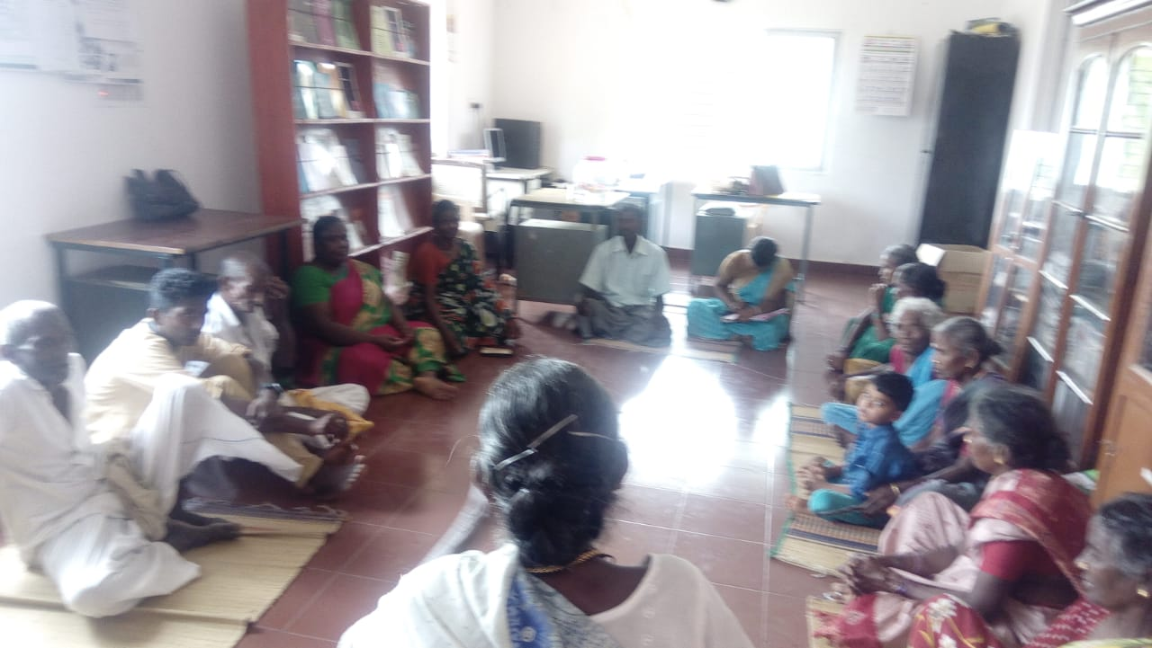
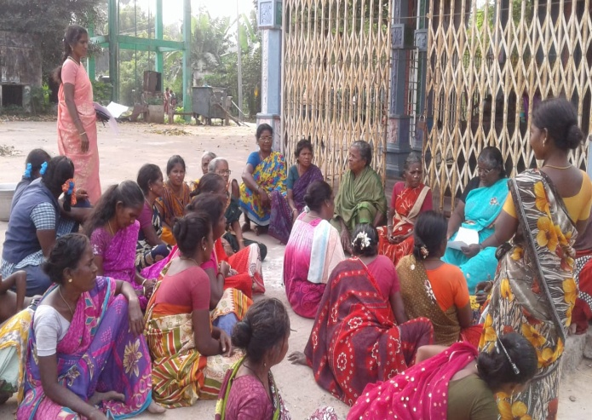
We thought that there was no treatment for mental health issues of the victims of domestic violence, now we know that we can seek psychological counselling and the legal system to get rid of it. We also have a toll free number for it now.

SHG women meeting at the community Cancer support meeting @RUWSEC office
A support group for diabetic patients have been formed to cater to services for the marginalised sections in the community, wherein a meeting is conducted in the villages as the number of diabetic patients are more in village Kamarajar Nagar yearly six support group meetings were held, as towns, Kunnavakkam and Naduvakkarai are closer to each other a combined support group meeting was conducted. Six support group meetings were held for them in this year. In these meetings, guidance and counselling are provided for them. Primarily women attend the support group meeting, and men rarely participate as most of them were working outside the home. Likewise, every month support group meetings for cancer patients were conducted in the office, and a kilogram of Nutri-mix powder was provided to each participant.
b) Centralised training and meetings
For adolescents and young people; Life skills education sessions are conducted for school and college students, focusing on promoting gender, sexual and reproductive health among adolescents and young people. After getting permission from the regional educational department officials, five sessions were conducted in 15 government middle schools in this programme. One hundred fifty-five boys and 167 girls benefitted from these sessions. This year five sessions were conducted in three middle schools, namely Nerumbur, NathamKariyacheri and Veerapuram. After getting permission from the respective school headmasters, 55 boys and 47 girls attended the sessions. Similar sessions were also conducted for college students, wherein 149 boys and 296 girls benefitted.
This year we signed a contract with Concern India Foundation, Chennai, to conduct life skills education workshops for 9th standard students in government higher secondary school Sholinganallur. Five sessions were planned for these students, and the sessions were conducted using our training manual by the staff; 62 boys and 58 girls actively participated in these sessions.
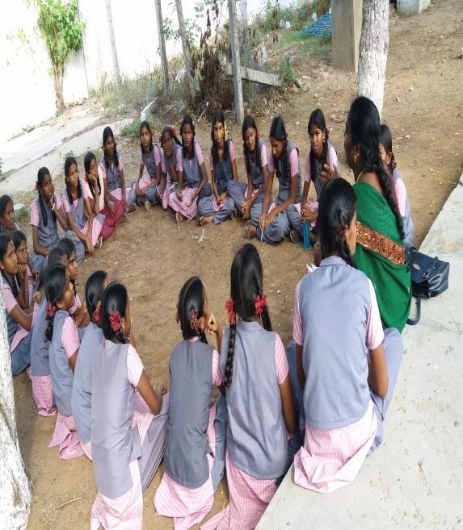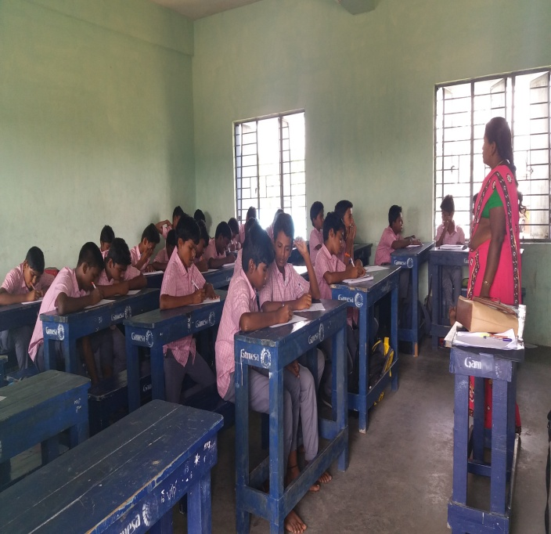
Centre for women’s development and research, Thiruvanmiyur, Chennai, requested us to conduct sessions for adolescents on sexual and reproductive health and rights; workshops were conducted in 13 villages in the Thirukalukundram region.
I learnt how gender operates at different levels; most interestingly, if we give equal opportunity to women, they can shine in all fields.
In the workshop, we have a chance to clarify our reproductive health-related doubts, which are highly useful for girls of my age.
During the workshops, functions of the reproductive organs and sexual and reproductive health rights were explained 319 girls took part in these community-based workshops. Similar sessions were also conducted in Veerapuram, Nerumbur and Pandur; after getting permission from the school headmasters, 166 girls participated. In these workshops, a total of 485 adolescent girls participated.

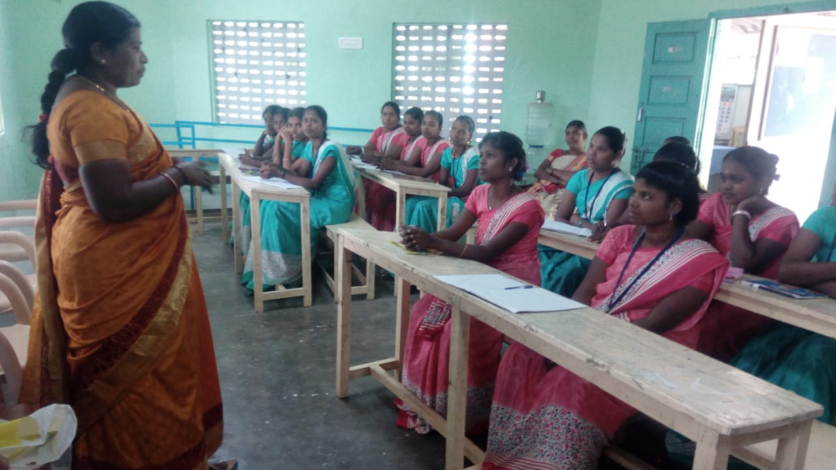
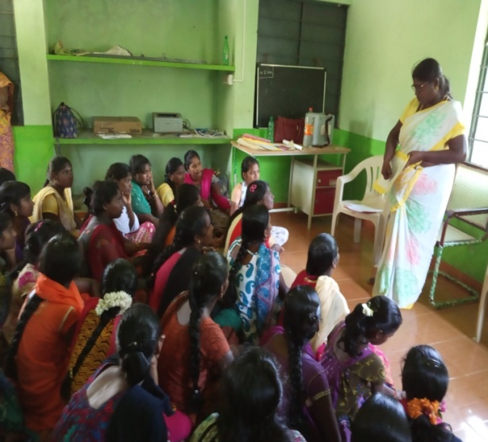
From the nearby villages, young men and women under 30 years of age interested in contributing to social change and taking up leadership initiatives to act as change agents and serve the community were selected and trained. A group of young leaders have been introduced over five years. Interested persons work as part-time staff and volunteer in various programmes.

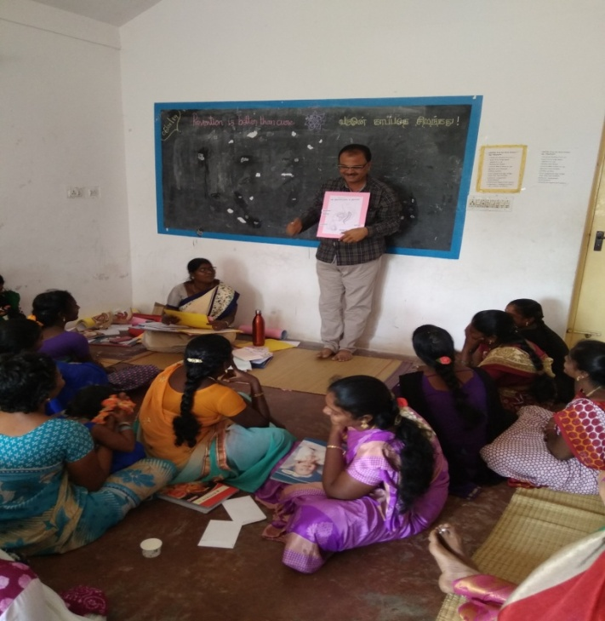
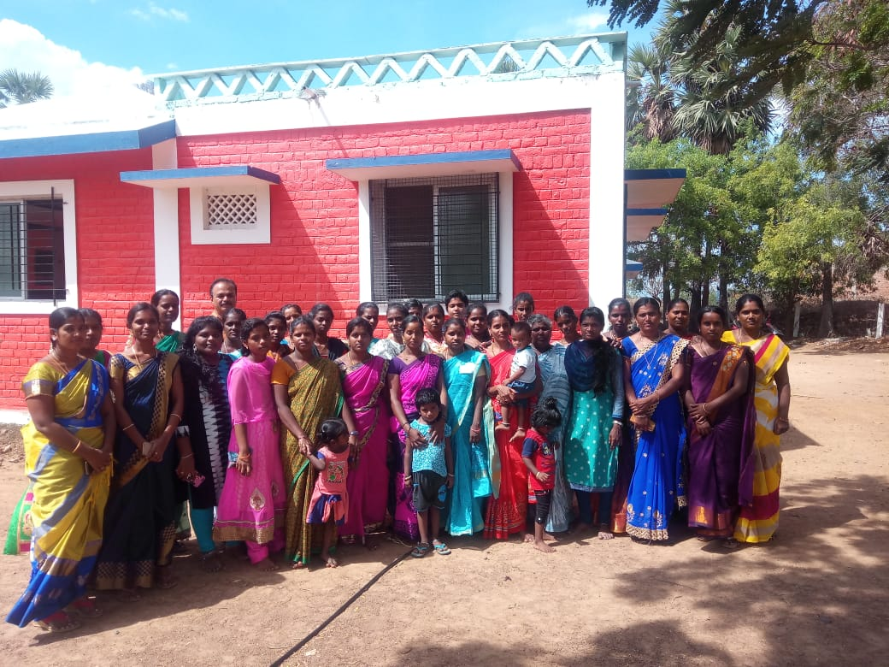
Fifth batch young volunteers were selected from the community and NGO’s group, ten days of intensive training was organised for them. In the first training, 31 women and the last activity, 26 women participated, awarded certificates. In addition to volunteers from our project area, workers from WWTC, Nagalapuram, Tuticorin district, Baniyan, Kovalam and ITWWS, Thandarai also participated.
The training has broadened my understanding of my body, and if I could have had this information before marriage, I would make a healthy and happy life.
There is no chance to get such an in-depth understanding of reproductive health, especially for women. The trainer’s approach and the participatory methodology used in all the sessions are excellent.
Self-defence training was conducted for young women in our resource centre as we constantly hear incidences of abuse and harassment for young people in the four-day training programme 19 young girls actively participated and towards the end of the session a participation certificate was given to them

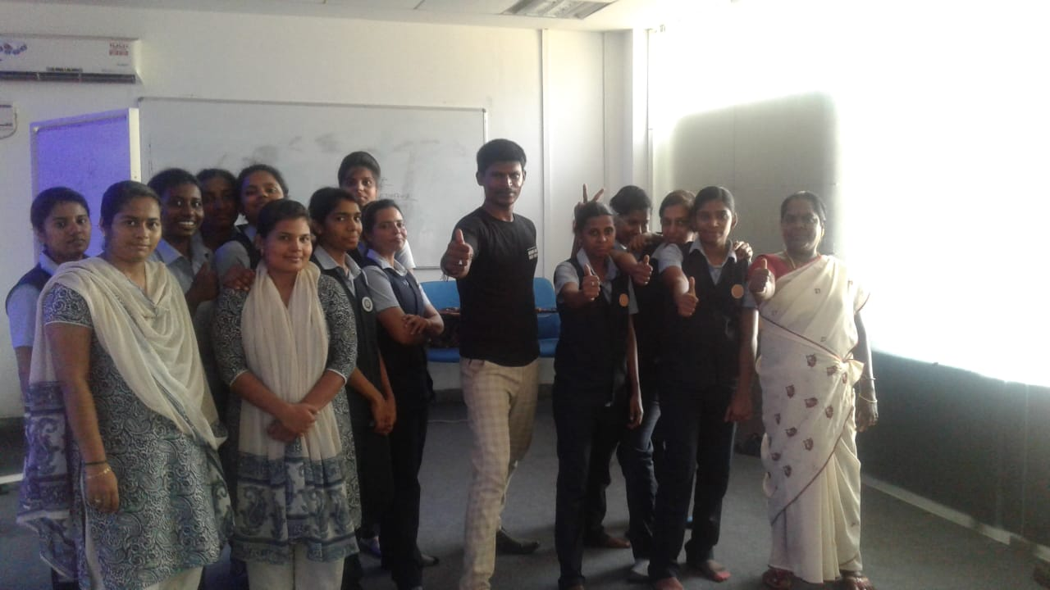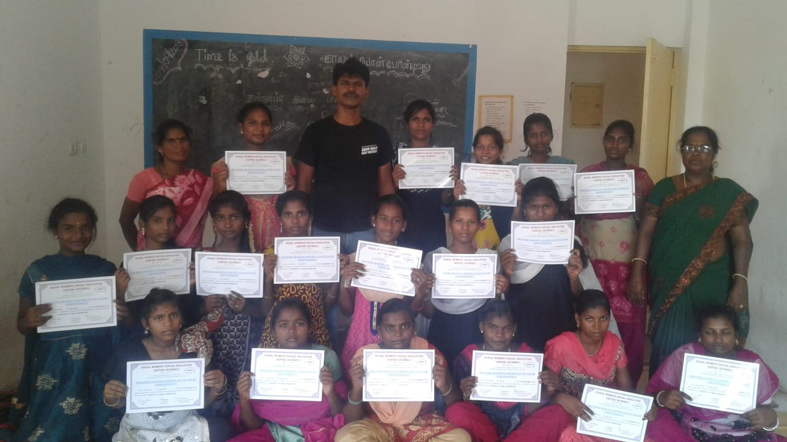

SRHR sessions were conducted for young women working in Mahle Filters India Limited in Thenur village. This year four sessions were completed, and an awareness lecture on women’s empowerment was given at International Women’s Day celebrations. 30 – 35 young women attended these sessions.
For adults and frontline health workers: We continue to train newly wedded couples on gender and SRHR. This is the year 12 participants participated in the session. With the long term vision of promoting gender equality, improving and stressing the importance of sexual and reproductive health rights, a training session was organised for newly married couples. Five newly married couples took part in this training. A follow-up training was also planned for them, but they did not turn up, but a new batch of five teams came for the activity. Staff invited all the newly married couples in the villages to exercise 30 couples concerned. Still, despite follow-up, only six teams turned up for the session despite informing them over the phone and sending messages via SMS.

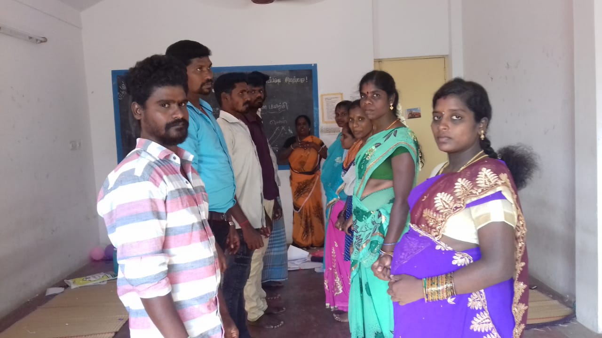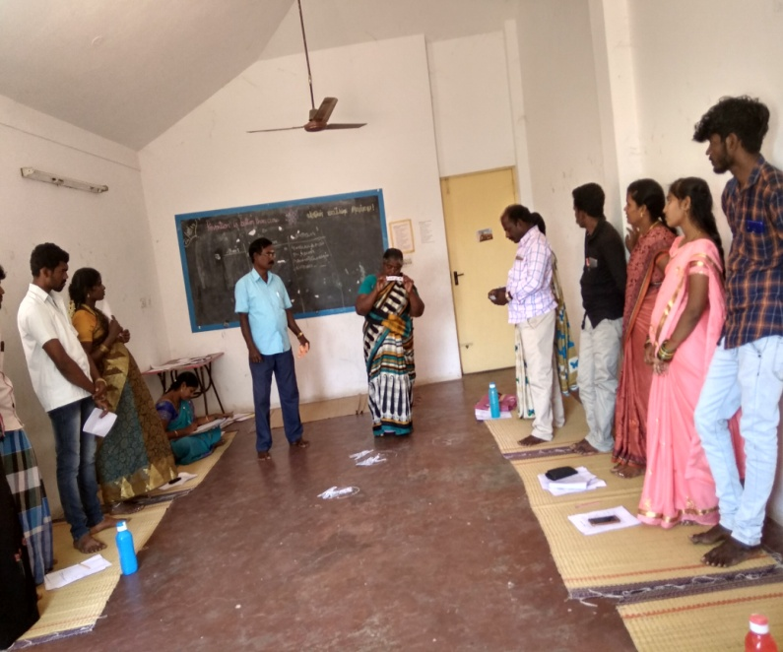
Workshop for newly wedded couples
A special workshop was conducted for women with single children and six months old child on spacing methods, though follow-up and inviting 30 women, only ten women attended the seminar. A workshop for pregnant women was organised to explain functions of the reproductive system, physical and emotional changes during pregnancy, and the expectations from the family members during pregnancy. Only seven pregnant women attended this workshop.
A periodic workshop for Anganwadi workers on gender and reproductive health was organised, and refresher training for women protection committee members in Thirukazhukundram was conducted. In this training, 24 ICDS workers and 23 committee members participated. We have been in constant touch with the community committee members formed by us all these years. Among them, 85 community committee groups are in constant contact with us; they update us about the incidences of domestic violence in the community and seek guidance as and when required. This year we planned a meeting with them, we invited 50 committees, but only 22 women from 16 committees and one man attended this meeting; two such meetings were conducted this year.
A community committee member says the recent updates on POCSO and sexual harassment at workplace acts are handy; we inform our village women working in the companies to demand the formation of an internal complaint committee in their workplace.

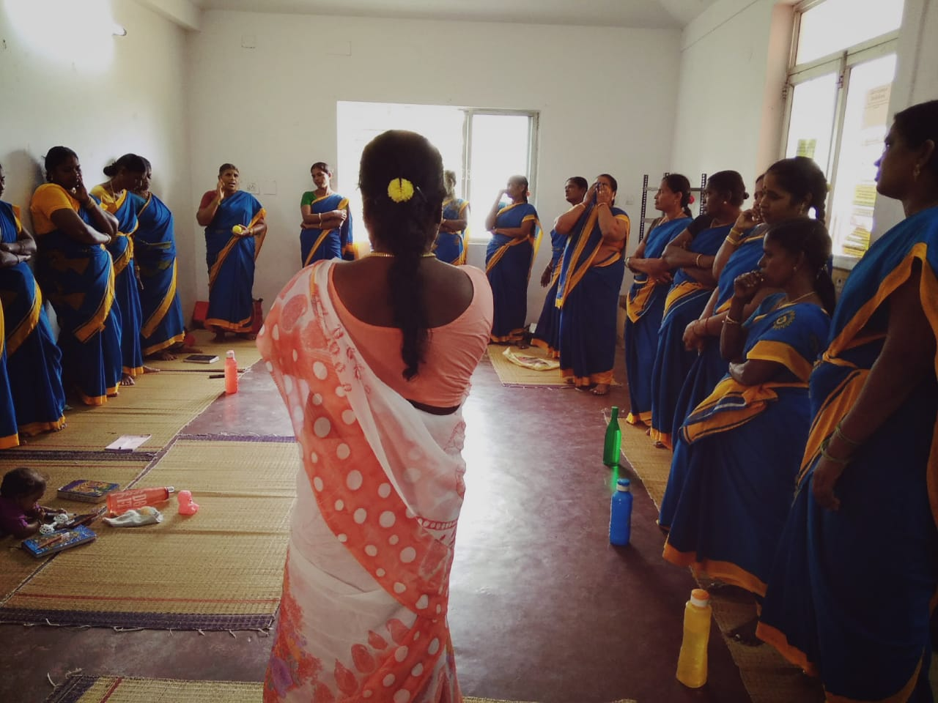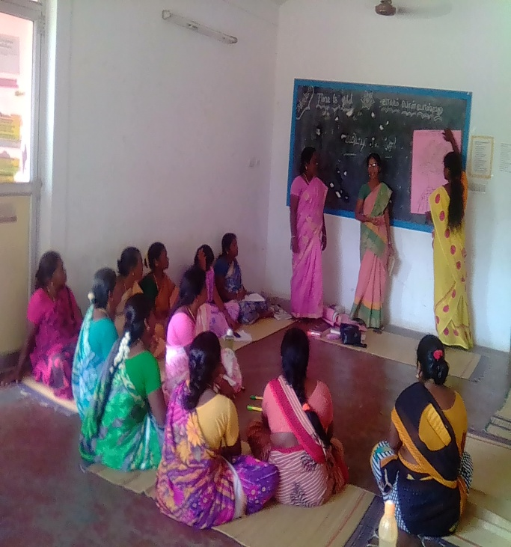

Strategy 2: Health Care services
During the house visits to all the 25 project villages, staff members met 588 diabetes patients. Out of them, 322were women and 266were men, patients with blood pressure were 330out of them, 160 were men, and 170 were women. One hundred sixty-five women and adolescent girls undergo regular follow-up treatment for anaemia. During the reporting period, counselling services were provided to 102 pregnant women, 83 women with single children and 98 women with a six-month-old baby. Counselling services are provided using counselling cards. All the people in the project villages with non-communicable diseases, pregnant women with reproductive morbidities, are monitored and under constant follow-up.
We continue our counselling services @ PHC by our staff members on all Tuesdays for pregnant women in Nerumbur PHC. Counselling for diabetes patients is also provided.

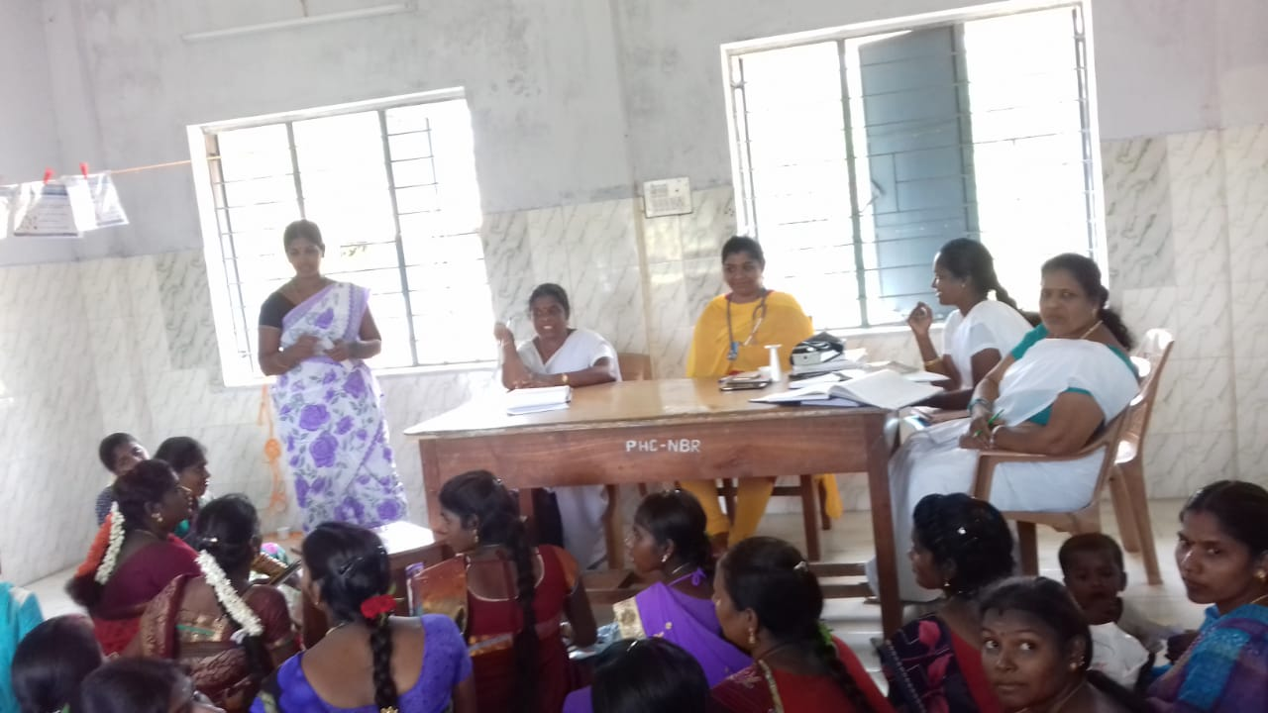

In our clinic, speciality services are also offered as an outpatient service. People accessing our clinical services opt for allopathic treatment and seek alternative medical interventions with no contra effects. These services are gradually improving every year.
Counselling, referral, and follow-up of women affected by domestic violence are essential services. During April- 2018- March 2019, 35 women who are the victims of domestic violence accessed our centralised counselling services.
In the reporting period, 20,618 availed medical services in our clinic; among them, 7,113 have accessed the allopathic services, 9,216 accessed side services and 2,381 accessed homoeopathic services. It could be observed that people accessing the medical services for long term ailments and old people accessing our clinic are more in number when compared to other cohorts. Most of the patients who sought treatment for NCD reported that the quality of care, especially the doctors’ approach and maintenance provided, is highly commended.
Till February 2019, the consultant for obestristics and gynaecology provided services on the fourth week of every month; this service got discontinued after this period. Allopathic services are provided only on Sunday’s.
RUWSEC Clinic Users Apri208-March2019
Month | Allopathy |  |  |  |  | Siddha |  |  |  | Homoeopathy |  |  |  | Laboratory
 | Male | Female | Children | Pregnant | Total | Male | Female | Children | Total | Male | Female | Children | Total | Male | Female | Total
April 2018 | 163 | 328 | 17 | 3 | 511 | 304 | 508 | 26 | 838 | 77 | 147 | 8 | 232 | 36 | 84 | 146
May | 134 | 307 | 0 | 1 | 442 | 256 | 418 | 5 | 679 | 56 | 120 | 1 | 176 | 49 | 76 | 170
June | 177 | 401 | 0 | 16 | 594 | 271 | 372 | 11 | 654 | 57 | 104 | 12 | 173 | 61 | 80 | 175
July | 156 | 345 | 13 | 0 | 514 | 332 | 604 | 26 | 962 | 83 | 130 | 2 | 215 | 59 | 126 | 218
August | 176 | 312 | 6 | 0 | 494 | 335 | 439 | 12 | 786 | 71 | 140 | 6 | 217 | 48 | 118 | 227
Sept | 188 | 485 | 3 | 0 | 676 | 295 | 411 | 12 | 718 | 57 | 111 | 1 | 169 | 46 | 131 | 209
October | 267 | 491 | 7 | 0 | 765 | 327 | 440 | 16 | 783 | 81 | 88 | 5 | 174 | 66 | 109 | 264
November | 242 | 450 | 4 | 0 | 696 | 272 | 345 | 12 | 629 | 80 | 111 | 11 | 202 | 81 | 97 | 275
December | 218 | 433 | 21 | 0 | 672 | 272 | 417 | 33 | 732 | 74 | 118 | 6 | 198 | 42 | 115 | 228
January 2019 | 127 | 223 | 9 | 0 | 359 | 369 | 538 | 14 | 921 | 100 | 174 | 5 | 279 | 41 | 89 | 170
February | 205 | 423 | 4 | 2 | 634 | 326 | 437 | 16 | 779 | 97 | 94 | 4 | 195 | 49 | 133 | 265
March | 244 | 499 | 0 | 13 | 756 | 350 | 461 | 24 | 835 | 65 | 72 | 13 | 150 | 23 | 93 | 158

Annual NCD camp; In our clinic, people are coming for follow-up treatment for long term health ailments; to cater to their needs, a camp was organised, wherein diabetes and eye tests were carried out for three days. A target of about 150 patients from the 25 villages where RUWSEC is currently working, people living below the poverty line, belonging to minority communities, were invited to participate in the camp. They were grouped into three villages to be screened on 20 Jan, 27 Jan and 03 Feb 2019. These patients reported to the RUWSEC clinic two days before the camp to give blood for testing in the fasting state and recorded their ECG. Then they came back to the clinic on the camp days to be seen by the ophthalmic team from Nirmal’s Eye Hospital and reviewed by the physician. Among the 120 people who came to the camp, the specialists identified that 28 had diabetes, blood pressure, cholesterol and heart problems. People diagnosed with difficulties were referred to the CHC in Thirukalukundram and PHC in Nerumbur village. Both these health centres are close by for them to access follow-up treatment. They are also monitored and followed up by the staff during the field visits.
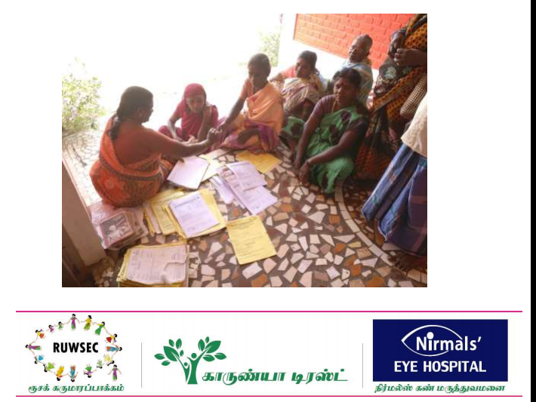
Strategy 3and 4: Research, Publication and advocacy activities
In collaboration with CommonHealth, we conducted a study about Safe Abortion Services in the Kanchipuram district; for this study, necessary tools and consent forms were prepared and sent to IRB members for review after incorporating the suggestions, tools, and tools questionnaires were finalised. Guidance was provided to the staff about data collection, and the data collection process included interviews and focused group discussions. The process was completed, and the report was submitted to CommonHealth for finalisation. We were invited to present a national level dissemination meeting in Mumbai, and our Executive Director did the presentation. Then we organised a state-level dissemination meeting in Chennai. Fifty-eight participants from civil society groups, activists, academicians, and front line health workers across the state, including media people, attended the meeting. The event and the study’s key findings featured two English newspapers and a Tamil journal.

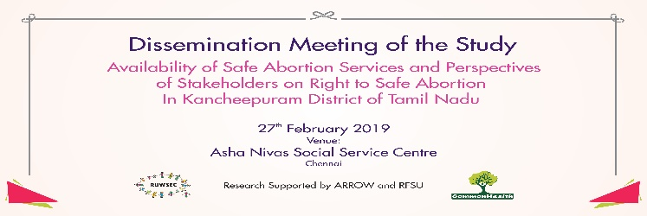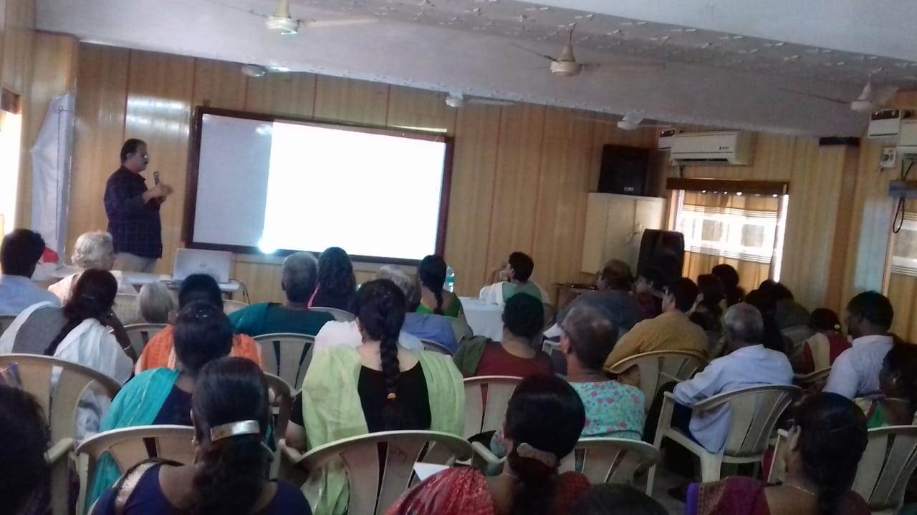
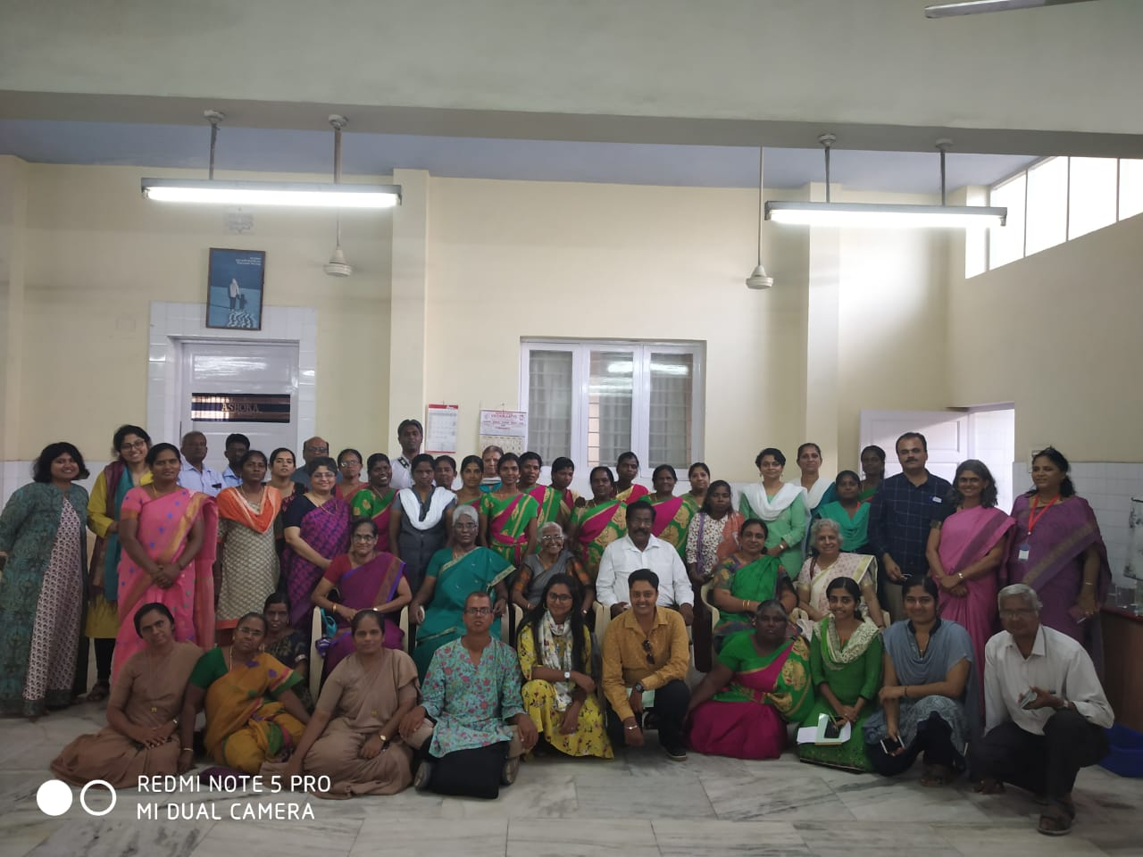
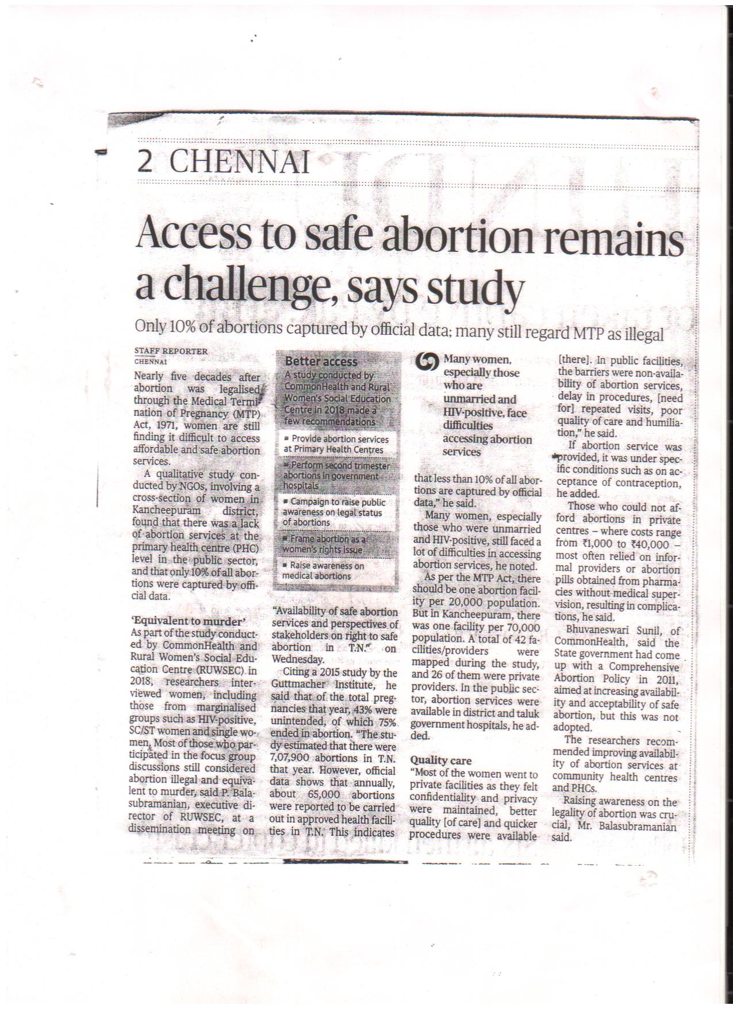
Banyan, Kovalam conducted a Diploma programme on Mental Health, five of our staff members attended this programme and their Diploma award with first class.
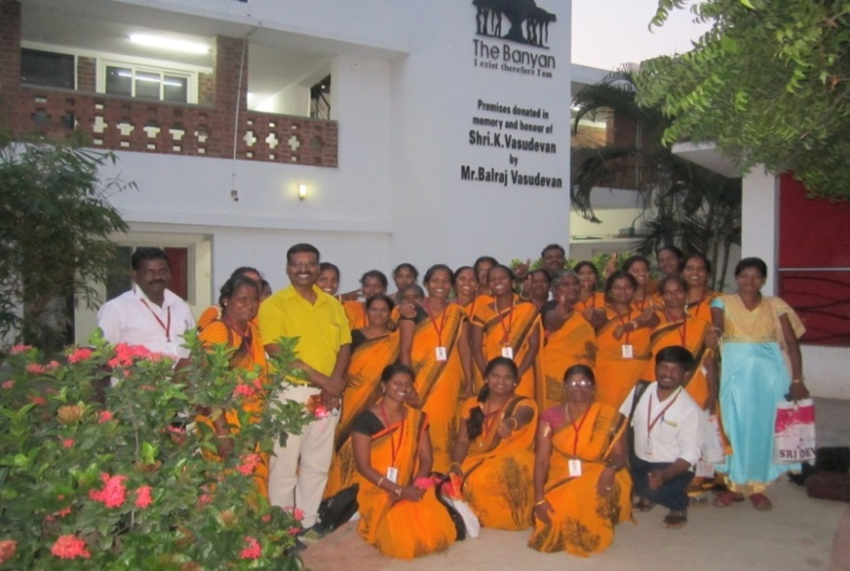
Five Staff completed Diploma in Community Mental Health course
We prepared a proposal for a programme on Diabetes care and submitted it to various donors; in collaboration with Ubasla University, Sweden, we drafted a research proposal on controlling diabetes, and blood pressure and treatment procedures along with background materials were submitted. As a follow-up, eminent persons from 4 - 5 countries had a joint discussion about this research study; based on their inputs and suggestions, now we are collecting relevant information for the analysis.
A community-based research study has been planned along with a professor from IIT, Chennai, on the SRHR status of the migrated population; we plan to conduct this study among women as they have approved for a collaborative study we prepared a draft plan and budget and submitted for their approval, now they have agreed for this study.
On occasion, on International Breast Feeding day, a campaign was organised in Mullikulathur village. During the event importance of breastfeeding was explained using chart display and skits, a special lecture, sharing poetry and awareness songs were also sung. More than 50 men and women took part in this campaign.
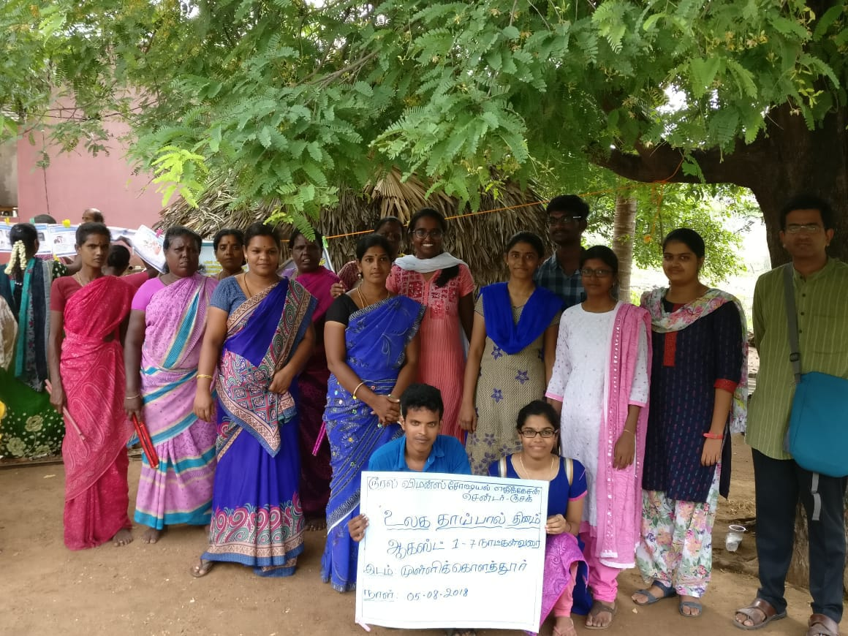
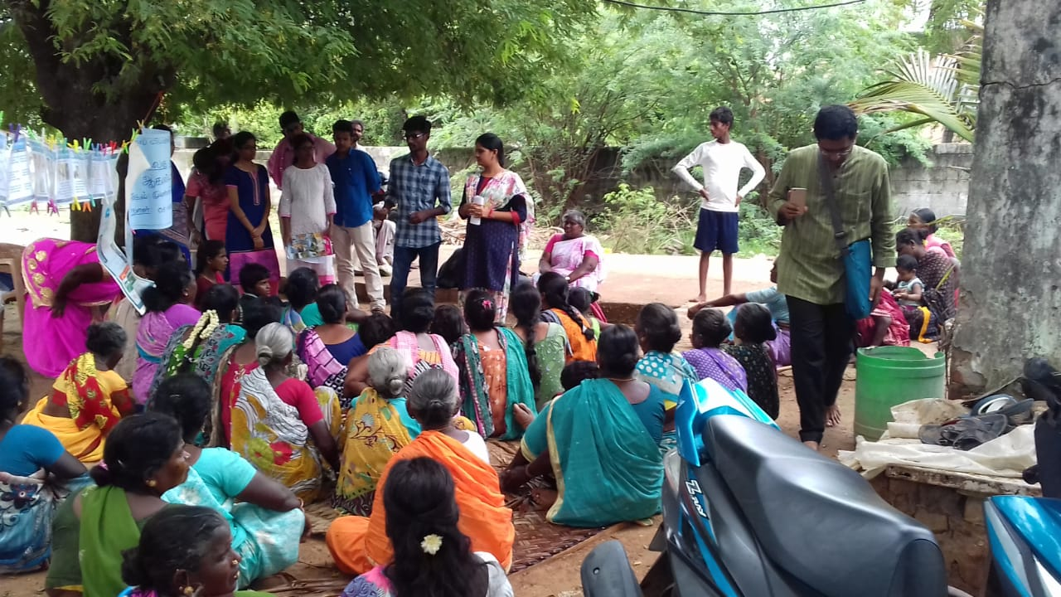
All our activities are carried out through funds and donations from many persons interested in supporting a social cause. Karunya Trust in Chennai supported us in conducting diabetes and eye tests camp. ARROW, Malaysia, Concern India, Chennai and CWDR supported specific programmes, Mahle filters India Limited kept running SRHR sessions for young women working in companies, Chennai friends club and Dr Bagiyam gave individual contributions. Most of the field-based activities and the clinic's functioning were carried out in the year with interest from the corpus fund from Ford Foundation. The women’s day celebration and annual day function of the life skills education programme were conducted through local contributions and donations.
International Women Day and School programme annual day in March 2019
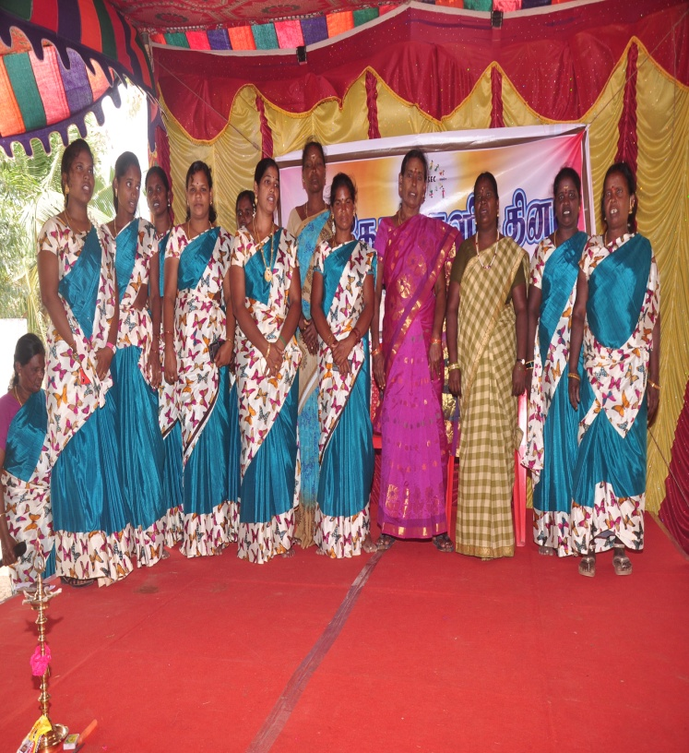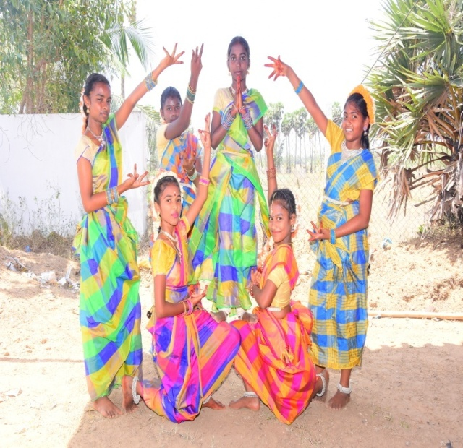
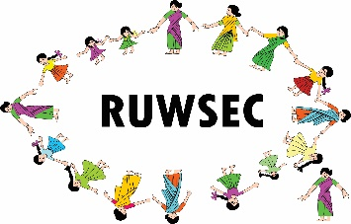Rural Women’s Social Education Centre (RUWSEC)
61 Karumarapakkam Village, Veerapuram Post,
Thirukazhukundrum Via Kancheepuram District, Tamil Nadu, India 60109
Phone: 044- 29542751, E-mail: ruwsec.tn@gmail.com
Website: www.ruwsec.org

