Rural Women’s Social Education Centre (RUWSEC) Activity Report 2019-2020
Rural Women’s Social Education Centre (RUWSEC) was started in the year 1981 by a group of
13 women are stepping into its 36
The
A year and continuously executing programmes for women’s
rights and empowerment. RUWSEC is functioning on its campus in Karumarapakkam
village, near Thirukalukundram temple town of Kancheepuram district Tamil Nadu.
From the year 2013 – 2014, the programmes in the organisation were integrated and executed
under the following thematic areas:
1. Strengthening general health care services in the villages
2. Imparting Sexual and Reproductive health rights among adolescents and young
people.
3. Strengthening sexual and reproductive health and rights among women
4. Combating gender-based violence
All the programmes mentioned above are carried out through four main strategies, namely 1.
Creating awareness 2. Providing services 3. Research and publishing in popular print media 4.
Advocacy and lobby to bring in policy-level changes. RUWSEC is presently focussing and
carrying out activities to create a more substantial field-based impact in the community. Women and young people carry out all the field
based activities, and the primary attention behind this is to
execute the programmes for and through
Rural Women’s Social Education Centre (RUWSEC) was started in the year 1981 by a group of
13 women are stepping into its 36
th
a year and continuously executing programmes for women’s
Rights and empowerment. RUWSEC is functioning on its campus in Karumarappakkam
The village, near Thirukalukundram temple town of Kancheepuram district Tamil Nadu.
From the year 2013 – 2014, the programmes in the organisation were integrated and executed
Under the following thematic areas:
1. Strengthening general health care services in the villages
2. Imparting Sexual and Reproductive health rights among adolescents and young
People.
3. Strengthening sexual and reproductive health and rights among women
4. Combating gender-based violence
All the programmes mentioned above are carried out through four main strategies, namely 1.
Creating awareness 2. Providing services 3. Research and publishing in popular print media 4.
Advocacy and lobby to bring in policy-level changes. RUWSEC is presently focussing and
Carrying out activities to create a more substantial field-based impact in the community. All the field
Based activities are carried out by women and young people, and the primary attention behind this is to
execute the programmes for and through
Rural Women’s Social Education Centre (RUWSEC) was started in the year 1981 by a group of
13 women are stepping into its 36
th
a year and continuously executing programmes for women’s
rights and empowerment. RUWSEC is functioning on its campus in Karumarappakkam
the village, near Thirukalukundram temple town of Kancheepuram district Tamil Nadu.
From the year 2013 – 2014, the programmes in the organisation were integrated and executed
Under the following thematic areas:
1. Strengthening general health care services in the villages
2. Imparting Sexual and Reproductive health rights among adolescents and young
people.
3. Strengthening sexual and reproductive health and rights among women
4. Combating gender-based violence
All the programmes mentioned above are carried out through four main strategies, namely 1.
Creating awareness 2. Providing services 3. Research and publishing in popular print media 4.
Advocacy for policy changes. RUWSEC is presently focussing and
Carrying out activities to create a more substantial field-based impact in the community. The entire field
Based activities are carried out by women and young people, and the primary attention behind this is to
Execute the programmes for and through women from the socially and economically
marginalised sections in the community
Rural Women’s Social Education Centre (RUWSEC) was started in the year 1981 by a group of
13 women are stepping into its 36
th
a year and continuously executing programmes for women’s
rights and empowerment. RUWSEC is functioning on its campus in Karumarappakkam
the village, near Thirukalukundram temple town of Kancheepuram district Tamil Nadu.
From the year 2013 – 2014, the programmes in the organisation were integrated and executed
under the following thematic areas:
1. Strengthening general health care services in the villages
2. Imparting Sexual and Reproductive health rights among adolescents and young
people.
3. Strengthening sexual and reproductive health and rights among women
4. Combating gender-based violence
All the programmes mentioned above are carried out through four main strategies, namely 1.
Creating awareness 2. Providing services 3. Research and publishing in popular print media 4.
Advocacy and lobby to bring in policy-level changes. RUWSEC is presently focussing and
carrying out activities to create a more substantial field-based impact in the community. All the field
based activities are carried out by women and young people, and the primary attention behind this is to
execute the programmes for and through women from the socially and economically
marginalised sections of the community
Rural Women’s Social Education Centre (RUWSEC) was started in the year 1981 by a group of
13 women are stepping into its 36
th
a year and continuously executing programmes for women’s
rights and empowerment. RUWSEC is functioning on its campus in Karumarappakkam
the village, near Thirukalukundram temple town of Kancheepuram district Tamil Nadu.
From the year 2013 – 2014, the programmes in the organisation were integrated and executed
under the following thematic areas:
1. Strengthening general health care services in the villages
2. Imparting Sexual and Reproductive health rights among adolescents and young
people.
3. Strengthening sexual and reproductive health and rights among women
4. Combating gender-based violence
All the programmes mentioned above are carried out through four main strategies, namely 1.
Creating awareness 2. Providing services 3. Research and publishing in popular print media 4.
Advocacy and lobby to bring in policy-level changes. RUWSEC is presently focussing and
carrying out activities to create a more substantial field-based impact in the community. All the field
based activities are carried out by women and young people, and the primary attention behind this is to
execute the programmes for and through women from the socially and economically
marginalised sections of the community
Rural Women’s Social Education Centre (RUWSEC) was started in 1981 by 13 women; for the past 38 years, we have been continuously executing programmes for women’s rights and empowerment. RUWSEC is functioning on its campus in Karumarappakkam village, near Thirukalukundram temple town of Chengalpattu district of Tamil Nadu. RUWSEC predominantly works with rural Dalit women, adolescents and young people with sexual and reproductive health issues.
From the year 2013 – 2014, all our field activities were integrated and executed under the following thematic areas:
- Promoting general health and healthy beings at the community
- Promoting sexual and reproductive health of adolescents and young people.
- Promoting sexual and reproductive health and rights of adults
- Prevention of gender-based violence against women
All the above programmes are carried out through four main strategies, namely 1. They are creating awareness 2. Providing health care services 3. Research, training and publication of popular health education materials 4. Advocacy for a more sweeping policy change. RUWSEC is focussing and carrying out activities to create a more substantial field-based impact in the community. All the field-based activities are carried out for women and young people. The immediate attention behind this is to execute the programmes for and through women from the socially and economically marginalised sections in the community.
The highlight of Activities 2019 – 2020
ACTIVITY 1: Community-level awareness generation and health education on non – communicable Diseases, Gender, Sexual and reproductive health
Towards the objective of promoting general health and well-being in the community, activities have been carried out to prevent and provide health care services for lifestyle diseases; diabetes, Hypertension, Anaemia, and Cancer. Community-level workshops were carried out in the 25 project villages in Thirukalukundram administrative block. The focus is on diabetes, blood pressure and anaemia. Preventive measures are taken, and health education sessions, workshops, and meetings provide suggestions for food practices and lifestyles. During field visits, the staff members visit all the households and counselling services are provided on food practices, the importance of exercises and physical activities, follow-up treatment, and taking regular tablets. Health care services are also offered through specialists in the RUWSEC clinic.

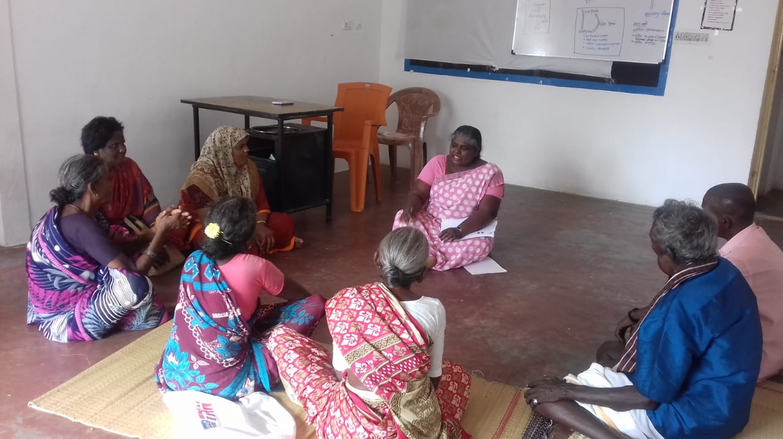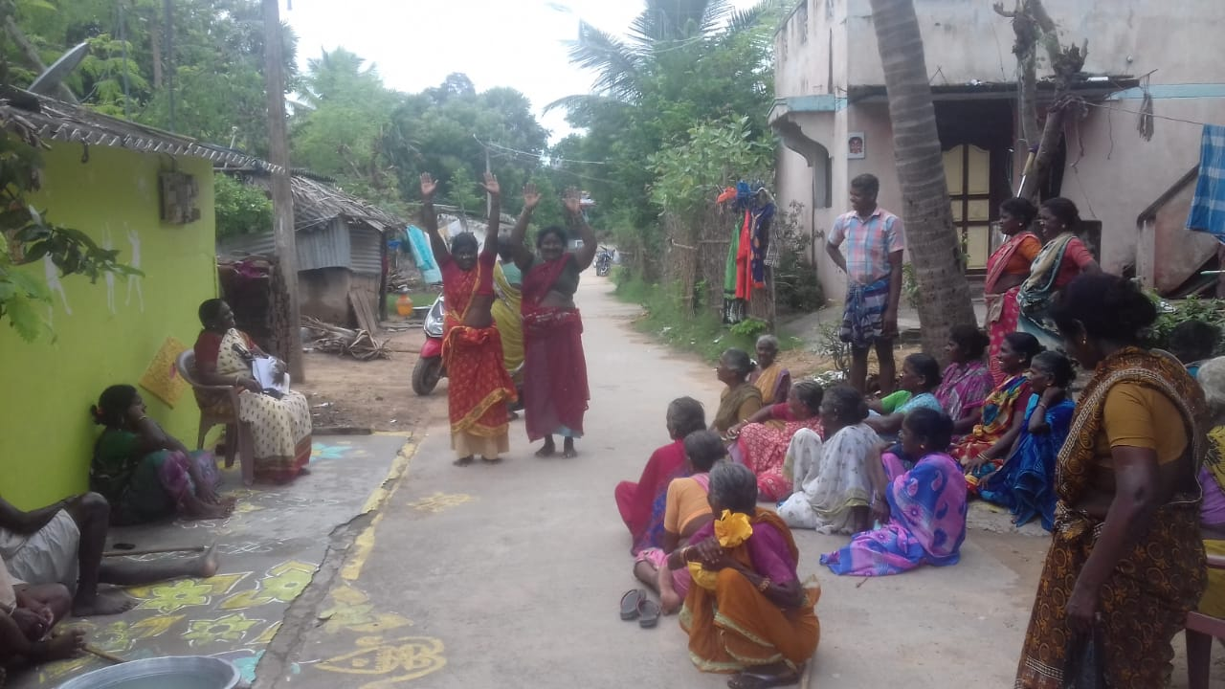
Support Group Meetings for Cancer and Diabetes patients
A support group for diabetic patients have been formed in two villages, where the diabetic patients are more in number. This year six support group meetings were conducted in Pandur village, and six support group meetings were conducted in Perumpedu village. In these meetings, support and guidance are provided for all the diabetic patients in the town.
Counselling services are an essential component during field visits. This year counselling services were provided for 630 diabetic patients. Among them, 325 were women, 305 were men, and 520 were for blood pressure. Among them, 345 were women, 175 were men, and 112 adolescent girls who were anaemic were taking follow-up treatment.
The diabetic patients in the project villages are classified under three categories: people who currently have diabetes or are in the pre-diabetic stage, diabetic for long years and taking treatment, and diabetic with other health problems. Based on the type of group they come under, staff members provide specific counselling services and follow-up them during the field visits. In the counselling process, the staff members stress follow-up treatment, periodic laboratory tests and following healthy food practices, like what a diabetic patient should eat? What should they not eat? Why is follow-up treatment necessary? How does the health gets affected if diabetes is not treated, and is the importance of timely medical intervention? With the help of specialists, counselling cards are prepared, and staff members use these cards for providing counselling services during house visits in the project villages

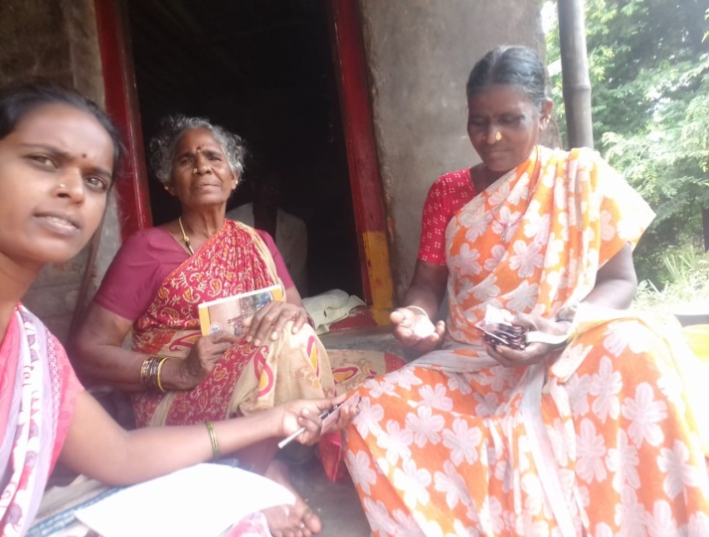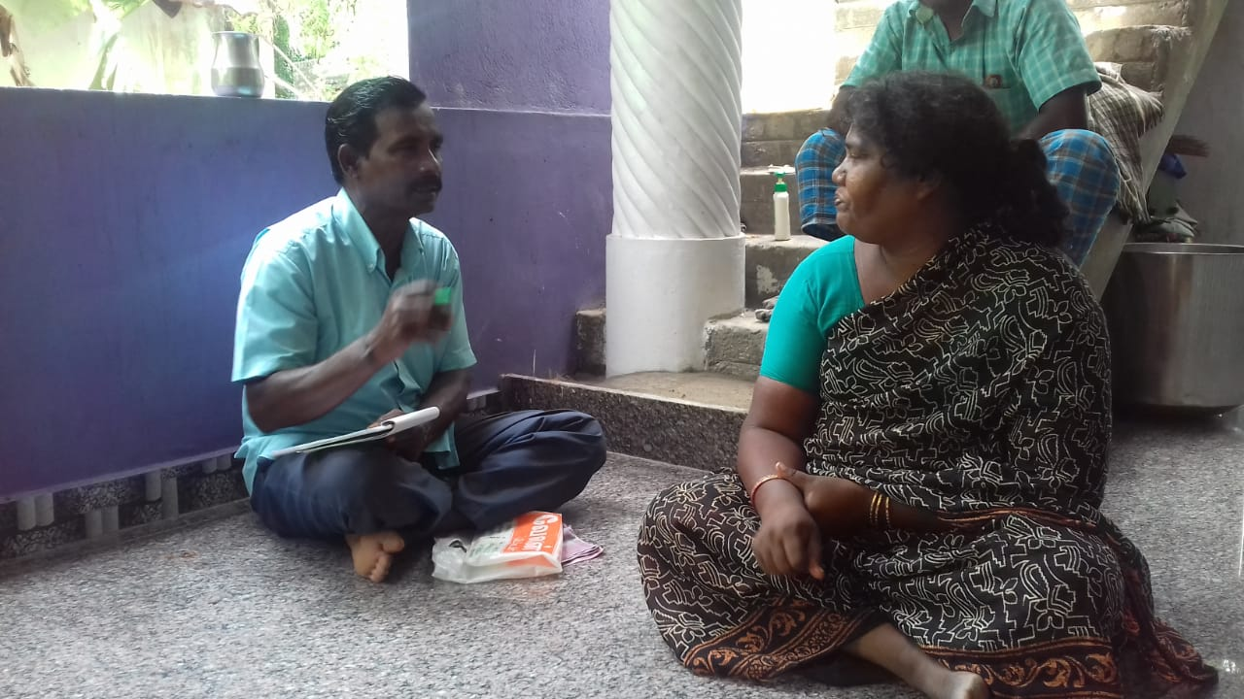
Counselling NCD patients through house visits

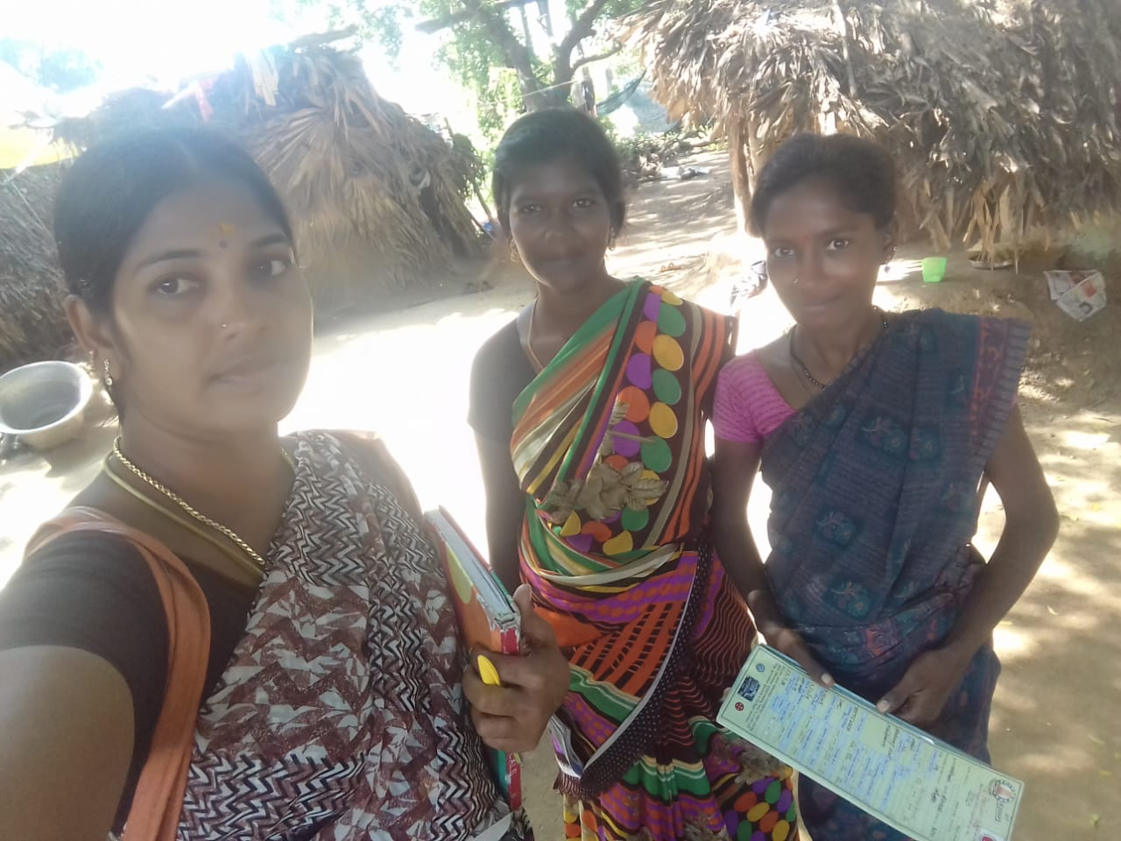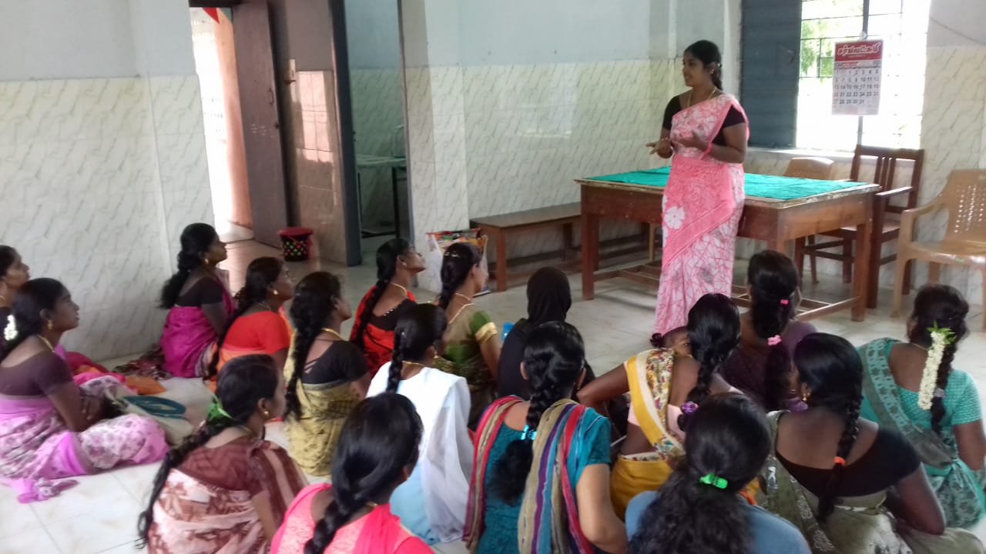
Community-level and Health Centre (PHC) based counselling services for pregnant women

ACTIVITY 2: Creating awareness on NCD, Gender and SRHR through centralised training and meetings
School and College-based Life skills workshops for adolescents and youth: This year, life skills, gender, sexual and reproductive health education workshops for adolescents and young people were carried out for three groups. In the first group, 15 middle schools in the project area were covered after getting permission from the Block Education Office Authorities. These school students had four sessions, and 40 boys and 131 girls attended these sessions. Five sessions were conducted after getting permission from four high school headteachers in the second group, namely Nerumbur, Veerapuram, Nathamkariyacheri and Vallipuram, and 57 boys and 71 girls attended these sessions. In the third group, one session for the Arthur Pattammal College students, 77 boys and 70 girls participated in these sessions.

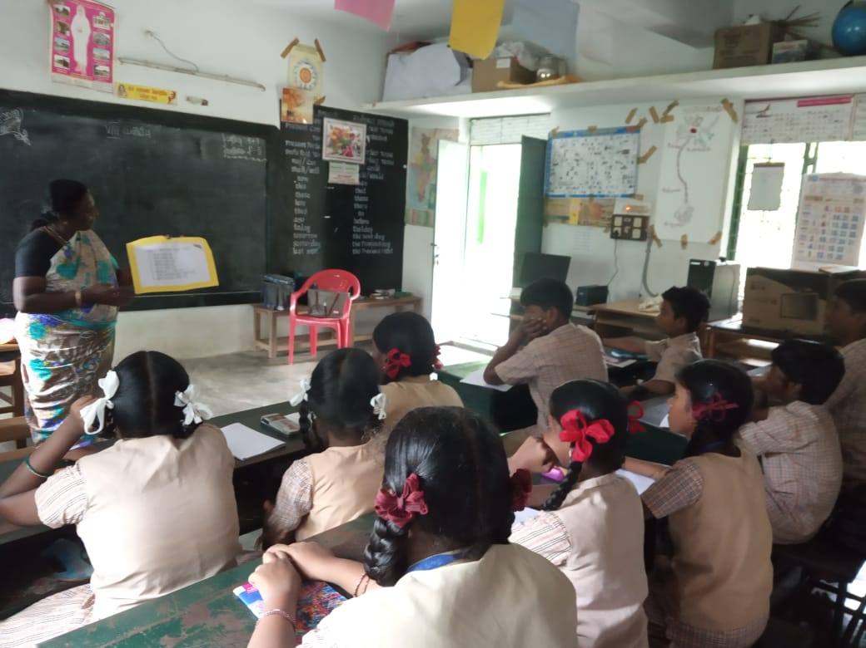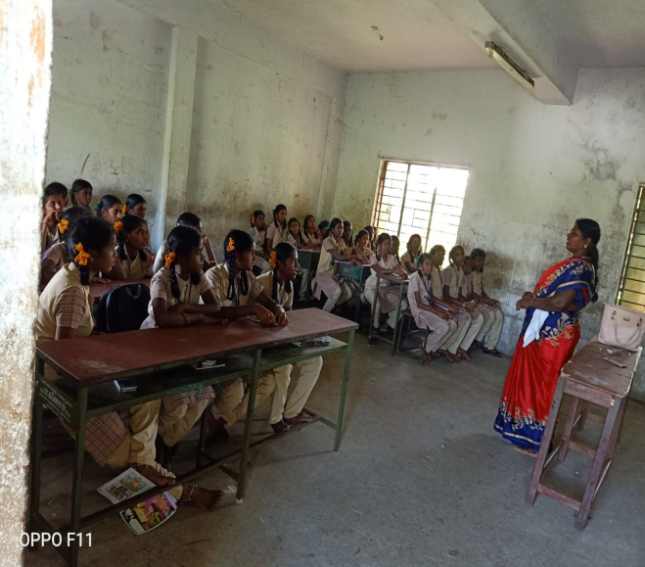
Life skill education workshops in government middle Schools
We agreed with Concern India Foundation, Chennai, to impart sexual and reproductive health education for the daughters ( 11-18 years) of domestic workers in slums. This year community level workshops on five topics were conducted in four urban centres; Mylapore school, Mylapore community, Perumbakkam and Choolaimedu; 105 adolescent girls attended these sessions.
Likewise, RUWSEC, in collaboration with the Centre for Women Development, has been jointly implementing programmes for Sexual and Reproductive Health Rights (SRHR) for adolescent girls in the Thirukazhukundram block. Initially, we collected information from 500 adolescents in our project villages and have conducted a session on the broader theme ‘My body my Right’. We have also associated with eight networks in the Kancheepuram district and have run a campaign in Mahabalipuram and Thiruporur. Twenty-five adolescent girls totalling 200 members, took an active part in the movement promoting SRHR.
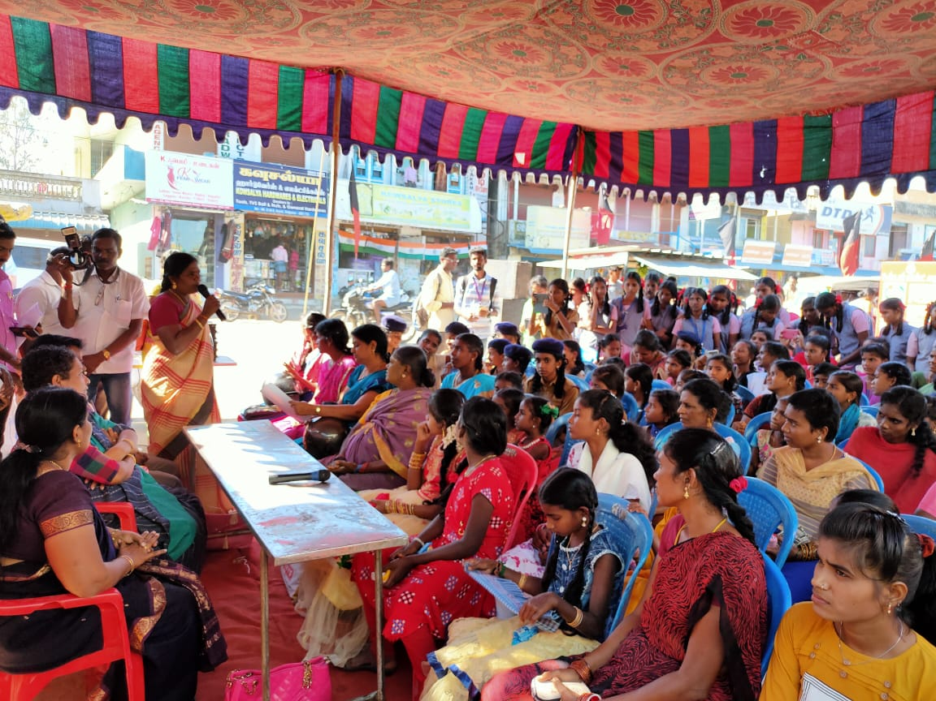

Adolescents Lifeskills programme annual day on March 2020. More than 200 students and 11 parents, and 23 teachers attended the programme.
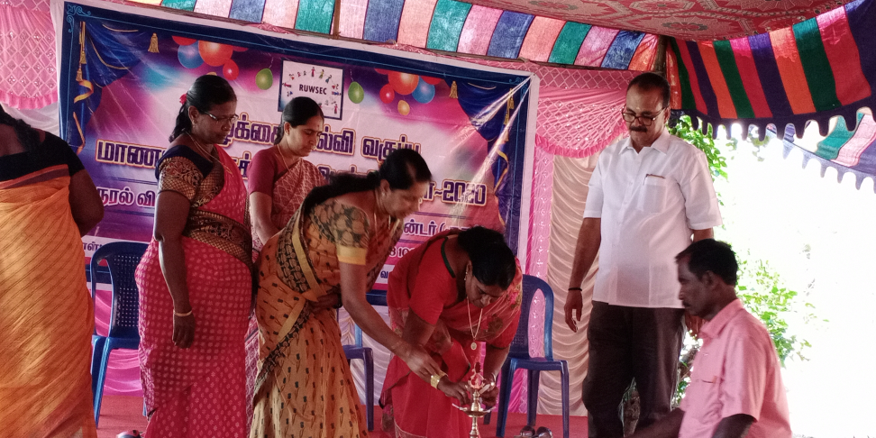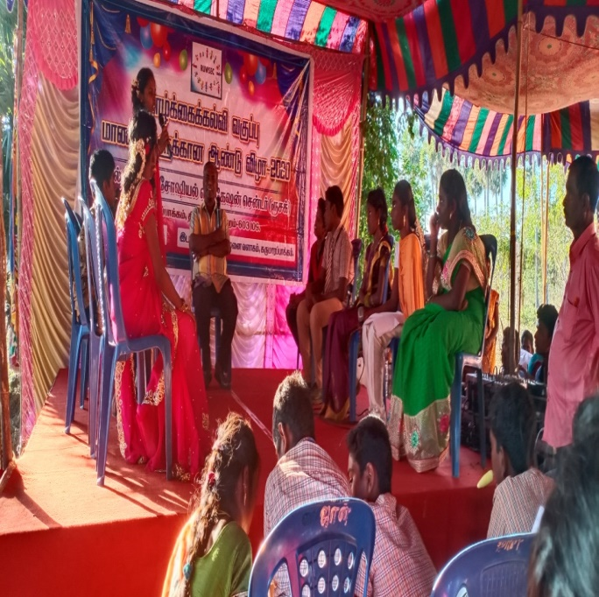
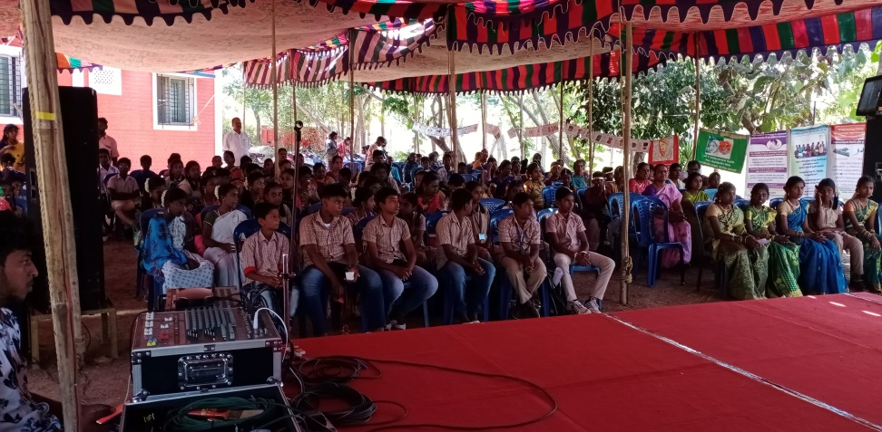

Youth leadership training programme: This programme has been carried out for the past six years, and in the current year, 25 young people have trained on gender and SRHR. It was a ten days certificate training programme. It was primarily conducted on weekends as some were students working in factories. Among them who are very active and committed have been selected and placed in various programmes in the organisation as part-time staff and volunteers. We have also conducted a youth leadership training programme for NGO staff in the Dharmapuri district.
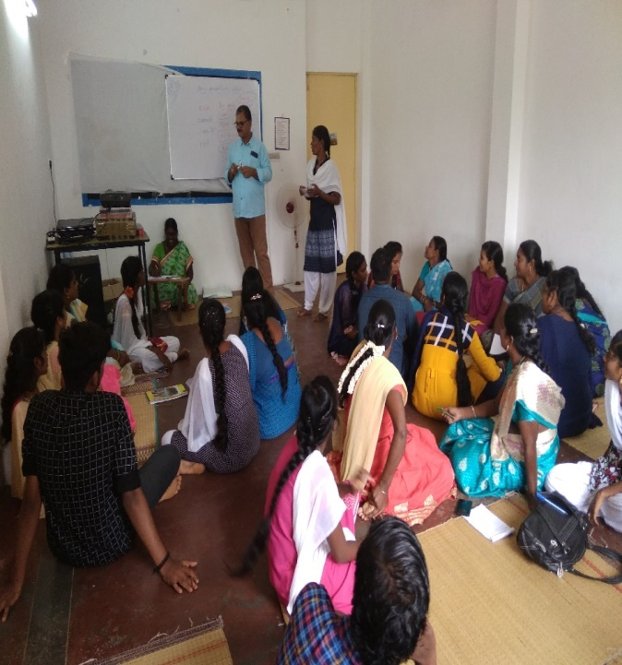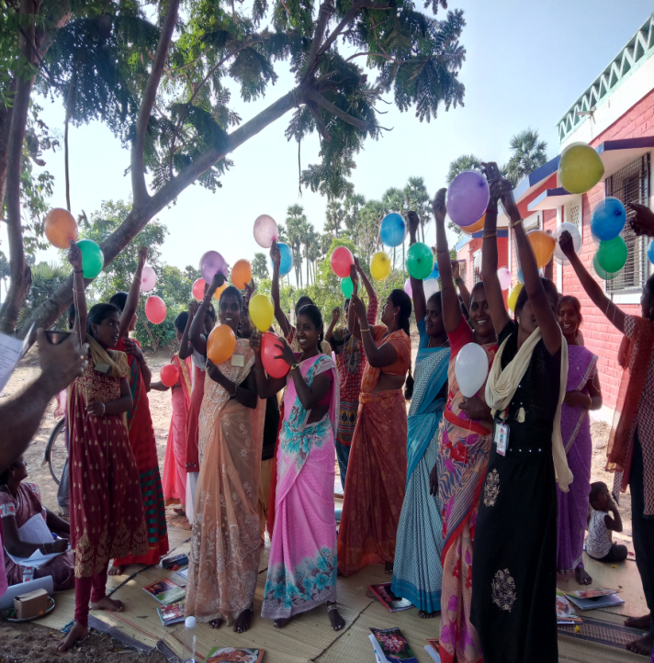

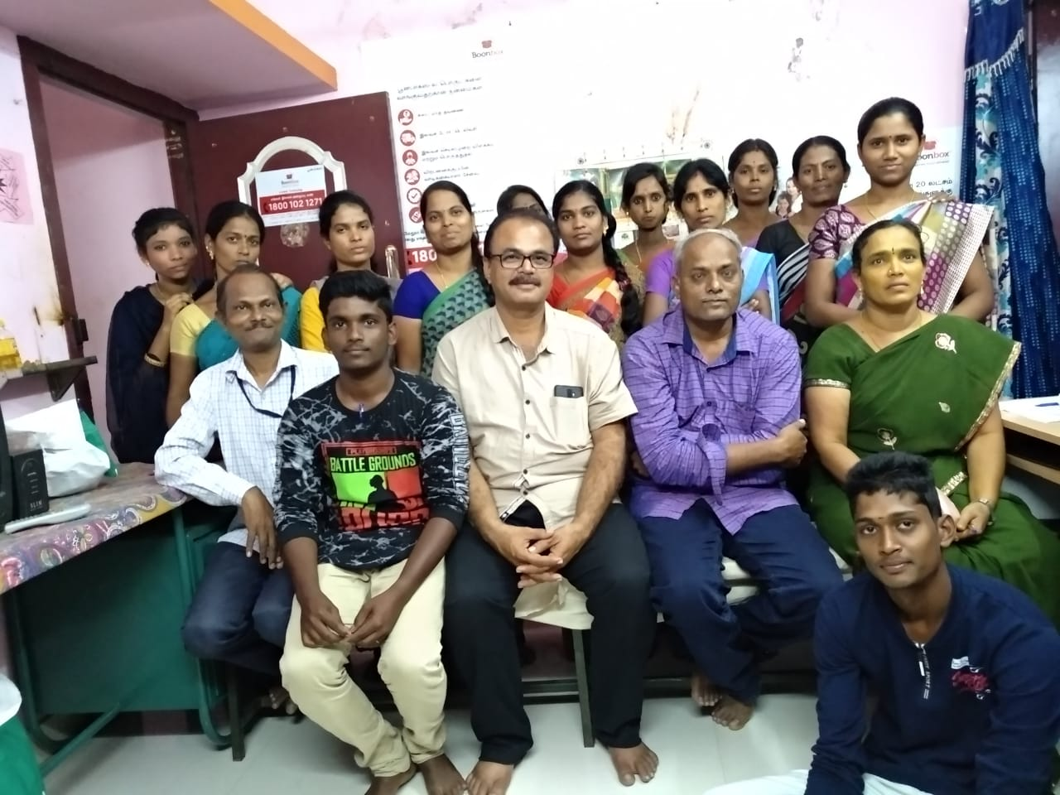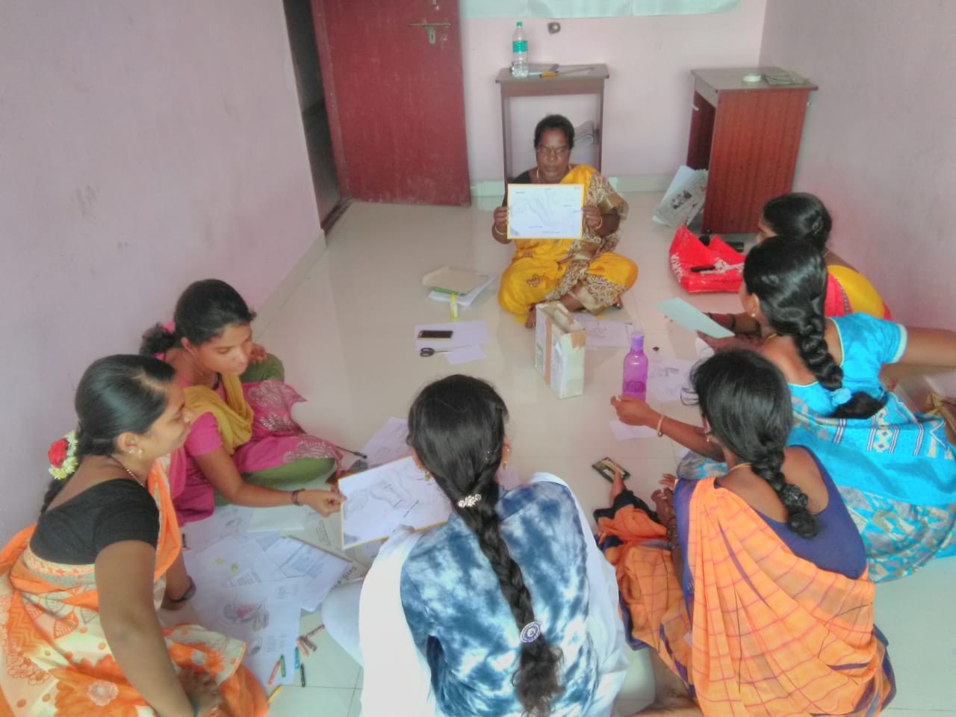
Youth Leadership trainers training programme for AWARD NGO’s workers in Dharmapuri
Upscaling of the adolescent life skills education programme:
We had submitted a proposal to United Nations Scientific and Cultural Organisation (UNESCO) New Delhi office to conduct training sessions for government school teachers in Tamil Nadu as a part of imparting school health programme under the Ayushman Bharat. The proposal was preliminarily selected and revised based on UNESCO’s inputs. Following it, UNESCO has established RUWSEC as a specialised agency to provide training support to TNSCERT- Tamil Nadu State Education Council for Educational Research and Training team. It was agreed to train district-level resource persons and planned two teachers in each school through the cascade model. Following it, we had a series of meetings with Director SCERT, Commissioner of Education. Follow UNESCO and TNSCERT organised project introductory cum orientation meeting with state and district level education officials. We reviewed the comprehensive training manual and materials translated into Tamil by TNSCERT, initially produced NCERT. During February 2019, a consultation meeting was conducted in Chennai wherein the DEOs, CEO and DIET principal, SCERT team and education department officials were present, and the state education minister formally inaugurated the programme.
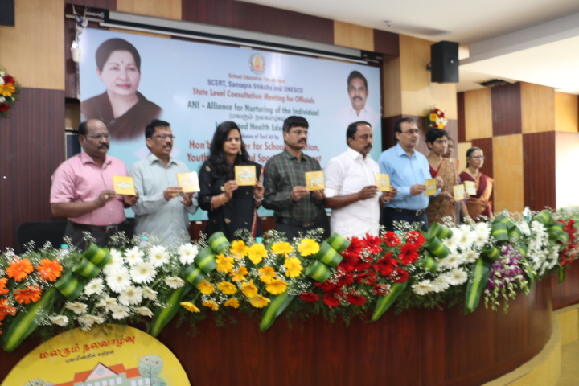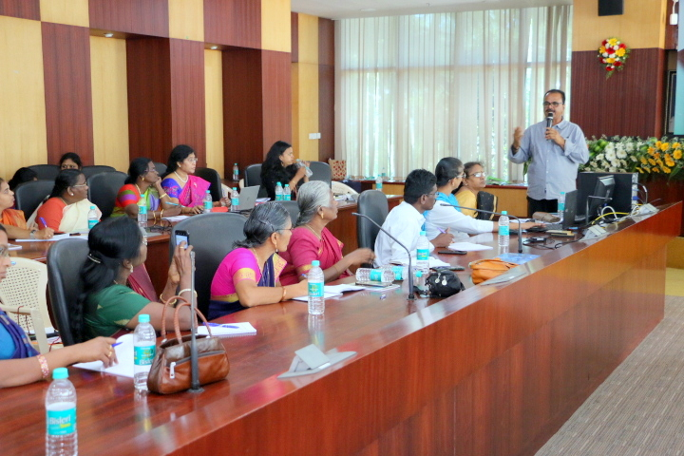
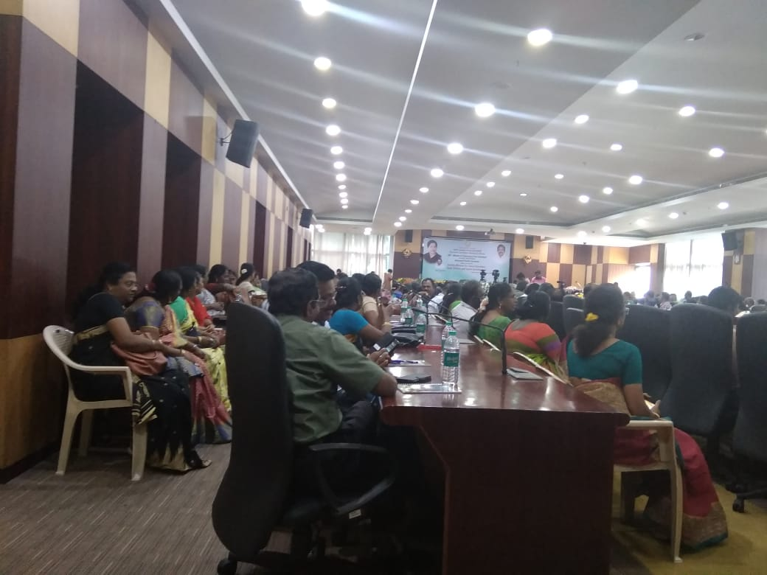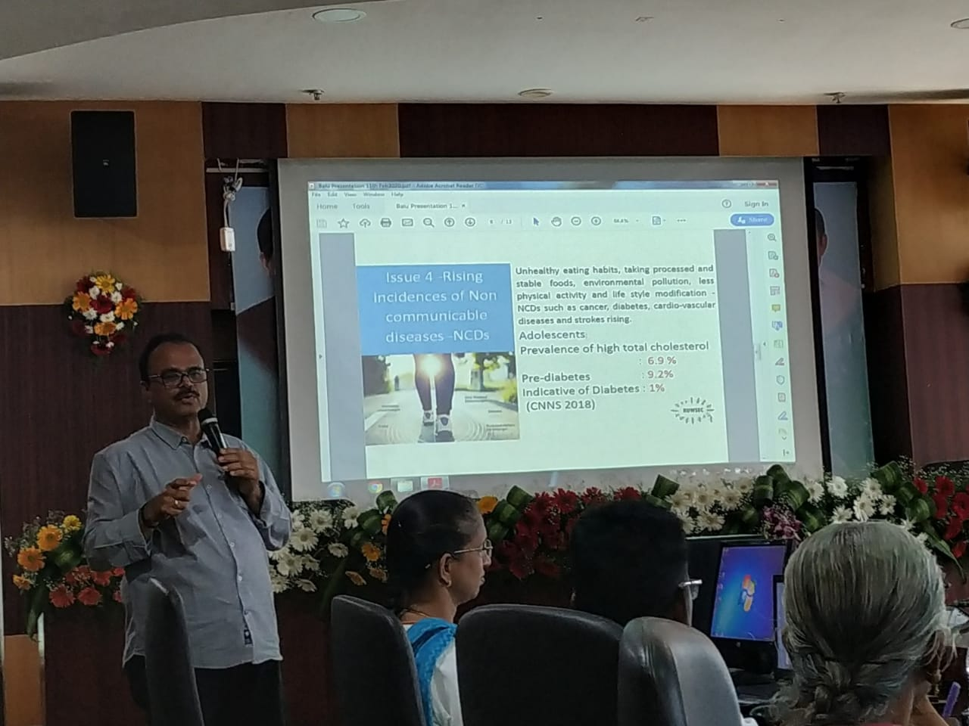
School Health programme introductory cum orientation meeting with state and district educational officials – Feb 2020
ACTIVITY 3: Provision of Health care services
This year, a special camp was conducted to adhere to the needs of the diabetic patients who access our clinical services for a continuous period. One hundred villagers attended this camp, and among them, 32 villagers had problems like diabetes, blood pressure, cholesterol and heart problems. These villagers were advised to access the specialised care services in RUWSEC clinic, Thirukalukundram and Nerumbur PHC. They are taking treatment, and staff members also follow up during field visits.
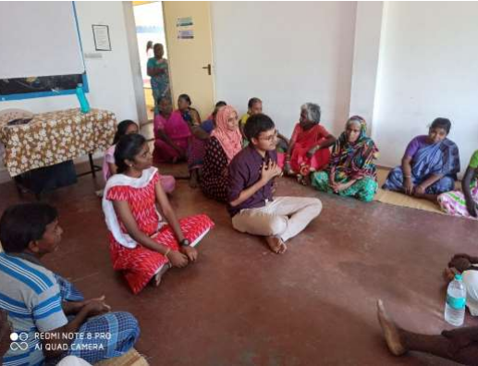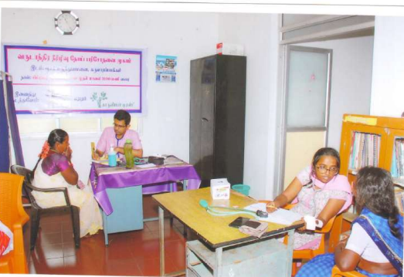
Only outpatient services are provided for the community’s health care needs in the RUWSEC clinic; people access the allopathic services and the other forms of medical practices, where there are no contra effects. We could observe that people accessing other systems of medicine is gradually increasing over the years.
16, 330 people have accessed our clinical services during this reporting period. Among them, 4,629 have accessed the allopathic services, 9,952 accessed Siddha services and 1,749 accessed homoeopathic services, and 4,481 persons have used our laboratory services. We could observe elderly persons and people with long-term ailments accessing our clinical services regularly from our clinical database. Allopathic treatment services are provided only once a week, and Siddha and homoeopathic services are routinely offered.
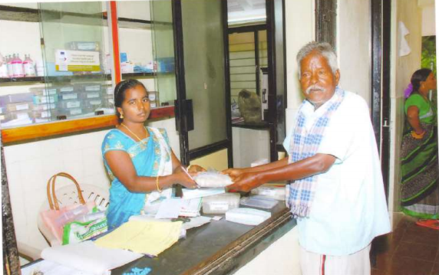

ACTIVITY – 4 Research, Training and Publications:
A research study on Reproductive Health Histories of Dalit women was conducted with the support of CommonHealth. In April, a survey tool was prepared after a meeting in Mumbai. Three days of training was completed for the researchers involved in the study in Tamil Nadu. It was decided to interview 12 Dalit women and eight service providers, totalling 18 interviews. Despite sending letters to DDHS and DPH, we could not get permission to interview doctors and nurses in public hospitals, so this is intimated to CommonHealth. The research team was divided into three groups and completed the interviews with 13 respondents, and the reporting process is in progress now.
RH Histories Research – Field Investigators training @ RUWSEC and Data analysis workshop in Mumbai
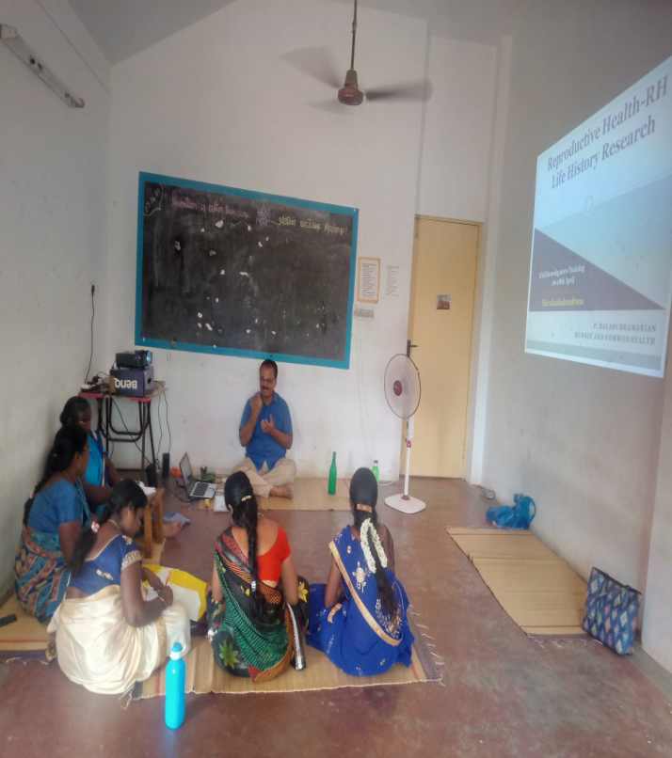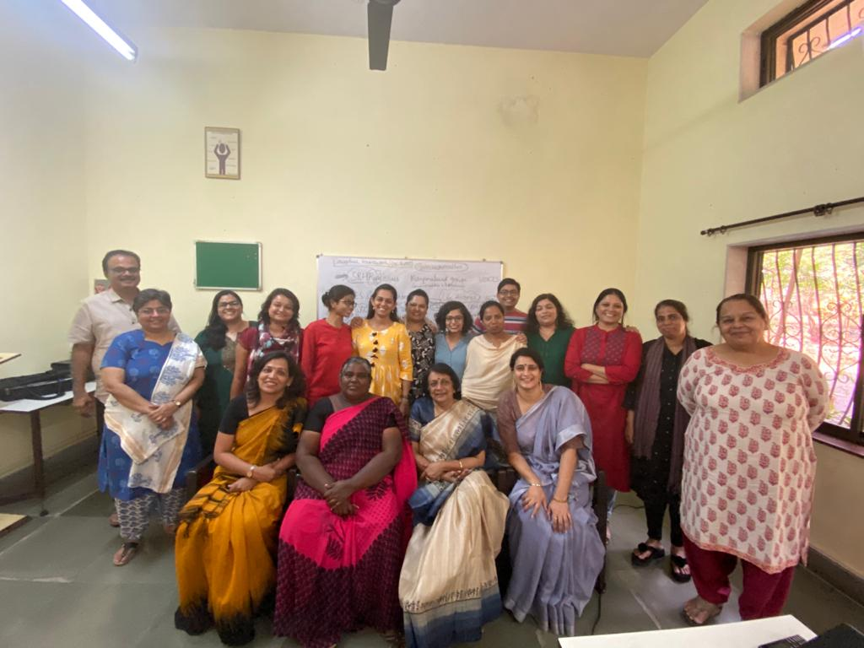

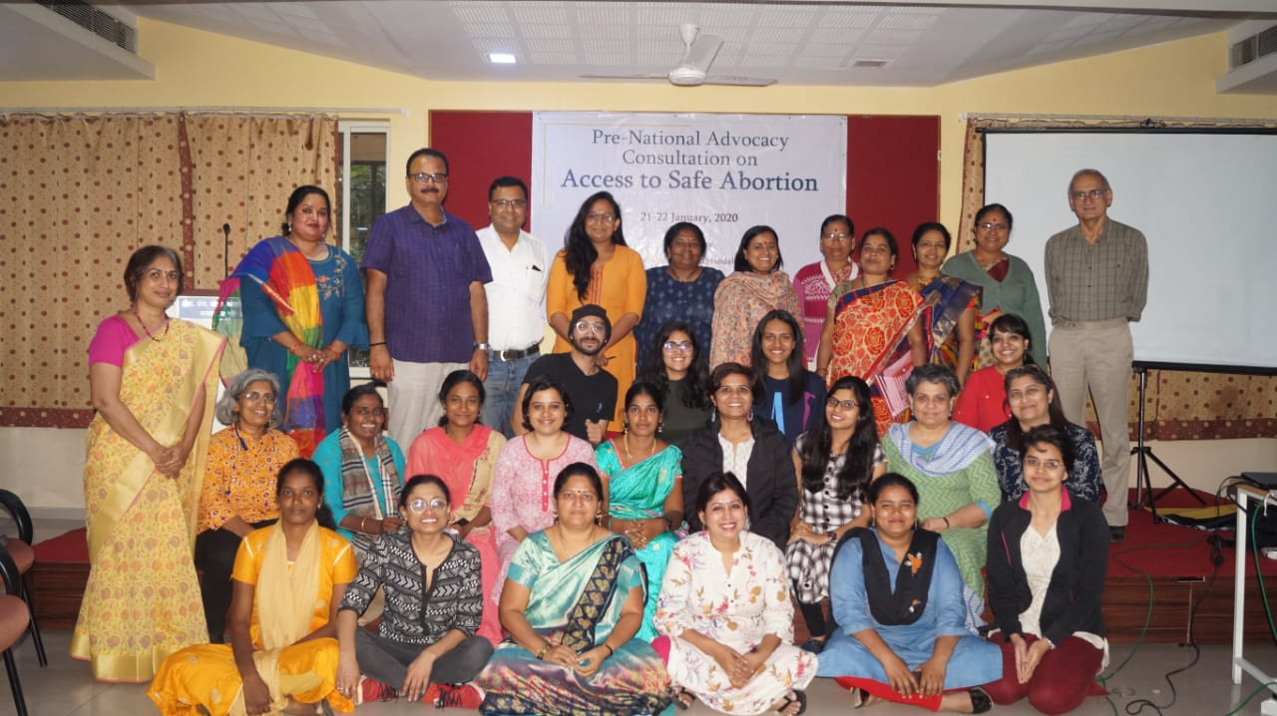
Access to safe abortion advocacy meeting in Pune

The reporting of the study on access to safe abortion services in Tamil Nadu was carried out, and the preliminary report was shared with the national level dissemination meeting in Mumbai. Then we were invited by ARROW to share the findings with the international forum on people’s health assembly in Bangladesh.
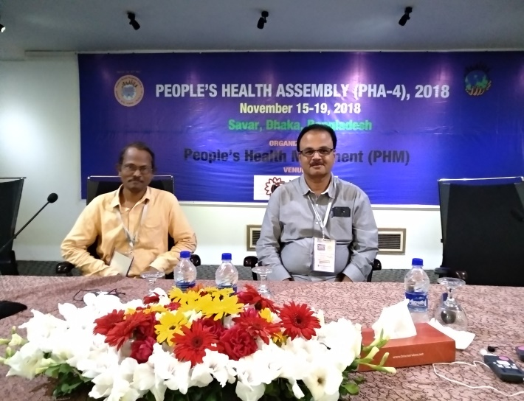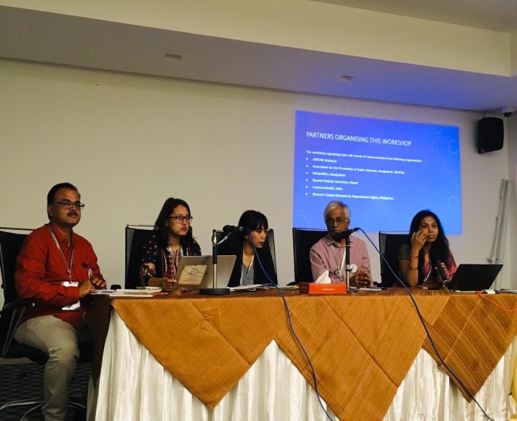
The new pamphlets of our organisation, Nutritional anaemia, Menstrual hygiene was developed, and 2000 copies were printed for broader dissemination. The Tamil translation of the main findings of the abortion study was done and printed 200 copies for dissemination. Two of our research papers were published in international peer-reviewed journals; One was on the impact of demonetisation on access to health care published British Medical Journal - BMJ. The other was titled reproductive health status of unmarried adolescent girls featured in ISSH.
ACTIVITY 5: Advocacy for broader policy change:
World Breast Feeding Day: As a part of addressing the needs of Women’s Sexual and Reproductive Health Care, World Breast Feeding Day was observed. During the day, a campaign was organised in the project village Echankarunai; the event was marked with a march by raising slogans followed by a health awareness session. Fifty-six villagers took an active part in this event.
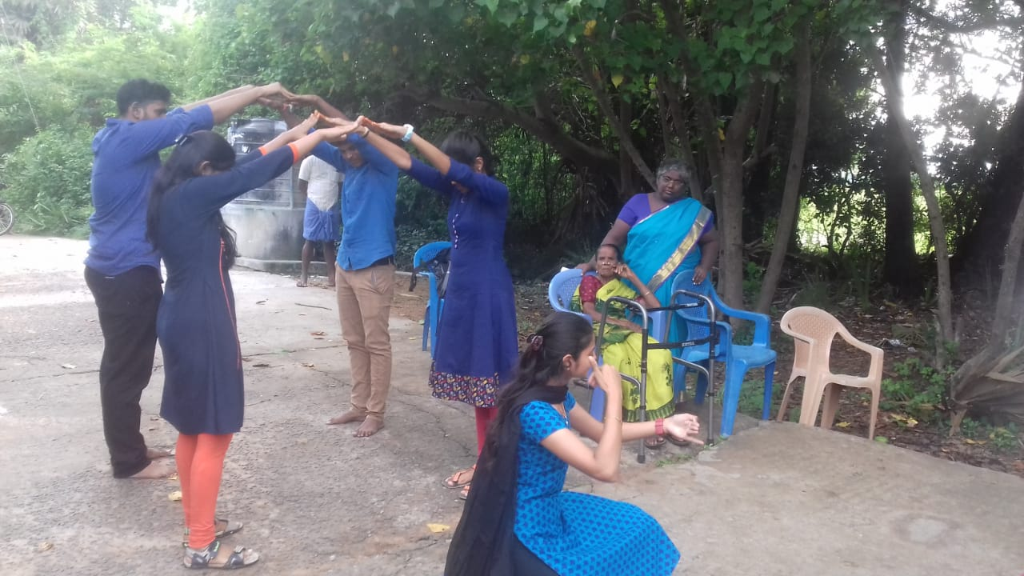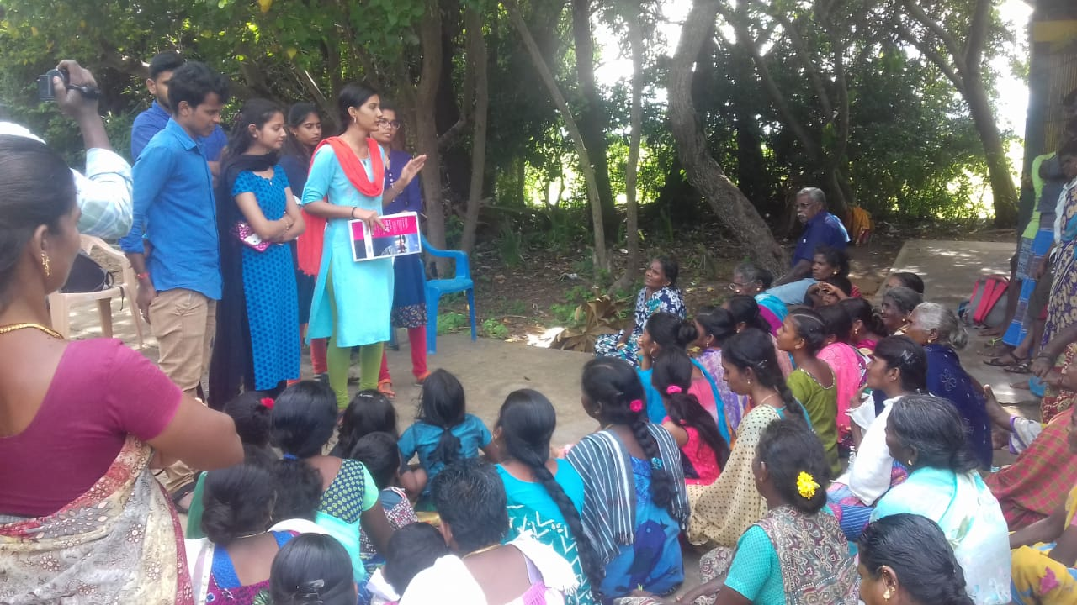
World Breastfeeding Day in a community
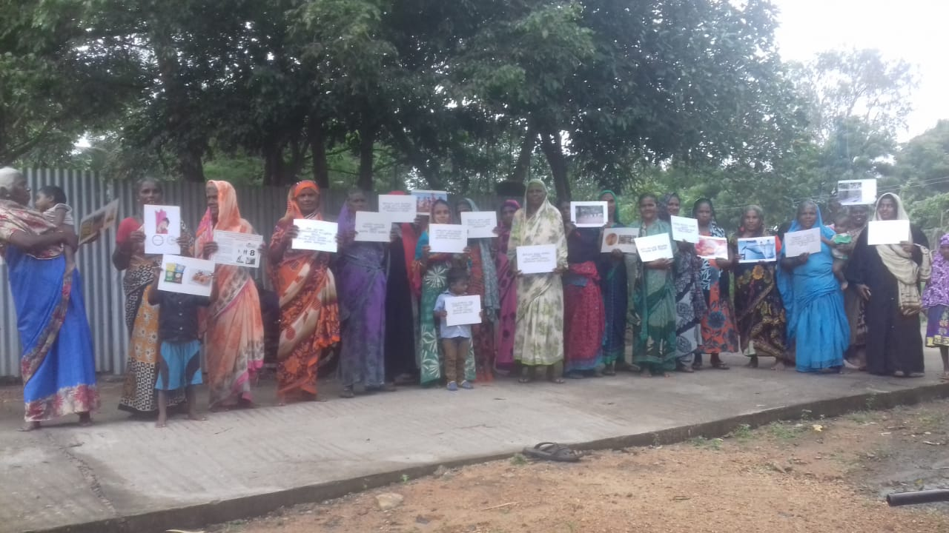
World Diabetes Day in a community
International safe abortion day: International safe abortion day event was organised at Nerumbur village on 29th Sept 20219 with a small procession of 150 participants, including 12 public health care providers. The parade started at Nerumbur four/crossroad Junction and ended in VP Mahal (meeting venue). Women carried placards with messages on safe abortion as a woman’s right, the importance of safe abortion, legal abortion up to 20 weeks of gestation, availability of medical abortion, consequences of unsafe abortion etc. There were 37 slogans on the cards. One person in the front read the slogans loudly, and others repeated. Many people in the market and bus stop watched the procession. A few sample slogans messages are given below,
“Pathukappillatha Karukkalaippai Naadi Unuyirnadia yiIllakkathey”- Don’t lose your valuable life in accessing unsafe abortion
Maruthuvar Alosanai Sindri karukkalaippu mathiraikalai eduthukkollathey- Don’t take abortion pills on your own without consulting a doctor.
Meeting began with a popular song- Tamil Thai Vazhthu - Invocation to Goddess Tamil, followed by a welcome address by Ms Kalavathy, co-ordinator of RUWSEC. She also shared the meeting objectives. The two new publications, RFSU Safe abortion study report (English) and two pages Tamil translated summary of the project, were released formally. Dr Gowtham, PHC medical officer, SHN Kalaiselvi and Dr Chitra released the books officially. The second event was a short quiz programme for the participants, followed by two dramas on unsafe abortion. Then Dr Gowtham, PHC, Medical officer, Nerumbur, started his presidential address by welcoming the large number of women who had assembled for an important event; he linked quiz programme with safe abortion and provided clear information on what conditions and circumstances abortion services are provided and types of abortion, concluded his speech with the need for safe abortion. Then two other health care providers spoke on occasion. Finally, Dr Balasubramanian, Executive Director RUWSEC, shared the key finding from the research study and stated open discussion on the topic. Then the meeting ended at 5.30 PM.
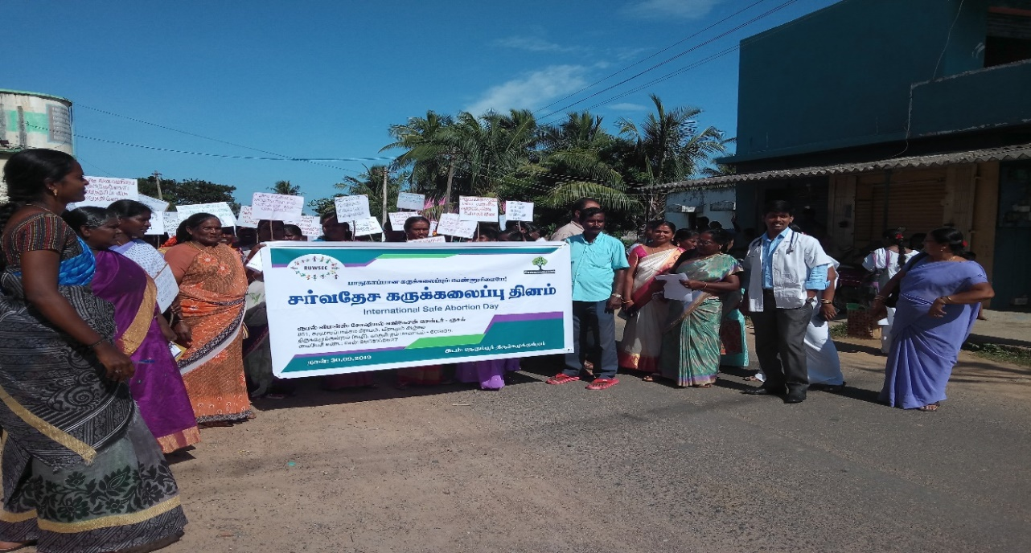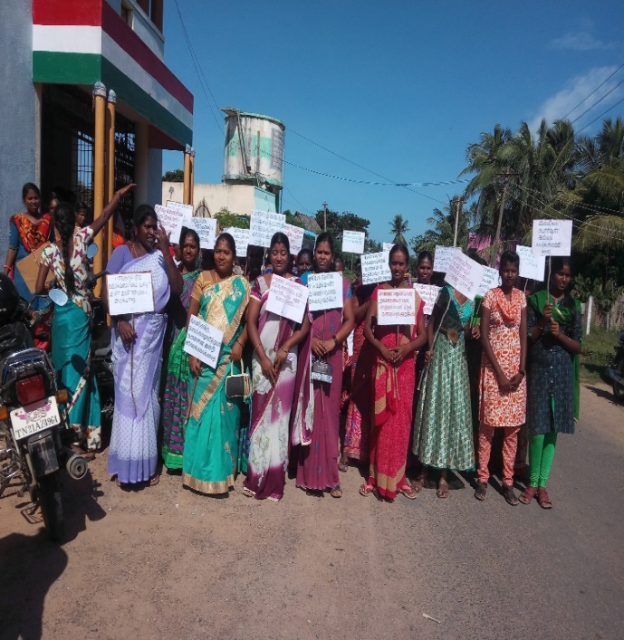
International Safe Abortion Day 30th Sept @ Nerumbur
Procession March
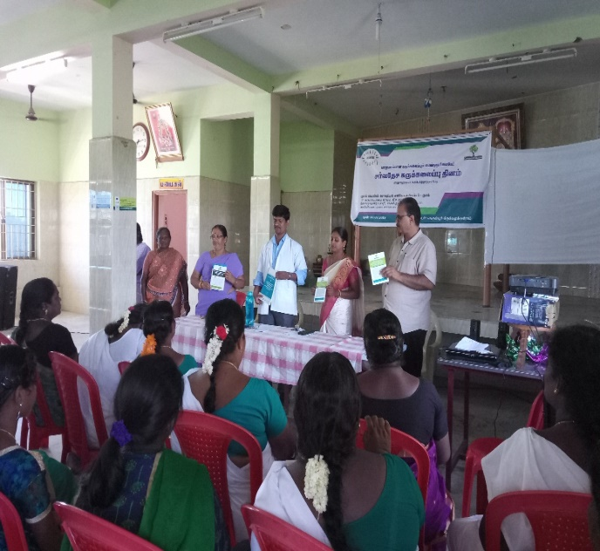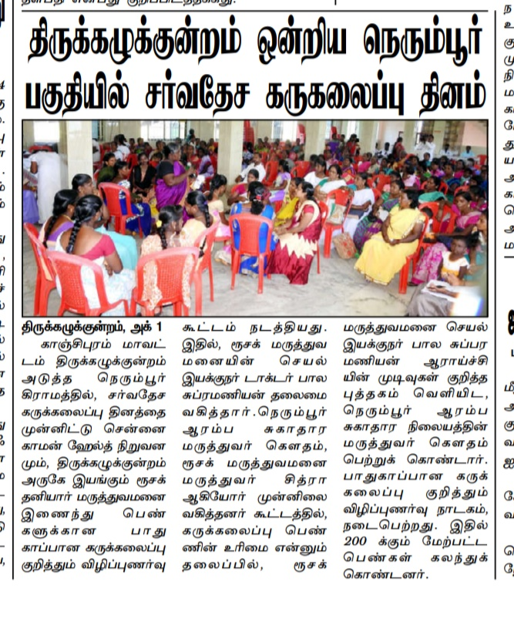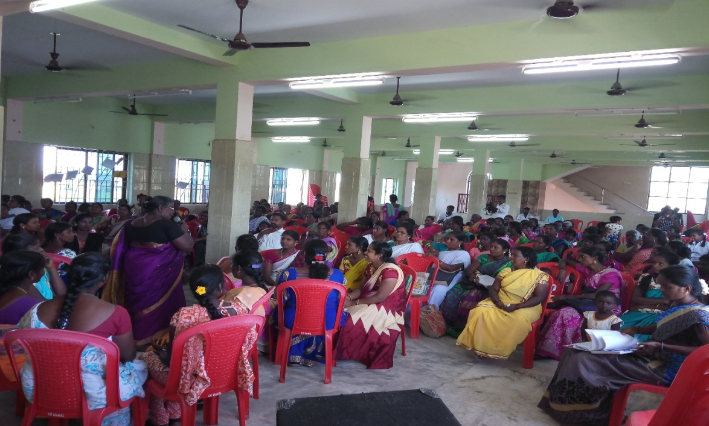
Access to safe abortion: As a part of our advocacy activity, using the key findings of our research on Availability of Safe Abortion Services and Perspectives of Actors on Right to Safe Abortion in Kancheepuram District, Tamil Nadu, conducted by RUWSEC in Collaboration with CommonHealth, we wrote letters to SHG women, and youth leaders in seven panchayats villages to demand safe abortion services in PHCs in Tirupporur and Thirukazhukundrum blocks of Kancheepuram District.
We circulated the letter to seven panchayats through RUWSEC staff and volunteers; they discussed the matter in the SHG meeting a day before the GRAM SABHA meetings. Then few representatives from each SHGs, youth and RUWSEC staff and volunteers in the village attended the GRAM SABHA meetings and requested the villagers to pass the resolution (15th August 2019). Of the seven panchayats, four villages (Echankarunai, Ammanampakkam, Perumpedu and Acharavakkam) have passed the resolution requesting the authorities to provide the services meeting was cancelled due to some problems with villagers and officials in the reaming three villages. We plan to present the matter in a few more panchayats in the meeting scheduled for 2nd October.
Echankarunai Panchayat Resolution No 17, dated 15th August 2019, says, “We, the villagers, strongly believed that safe abortion services are essential for us. If we get the services in our Nerumpur PHC, this would be very useful for poor and marginalised women in our panchayats, so we pass this important resolution requesting the authorities to provide the services”. Passed with the consent of all members presented in the meeting and signed
Acharavakkam Village – Tirupporur Block,
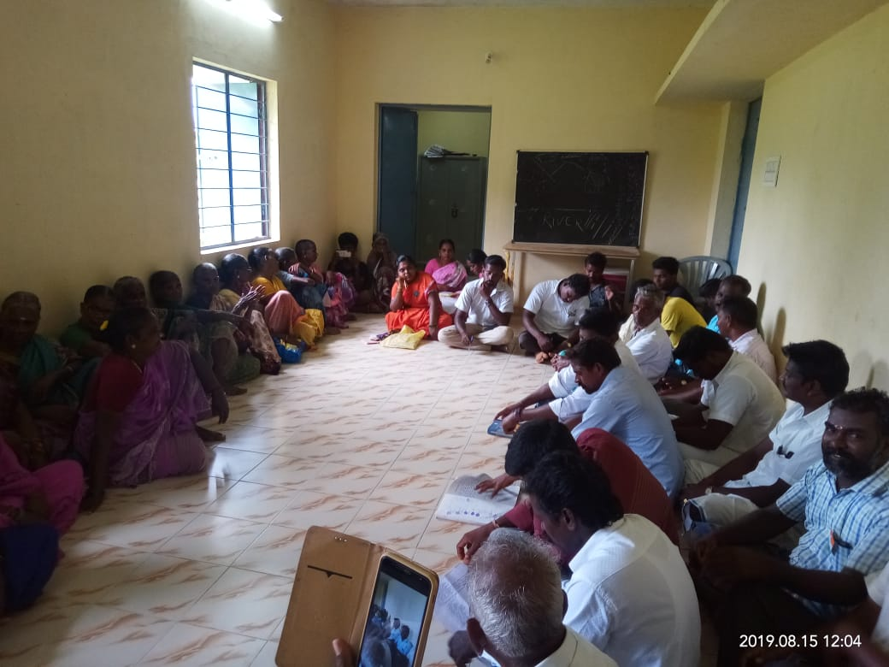
Ammanampakkam village, Thirukazhukundrum Block,
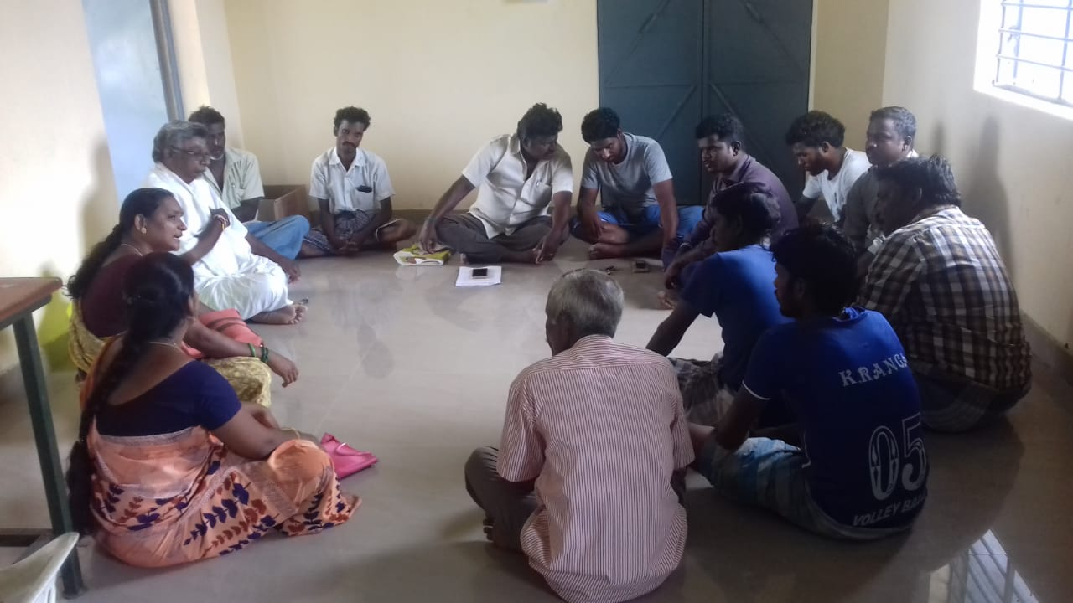
Perumpedu Village, Thirukazhukundrum
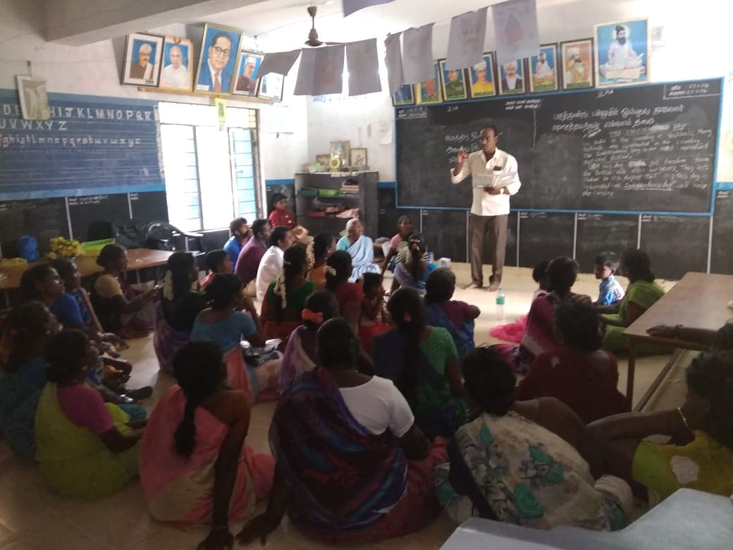
Echankarunai Village, Thirukazhukundrum Block

International Women’s Day: International Women’s Day was celebrated on 8th March @ RUWSEC campus; the removed social activist Mrs Krishnammal Jeganathan delivered a special address to the rural women on how women’s rights activism emerged. About 210 rural women participated in the meeting. It was a full-day event with various talk shows, drama, cultural events and competitions.
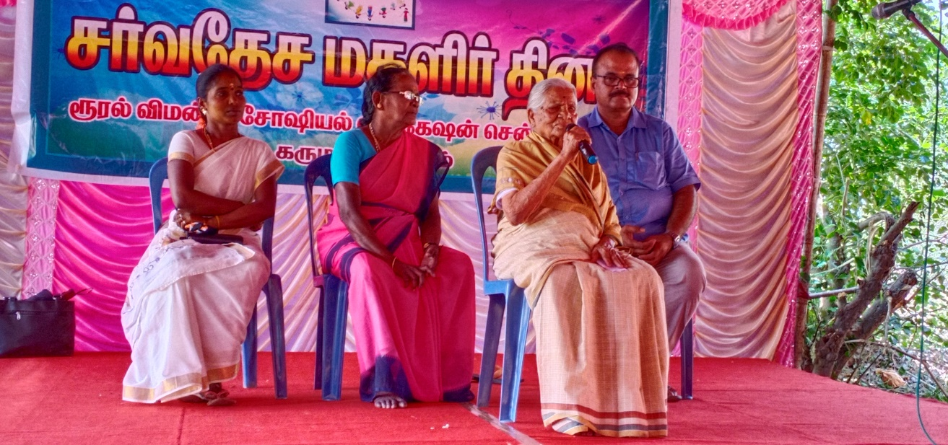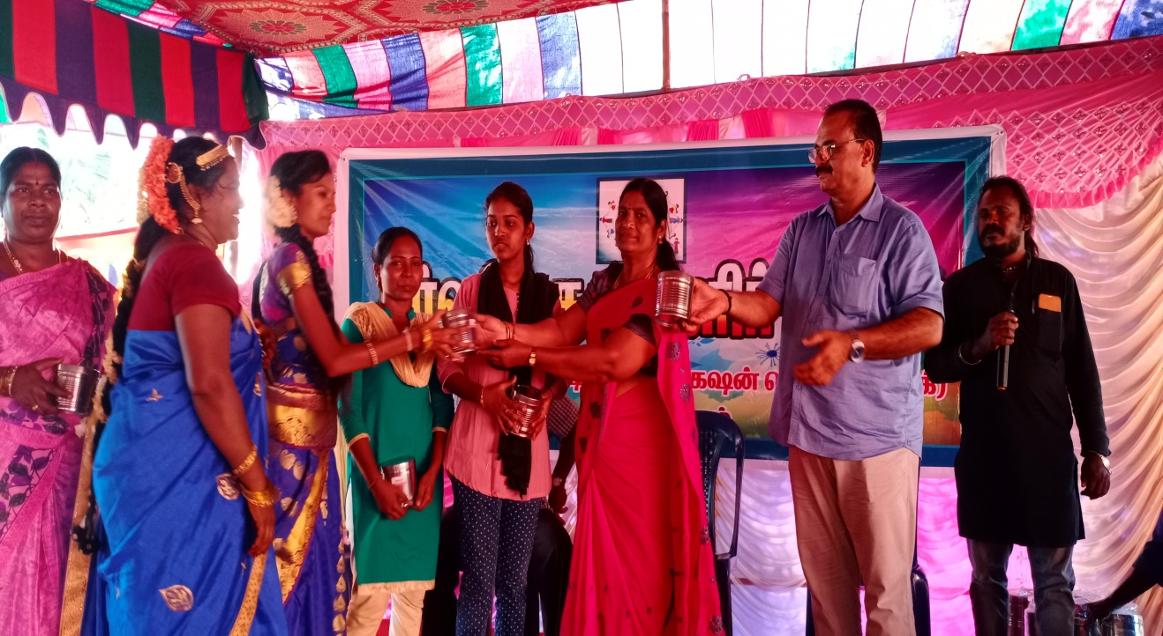
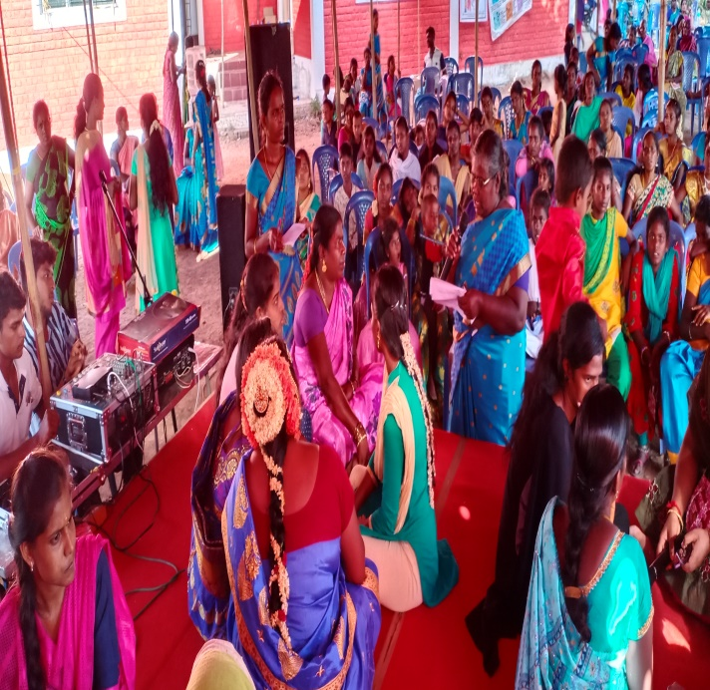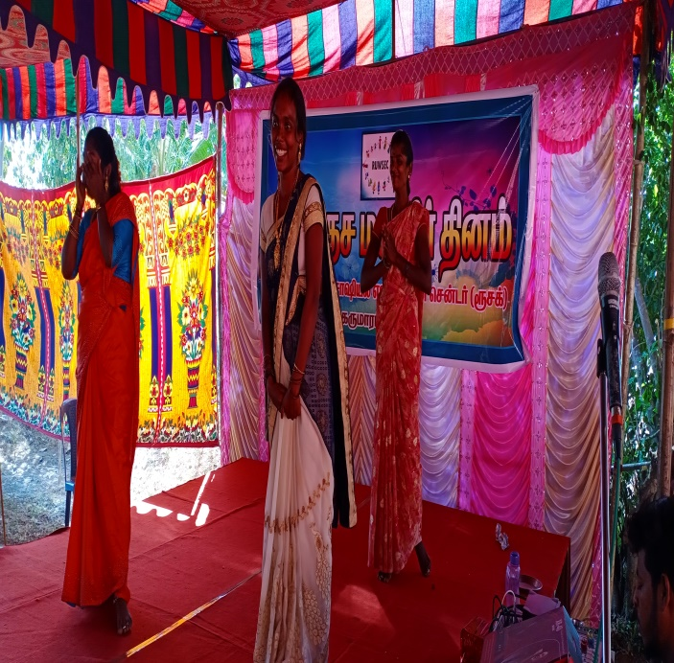
Under the programme on prevention of gender-based violence, special workshops for ICDS workers and mass awareness sessions were conducted in the community on the occasion of the international day on the elimination of violence against women.
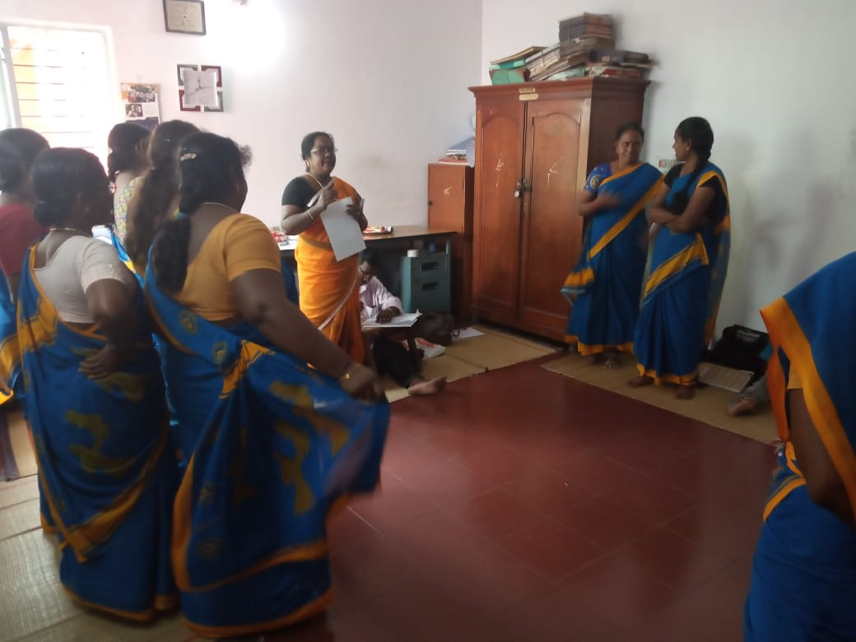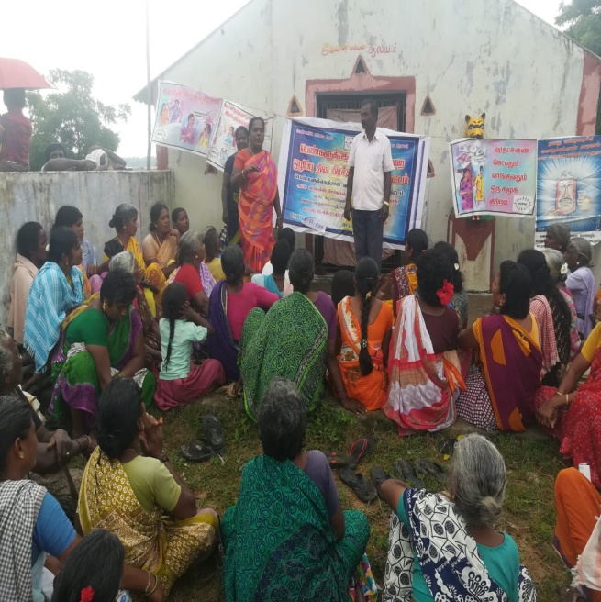
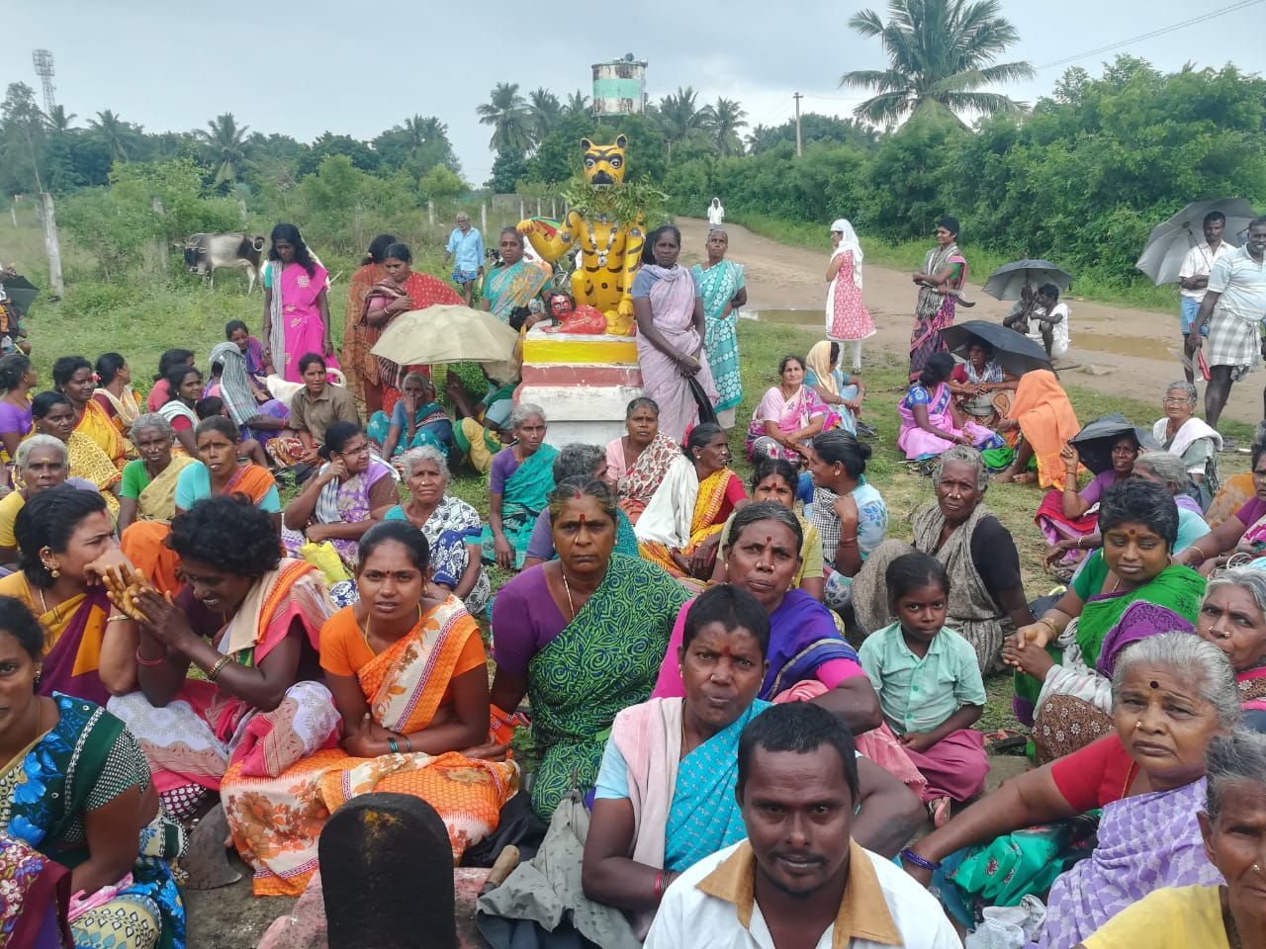
A collaborative effort to provide training for One Stop Centre staff on Combating Gender-based violence with CEHAT, Mumbai, was planned this year. Towards this, letters were submitted to NRHM officials. After follow-up, they forwarded the letter to the Ministry of Social Welfare. We had a meeting during February 2020 with the project manager, One Stop Centre, and shared the organisation's activities, especially about combating violence against women. After the meeting, they requested us to submit a proposal for training the One-Stop Centre Staff to plan the movement from June 2020. A concept note, detailed training plan, and budget were submitted per their request.
Staff capacity building training: Regular training programmes were conducted to develop staff skills and capacities. In addition to it, all our staff were encouraged to enrol in a diploma programme on community mental health run by BALM academy. During the financial year, 15 staff members joined the diploma course.
