Summary Report of Activities April 2020 – March 2021
Rural Women’s Social Education Centre - RUWSEC is a non-government women’s organisation working for young people and women’s Sexual Reproductive Health and Rights- SRHR. 13 women founded the organisation in the year 1981, and it is located at Karumarapakkam village Thirukazhukundram town, near Chennai, Tamil Nadu, India. Achieving women’s wellbeing through women’s empowerment is the mission of RUWSEC. Its primary focus has been on enabling women to gain greater control over their bodies and their lives and achieve well-being by promoting gender equality and sexual and reproductive rights.
RUWSEC’s overall approach has been to motivate, educate and organise women from poor and marginalised communities to stand up for their rights and become agents of social change. Over the years, our work has included not only women but also men, adolescents, and young people towards promoting well-being and sexual and reproductive health and rights. The core values of our organisation’s work focus on two critical themes 1) Empowerment and Rights-based 2) Women centred and Participatory. The strategies of our work are to
  - Bringing forth the voices of women (and men) from the most marginalised sections of society, especially Dalit and rural poor communities;
  - Promoting leadership skills of the above groups to effectively participate in existing governance and accountability structures and other spaces for community participation strategy.
  - Developing critical thinking and alternative models in health care provision, research and planning for social action.
Around the four decades of its existence, RUWSEC has been implementing a broad spectrum of activities ranging from comprehensive community based reproductive health education and health promotion, community-based interventions to prevent domestic violence against women; and, innovative work with young women and men on gender and sexual and reproductive health and rights. Providing women and patient-centred quality health care services is also a significant component of RUWSEC’s services.
RUWSEC has been working at different levels; community, schools, colleges and health systems. We have school-based life skill education for adolescent students, young women working in factories and youth groups in the villages; we work with the public health system towards improving the quality of reproductive health care services. Currently, our intensive field programme activities focus on the following four significant aspects:
- Promoting general health and wellbeing in the community,
- Promoting sexual and reproductive health and rights (SRHR) of adolescents and young people,
- Promoting sexual and reproductive health rights of adults with a particular focus on women and
- Prevention of intimate partner violence against women.
In each of the above, we adopt four strategies, namely, 1) Community capacity building, 2) Providing health care services, 3) Monitoring, research and bringing out popular health education materials 4) Advocating broader policy change.
Currently, RUWSEC’s intensive community-based activities cover 25 villages (12 panchayat villages), and our clinic services cater for the needs of over one lakh people in the Thirukazhukundram block. RUWSEC predominantly works with rural poor and marginalised Dalit communities. Even though our main focus is on sexual and reproductive health. However, we have also engaged with health education and preventive and curative care for non-communicable diseases in the project villages because of its significant prevalence and interconnections/interactions with sexual and reproductive health. Our focus is on gender and other social dimensions of risk of acquiring NCDs, SRHR and access to healthcare. RUWSEC’s workers continue to work within their communities at this time of lockdown, while the clinic has been providing essential services.
Due to the COVID 19 pandemic, the government of India declared a complete lockdown from March 22nd 2020, since lockdown, all the staff started to work from home and in their community. The people in the project villages were provided counselling and assistance through phone calls with the help of the volunteers as the diabetic and BP patients needed constant monitoring. But we postponed and cancelled some of our intensive field activities (Community level meetings and workshops, House visits, door to door counselling services) scheduled between April and September 2020. However, we have continued to provide essential service with standard operating procedures, run outpatient care services, laboratory and dispensing medicines to the NCD and elderly patients at their doorsteps through community health workers. The following section briefly discusses the main activities carried out during April 2020-March 2021.
STRATEGY 1: COMMUNITY CAPACITY BUILDING
- 1 COMMUNITY LEVEL ACTIVITIES: Creating awareness about the Covid-19 pandemic at the community level, educating safety measures, referring persons with symptoms, and distributing relief materials to poor and older adults.
In April 2020, with the support of RUWSEC doctors, we prepared a leaflet on the Covid-19 pandemic: what it is, how it spreads, its symptoms, steps to be taken on developing symptoms, and self-care and the importance of physical distancing and the need for isolation, and distributed it widely in the project villages. We also disseminated it through youth volunteers of RUWSEC (210 persons) through short SMS and our WhatsApp group, Facebook pages which then share it with their peers and family members. Scientific information about the pandemic, protective measures were collected from government and authentic sites and shared with the volunteers.
Assessment of the COVID 19 Pandemic situation in the villages and planned prevention activities.
Following the national wide lockdown, an assessment was done by the staff in the villages about the impact of Covid-19. There were questions about whether disinfectant was sprayed at regular intervals, bleaching powder sprinkled, sanitation workers regularly performed their tasks and about the functions of the ICDS centres. The study found that bleaching powder and spraying disinfectant was done at periodic intervals. The sanitation workers carried out their work in the villages either once a week or twice a week. The ICDS staff supplied rice, egg, dhal and Nutri mix powder to the children and pregnant women in the villages once in 15 days. The villagers did not go out of their villages. People working in companies went for work, and others took care of grazing animals and carried out agricultural activity to continue their routine work. About half of the villagers felt that they wouldn’t get Covid infection and were careless; others used all safety measures like wearing masks, using disinfectants and maintaining social distancing to stay protected.
Following it, our staff and youth volunteers provided different community services in their villages; they instructed the villagers to maintain social distancing in front of the PDS shops and asked them to wear masks when they came to buy supplies from the PDS shop. Along with the panchayat workers, they took care of the safety measures in the villages and checked whether bleaching powder was sprinkled periodically. Four of our staff members were involved in the preparation of cloth masks at home and distributed to poor persons in the community and patients visiting RUWSEC hospitals
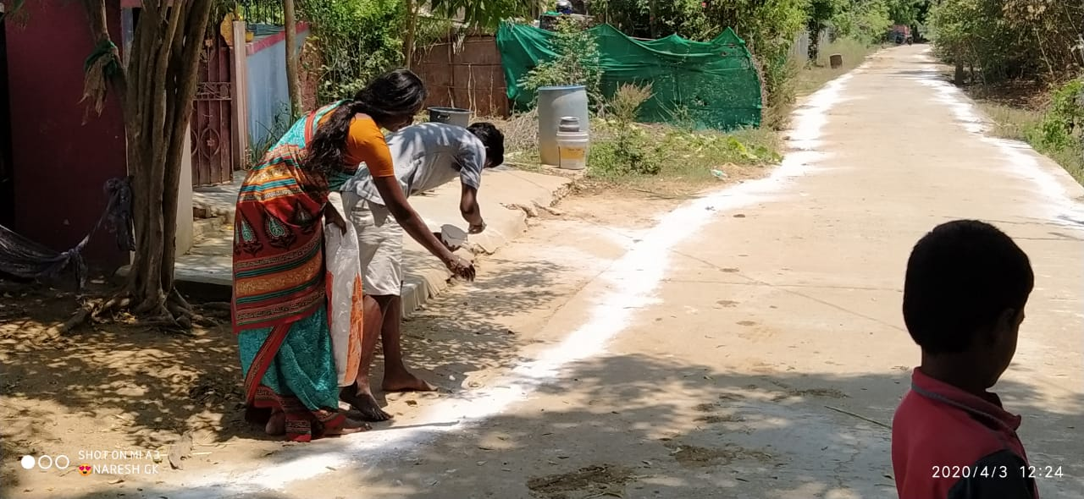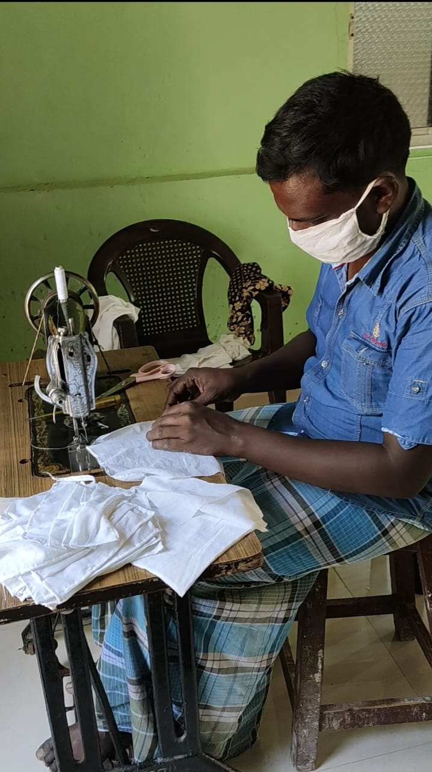
People having fever and cough were asked to take immediate care and treatment from the hospital. Pregnant women, women with small children, BP and diabetic patients were provided counselling and were advised to follow safety precautions to stay protected from Covid
Initially, there were no Covid positive cases reported in the villages. The villagers also requested that people from other places stay isolated and restricted them from mingling with others. But later in June – July, four villages had positive cases, and a section of these villages was declared as containment zone and restrictions for outsiders. There were two Covid deaths reported in the villages. Our staff assisted the government health workers and PHC team in conducting Covid screening camps in five villages
Our team members referred patients with any symptoms of COVID 19 to the nearby public health facility for screening and treatment. RUWSEC is aware of gendered barriers to seeking healthcare and will provide social and economic support to women and girls who may face obstacles to care-seeking. Our workers have also ensured that advised home-based isolation adheres to the same.
The volunteers in the villages helped the nurses and ICDS staff maintain hygienic practices in the town and helped them pass messages about pregnant women and women with small children so that their needs were addressed during the pandemic. They also helped the sanitation worker sprinkle bleaching powder and spray sanitisers in the villages. They, too, created awareness among the villagers about the importance of having the herbal drink ‘Kaba Sura Kudineer’ – a herbal beverage to boost their immune power.
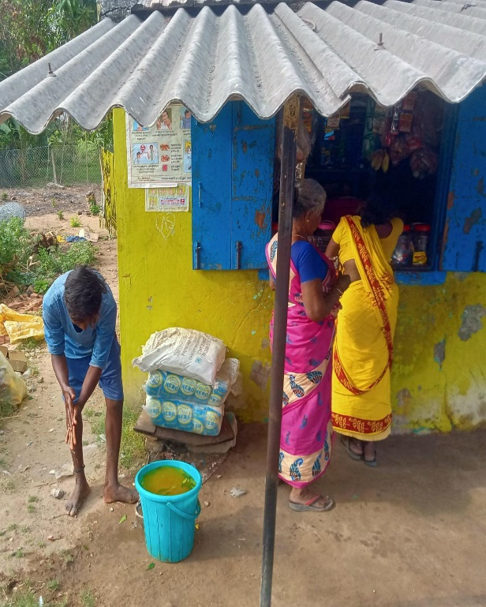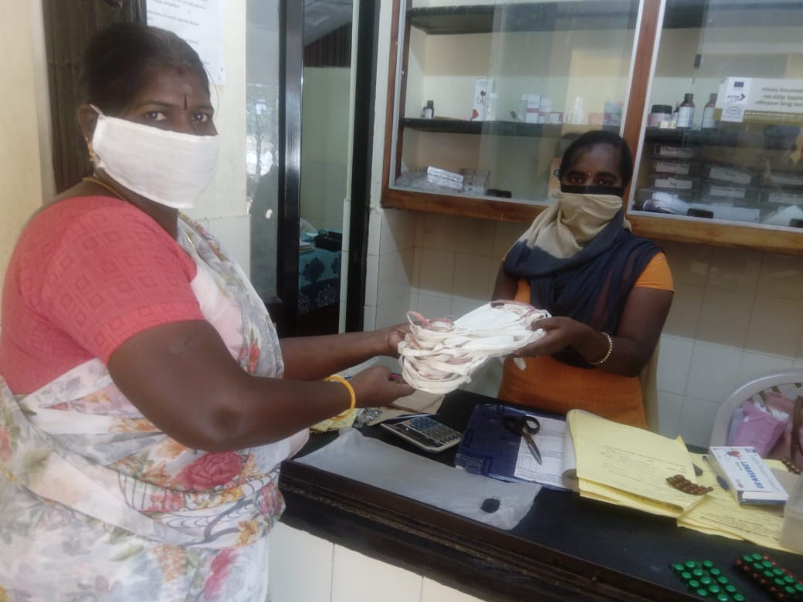
They also set up community washing stations in the community. They kept big water drums in front of the provision shops and temples, churches in their villages, and soaps and requested all the villagers to wash hands at regular intervals and stressed the importance of washing hands. The volunteers also kept big water bowls in front of the Public Distribution shops, PDS and soap and created awareness about the importance of washing hands.
The volunteers also helped the front-line health workers organise and conduct ‘Corona screening Camps’ - fever camps in their respective villages. The volunteers also informed the villagers about the services provided in the RUWSEC clinic. They asked them to make use of the services provided for pregnant women, diabetic patients and BP patients.
We distribute relief materials to the poorest and most deprived persons and families.
During the initial telephone conversion with our community workers, it was observed that specific cohorts of most deprived people in the project villages were severely affected, and they did not even get enough food. In April 2020, we asked our workers and volunteers to prepare a list of deprived persons in their villages. From the list, we found the most deprived groups were poor and elderly single men and women, persons who do not have a family to support them, physically challenged persons, persons with mental illness, persons who do not possess a Public Distribution System PDS card ( Government card to get free rice, wheat and dhal), persons not covered under the old-age pension scheme, older adults in the village left alone by their children, widows, people belong to the Irular Tribal community; migrant labour faced lots of difficulties during the lockdown. Then we had a conference call with the staff members and volunteers, and based on their suggestions, it was decided to distribute food materials for these people.
As per their suggestions, provisions ( Dry ration and vegetables) worth Rs.500 for a family and Rs.300 for single persons was distributed. Each food packet contained rice, dhal, oil, pulses, soap, masks and vegetables. In the first phase (In May 2020), 33 single persons and 46 families totalling 79 food packets have been distributed to the beneficiaries through our staff and volunteers at their doorsteps. From the second list, similar food packets were distributed to 61 more persons and four families totalling 65 food packets were distributed. Then in July, the second round of distribution was done to all those who received the materials in May, and a few more persons were also added; in total, 192 persons from 18 villages were supported.
In August, 60 more deprived persons (persons with physical and mental illness) were identified, and relief materials were distributed. Then in September 2020, relief materials (same as above) were distributed to 69 elderly single persons in 19 villages. In all the distribution at the community level, the staff and youth volunteers of RUWSEC handed over the food packets in person to the people in the villages.
Photographs of COVID 19 relief materials distribution
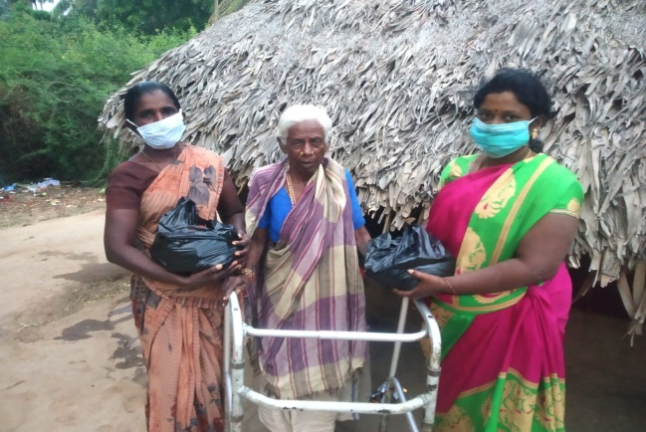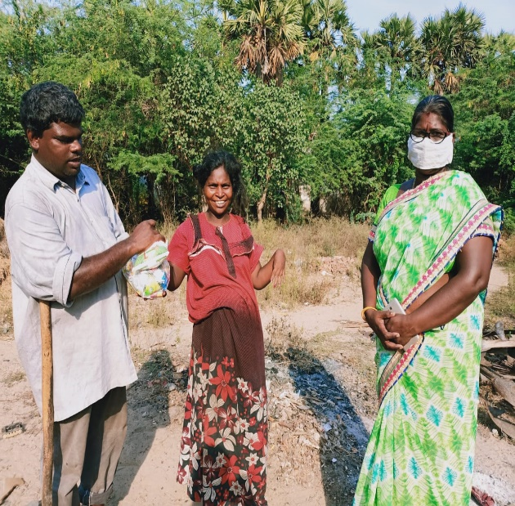
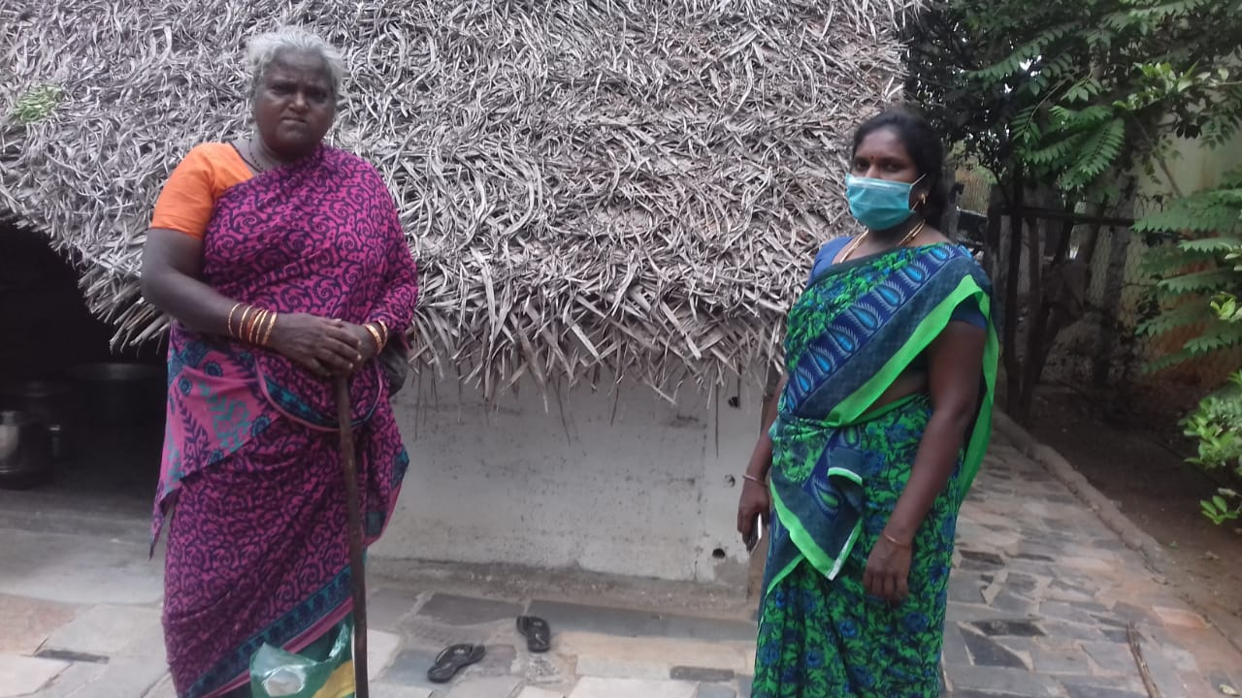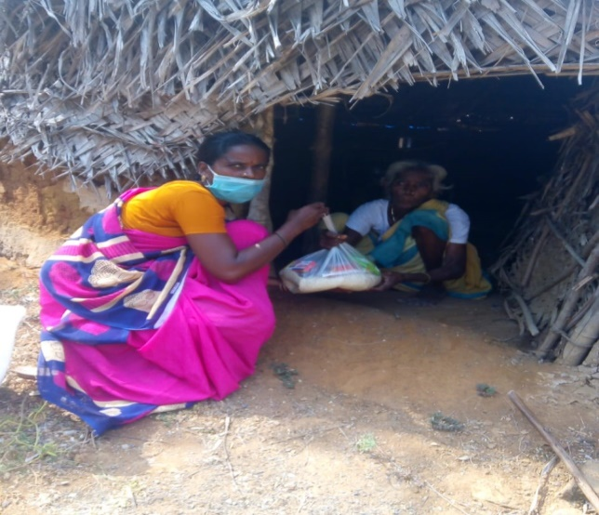
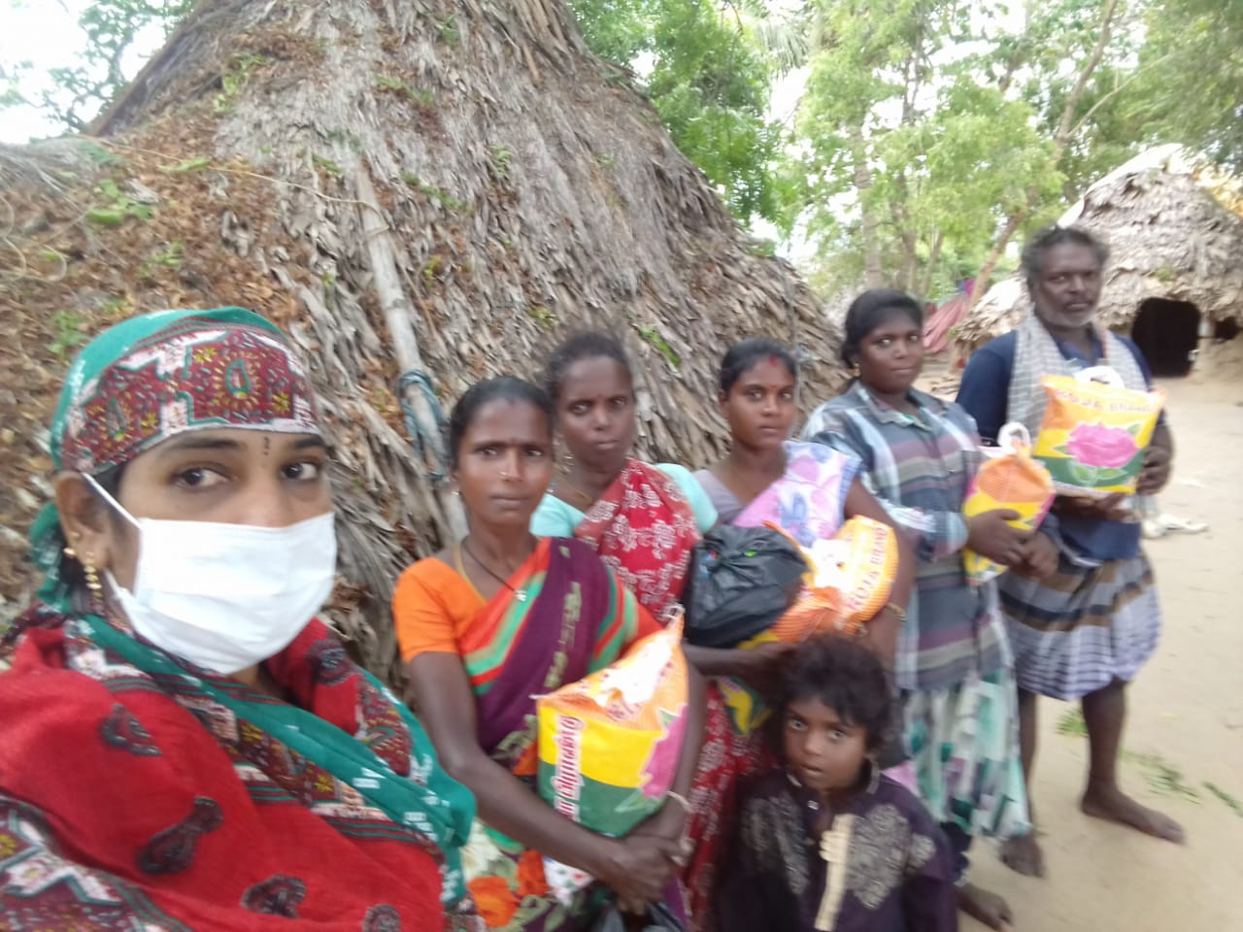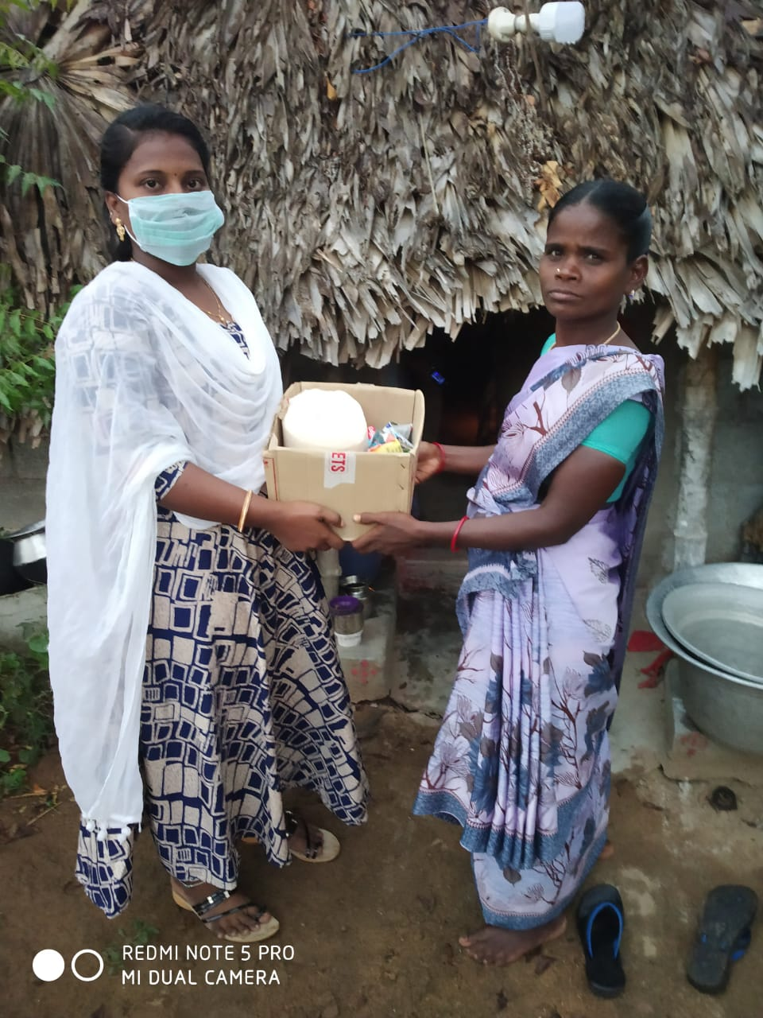
The relief items supplied by RUWSEC were of great help as no one provided such kind of help for us during the pandemic period.
Even our children did not care to ask whether we had our food or not, but RUWSEC provided this help to us at the right time; we are very thankful for the organisation.
COVID -19 relief materials distribution for elderly persons.
Right from early April 2020, when the COVID -19 pandemic has been ravaging several parts of Tamil Nadu, RUWSEC has been active in the community, providing relief assistance to migrant
labourers and poor, marginalised families who were suffering due to the effect of the nation-wide lockdown. We also continue to provide health care services and dispensing medicines and laboratory services to poor elderly patients, including pregnant women.

During our first phase of COVID relief work, we observed that elderly and single women from marginalised groups were severely affected. During this pandemic, one of the most severely affected people are the elderly who live in various villages of this block, who have entirely lost any source of livelihood and are solely dependent on the welfare assistance provided by the government, which often reaches them late in a diluted fashion. Data collected as part of a demographic survey indicate that about 6% of the total population of this area is elderly. It is also observed that many elderly live alone without any supported source. Therefore, RUWSEC is keen on supporting basic living necessities like food, sanitary supplies and health care for older adults who live in poverty.
.
Selection of Beneficiaries: We have community health workers and volunteers in all 25 villages using the link and clinic data. We first prepared a potential list of beneficiaries for the programme using the following criteria. 1) 60 plus aged from RUWSEC project villages 2) Poor and single without any family support 3) Taking medications for chronic illness 4) Source of sought for chronic illness. The list was reviewed by the two senior coordinators of RUWSEC and was approved. In total, we had 69 beneficiaries in 19 villages.

Profile of the Beneficiaries: Of 69 persons from 19 villages, 55 were women and 14 men; among women, 33 were widows, and 14 others were separated and living alone. Almost all were chronic morbidity patients; 27 persons had diabetes and 24 BP patients; five others had both diabetic and BP. The remaining 13 persons were suffering from an eye problem, severe anaemia, asthma and heart problems.

All the relief materials were purchased in a wholesale shop and vegetable markets and parcelled in separate packets to distribute them individually. Each pack contains; Rice – 1 Kg; Dal ½ Kg, Cooking oil ½ lit, Salt 1Kg; Bath and washing soaps; Face mask two numbers, five vegetables of one kg each. The value of materials distributed is worth Rs 350 per person. The staff/volunteers in each village collected materials from the office and distributed them to the beneficiaries.

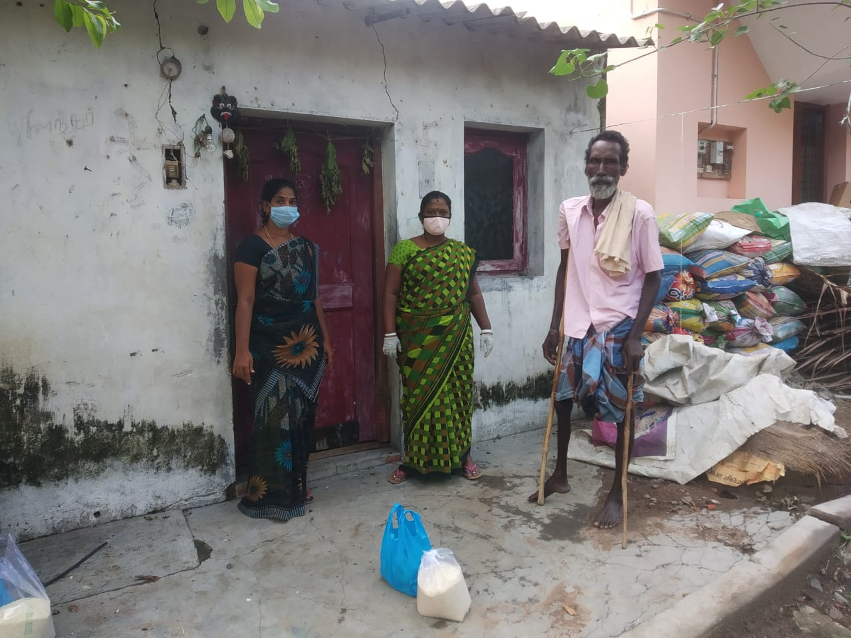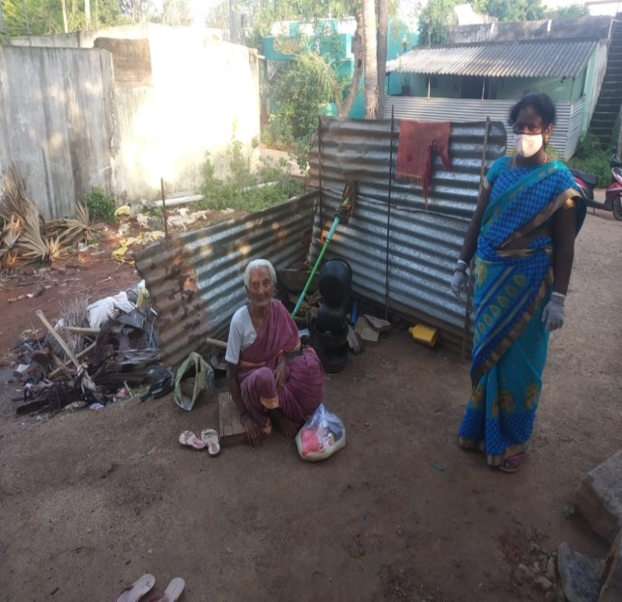
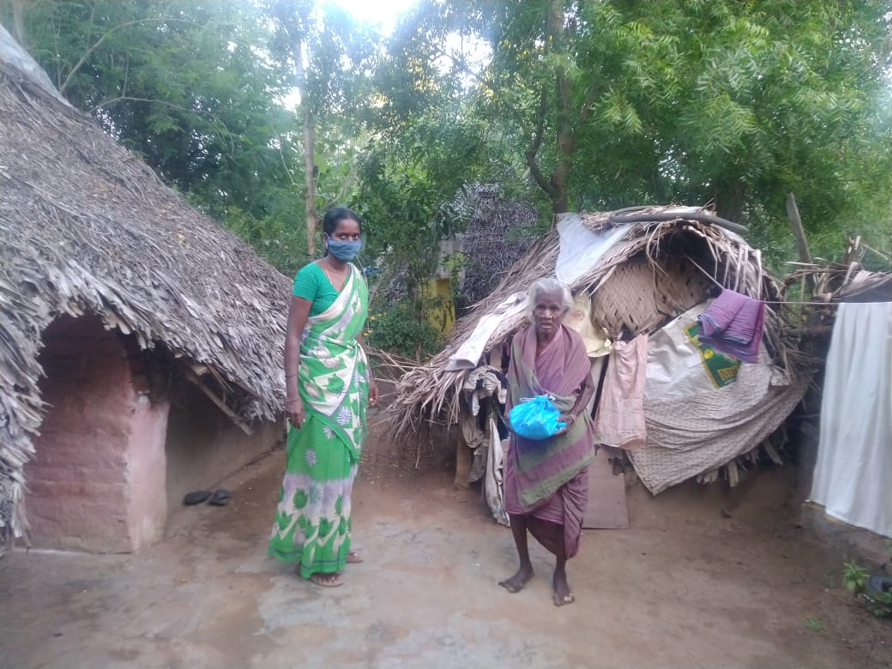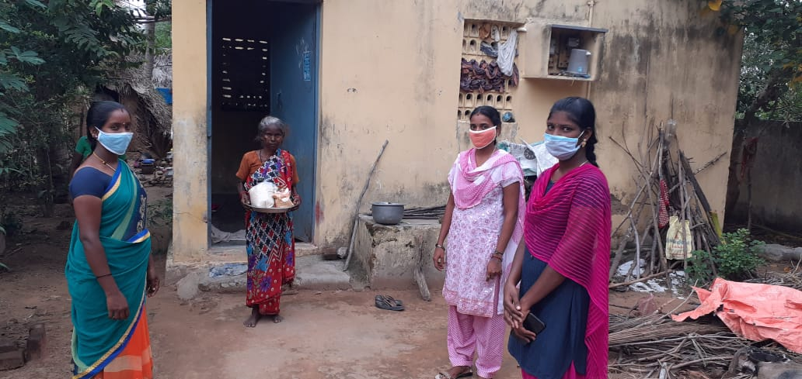

Views of the elderly beneficiaries:
A 65 years old widow said that I was very deprived, and no one supported me in this pandemic time; even my sons and daughters didn’t listen to my miseries. But RUWSEC and its partners have provided us relief materials, and we don’t have words to thank them.

Another single woman from Jamberi village reports that RUWSEC has supported us during difficult times like the Varadha cyclone and Covid lockdown; this is useful for people like me.

A man from Veerapuram village says that the Doctor at RUWSEC clinic treated us very well they provided us with free medicines and gave us food materials.

A woman of 60 years old in Perumbedu villages says my son has a mental illness, and I don’t get any work during the COVID pandemic, so it was tough

Another single woman of 75 years old in Amijakari village says only my daughter in law lives with me and my son works in another district, and he rarely comes home. The food materials that RUWSEC provided me would be sufficient for one week.

During the COVID pandemic, as I didn’t have any money, I didn’t cook food at home; my neighbours and villagers gave us the left-out food in their home and porridge; now, I could cook with the food that RUWSEC provided and used for a week.

During May-Sept 2020, we distributed dry food items and vegetables to low-income families in each of our project villages; we prepared a list of poor and deserving people in the community and spread the relief materials with the support of RUWSEC staff and volunteers in their respective villages. Relief materials were distributed in four rounds; 237 single women and men, 30 families benefited. For individual’s 2kg rice and families, 5 kg of rice were given along with the other materials.

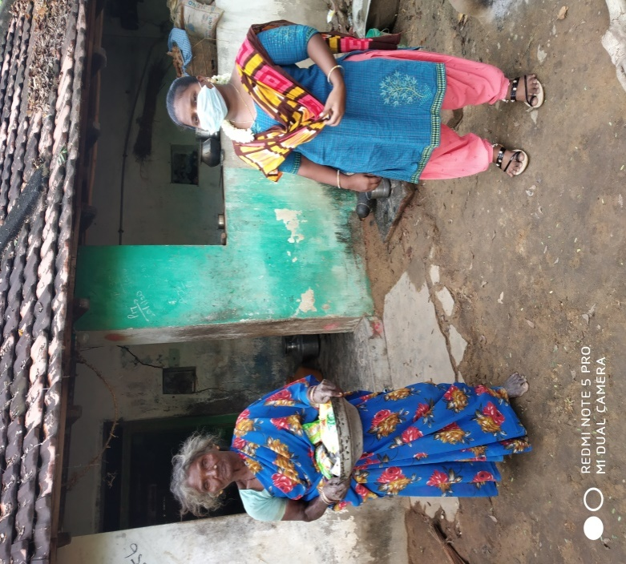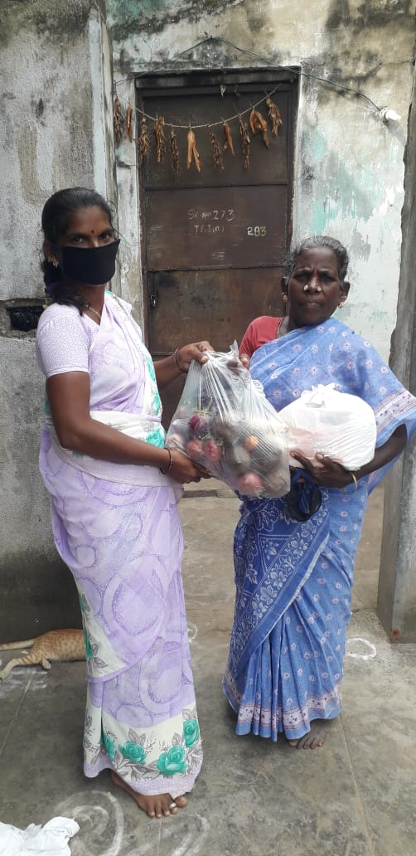
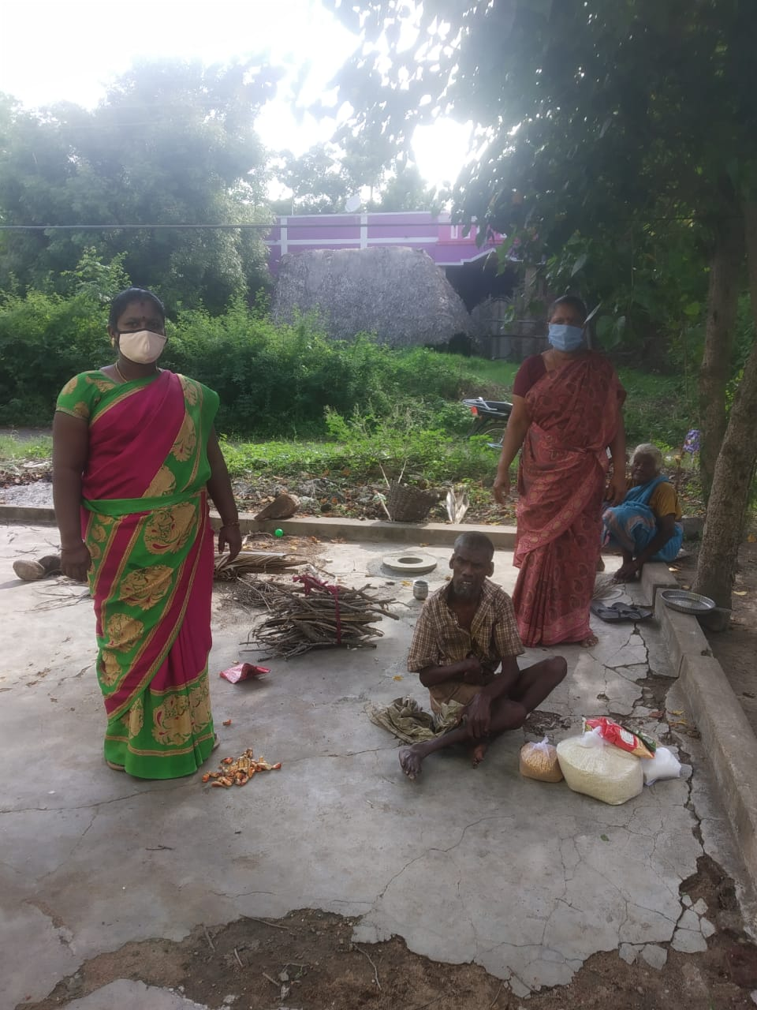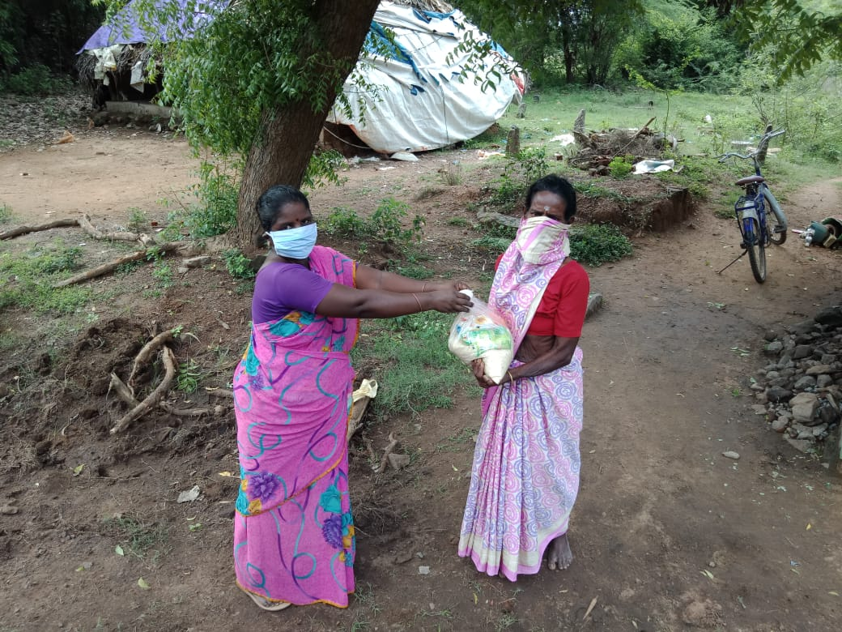

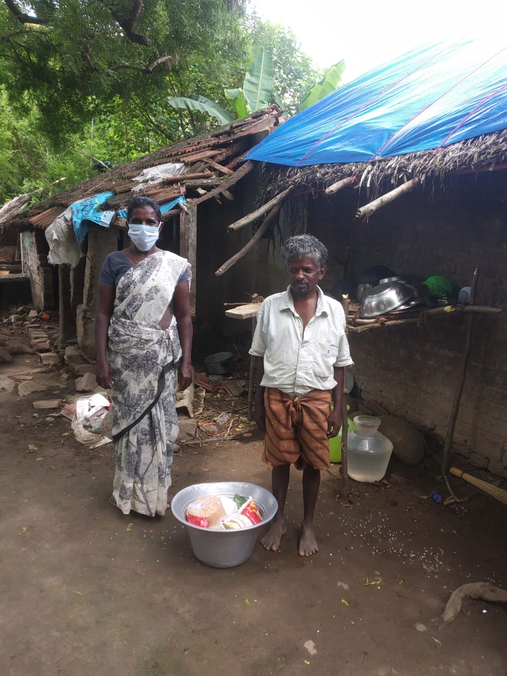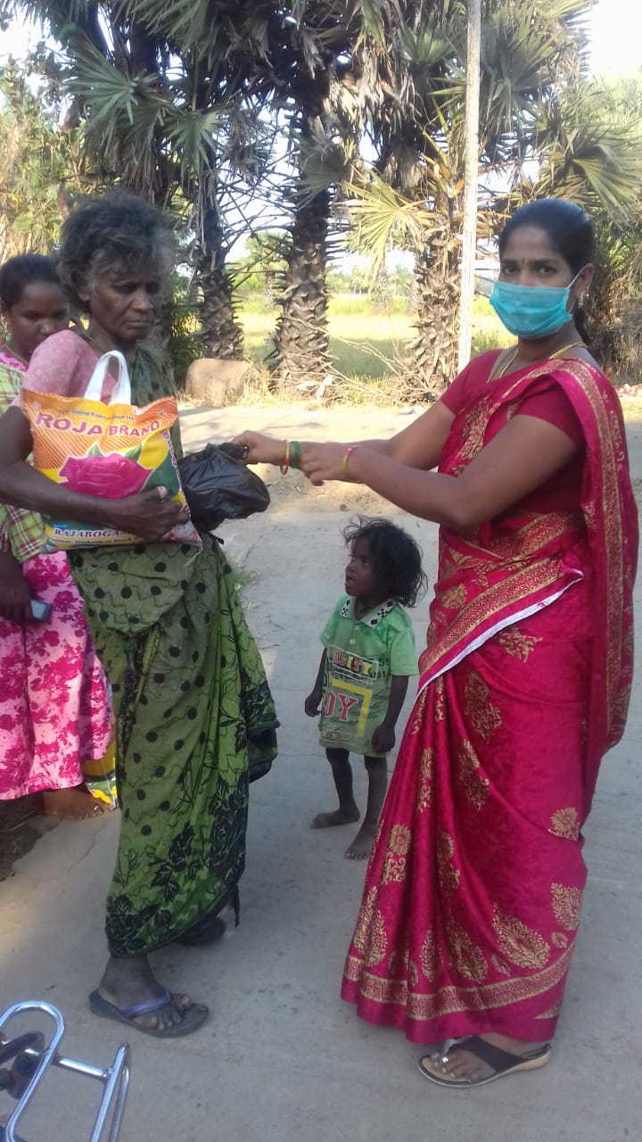
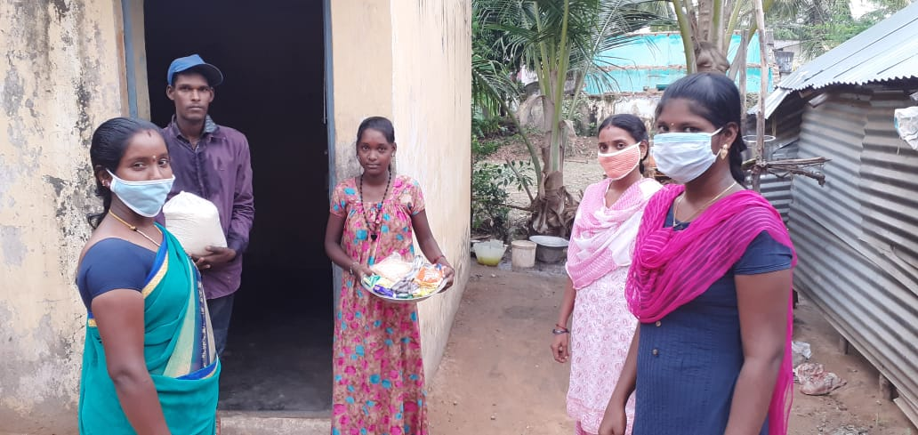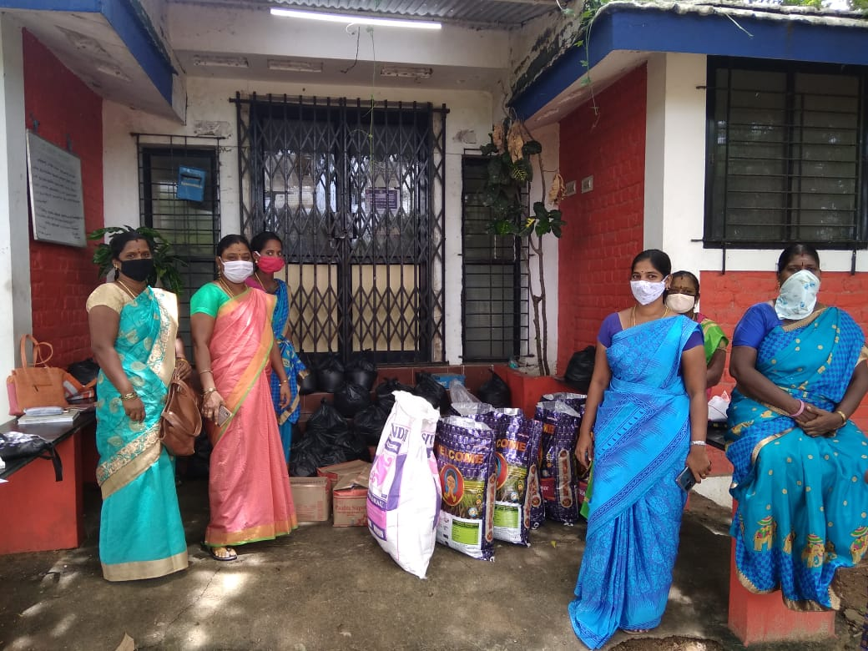
1.2 NCD AND SRHR AWARENESS GENERATION ACTIVITIES & COUNSELLING SERVICES;
Provided psychosocial support and menstrual hygiene supplies to adolescents and young women:
During the lockdown period, our staff and volunteers had regular contact with adolescent girls and young women working in factors in our project villages. Our workers provide SRHR and psycho-social support counselling services in the community. We also help them get sanitary pads supplied by the Anganwadi and primary health centres. It seems to be out of stock; our workers in these villages helped them get it from the private shops and distributed it to the needy.
“We are destitute, and my parents don't even have the money to buy food; under such circumstances, how I can buy sanitary pads. Earlier, I used the pads provided by the government, but it has not been supplied for the past one and half months, so I use cloths”.
We distributed sanitary pads free of cost to rural poor adolescent girls in our project area to address these concerns.
Distributing Sanitary Napkins to adolescent girls
During the pandemic, the supply of sanitary napkins to adolescents was disrupted, so with the help of CWDR, hygienic napkins were distributed. In the project, 250 adolescent girls from low-income families were identified and given sanitary napkins, masks, bit notice about Corona prevention, pamphlets on anaemia and menstruation.
During September 2020, staff members organised a community-based workshop for the adolescent girls in their respective villages on prevention against Corona, the importance of social distancing and wearing masks. These girls were explained about self-care and hygienic practices, and the bit notice on Corona prevention was also distributed towards the end of the workshop. Sanitary napkins were also distributed to the girls.
As most families did not have a regular income and even the working young girls also lacked employment, they all thanked CWDR for supplying napkins for them as they did not even have money to buy sanitary napkins.
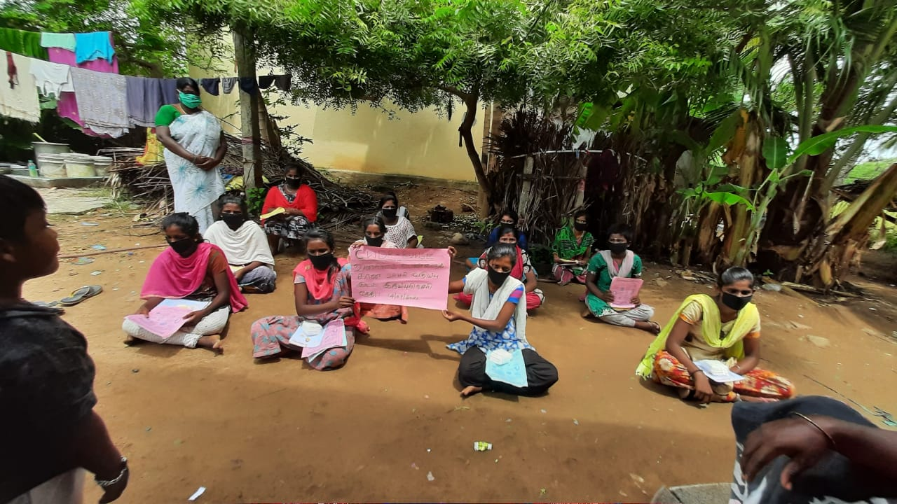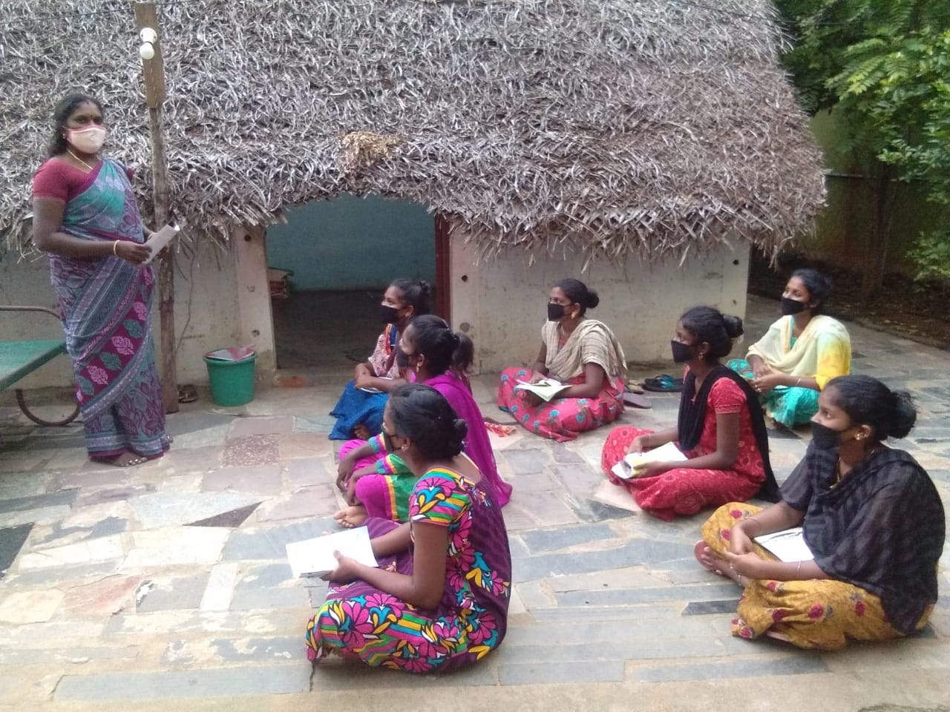
Community-based workshops for Adolescent girls
In October and November, workshops were conducted for adolescent girls on Reproductive health and hygiene in two of the project villages and Naduvakkarai and Suradimangalam. They had sessions on gender, functioning of the reproductive organs, pamphlets on anaemia and vaginal discharge were also distributed during the session doubts were clarified through a question-answer session, and real-life experiences were also shared for better understanding. Thirty-nine adolescents took an active part in the workshop, and the sessions were conducted by following social distancing, and all the participants were asked to wear a mask.
Provided counselling services and follow up for NCD patients in the community:
In 2019, there are over 700 diabetic, 350 hypertension and 200 other chronic morbidity patients in the RUWSEC project villages. A majority of them are women, and nearly half of the patients (47 per cent) belonged to 40-60 years and another 37 per cent aged above 60 years. As our target population are predominantly Dalit, they are poor and mainly use public treatment facilities. Nearly half of the NCD patients seek treatment from public facilities, one third use RUWSEC clinics, and the rest opt for private doctors. So, our health workers and youth volunteers in the project villages have been following up with the NCD patients to ensure treatment adherence, the continuation of medicines and helping them collect drugs from the PHCs and RUWSEC clinic.
Supply of Nutri-mix powder to cancer survivors:
Since 2010, we have been running a support group for cancer survivors. Currently, there are 14 persons in the group. We have also provided them with a one-kilogram packet of homemade Nutri mix powder to consume as a liquid diet. We continue the supply by delivering it to their homes.
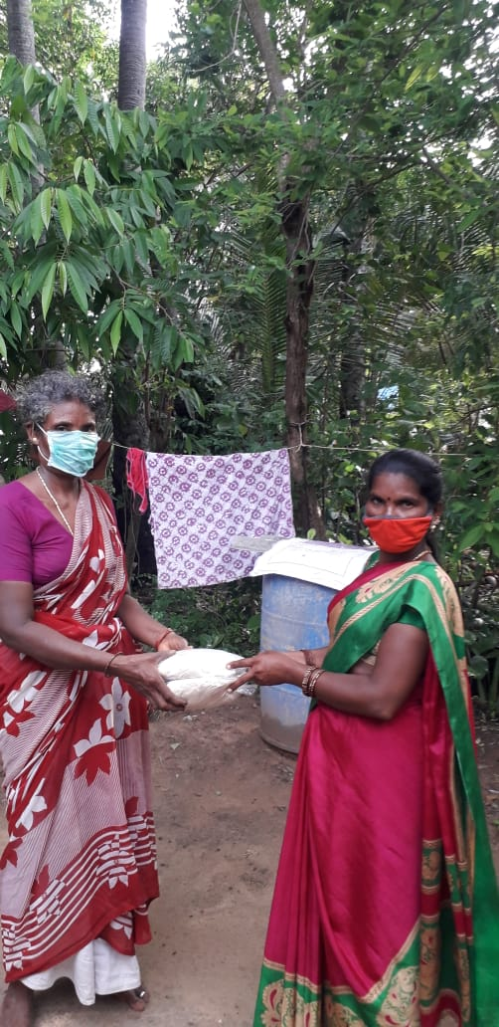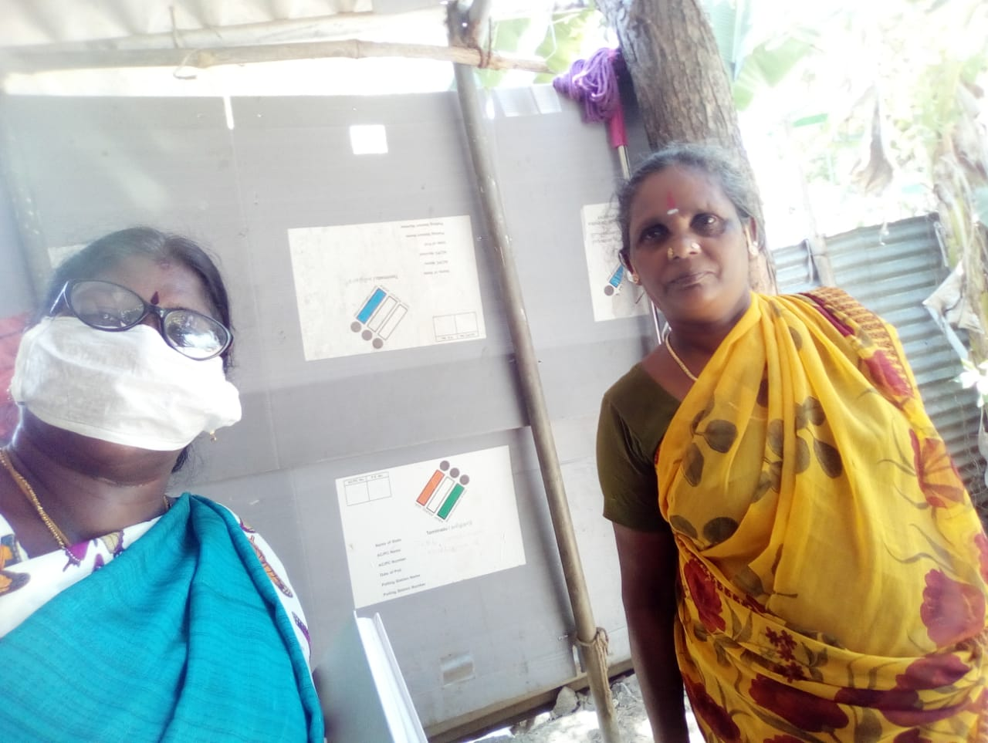
Supply of medicines to NCD patients from vulnerable households:
As most of our consultant Doctors are from Chennai and were unable to travel in the lockdown period, we provided limited outpatient care services in April and May; doctors consultation was done on only two days a week in the first two months and then gradually increased the frequency four days a week services. But at the same time, we have about 250 NCD patients (Diabetes, hypertension, and other chronic morbidities) who were taking regular treatment in our clinic. Most of them are very poor older women and men. So, we run the pharmacy and laboratory services on Sundays and Thursdays and dispense drugs for the NCD patients in April. Using the clinic register, we prepared a list of patients from the 25 villages undergoing treatment from our clinic and receiving medicines for diabetes, hypertension, and other chronic conditions. We have been informing them through our community health workers and youth volunteers to collect their medication for a month. There are also a few people in each village who cannot travel alone. We are packing a month’s supply of medicines and delivering them to their home with the help of youth volunteers. Free pills were provided to poor elderly and single women.
RUWSEC’s staff could not go in for field visits during the pandemic, so they stayed in touch with the villagers through phone calls. Voices from the ground …..
One of the diabetic patients in Kamarajar Nagar expressed that her husband neglected her, and she felt angry and depressed, she stopped having tablets, and the food intake too became less. The staff members made regular phone calls to her as she was mentally upset. Through constant follow up over the phone, she started to have a normal diet and had her medicines.
A diabetic patient in Andimadam was scared to go to the hospital to get diabetic medicines as she stopped taking the medication. Her blood sugar levels shunted up through phone counselling staff got to know about this and asked her to consult the doctor and have a check-up. After follow up she went to the hospital and started having the tablets.
A Blood Pressure patient in Echankarunai village could not go to the hospital for getting medicines, and he got hurt in his legs, and it did not heal. The staff discussed this with the helper in the village, and after that, he was taken to the GH for treatment.
A physically challenged poor woman in Erumbulicheri was eight months pregnant, and it was her 7th delivery. There was no support from family or husband as even her husband was visually challenged. The staff knew that she did not have a scan as she did not have money. The staff members arranged cash and took her to the doctor. She had a normal delivery, and she and her three-month-old boy child are feeling better now.
Support group meetings for Diabetic patients
A support group meeting for diabetic patients was conducted in Pandur village. They had a session on exercises and healthy food habits; the importance of maintaining blood sugar levels under control was presented. Thirty-three villagers took part in the session, and the session was conducted following safety standards like wearing masks and carrying social distancing.
Assisted women in need of maternal health and contraceptive and safe abortion services and assisted them in obtaining the necessary services:
RUWSEC’s workers provide regular counselling and health education to pregnant women and lactating mothers and women in need of or currently using spacing methods of contraception. This is done in all our project villages and one PHC in our area. During this period of lock-down, RUWSEC’s workers and youth volunteers were regularly in touch with these women over the phone and assisted them in obtaining Iron and Folic acid tablets; in a few instances, they accompanied them to health facilities and obtained contraceptive pills and condoms for them from the PHC and distributed in the villages.
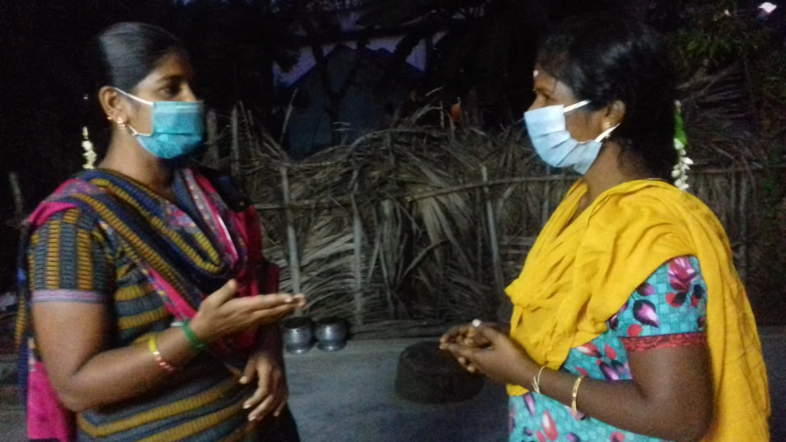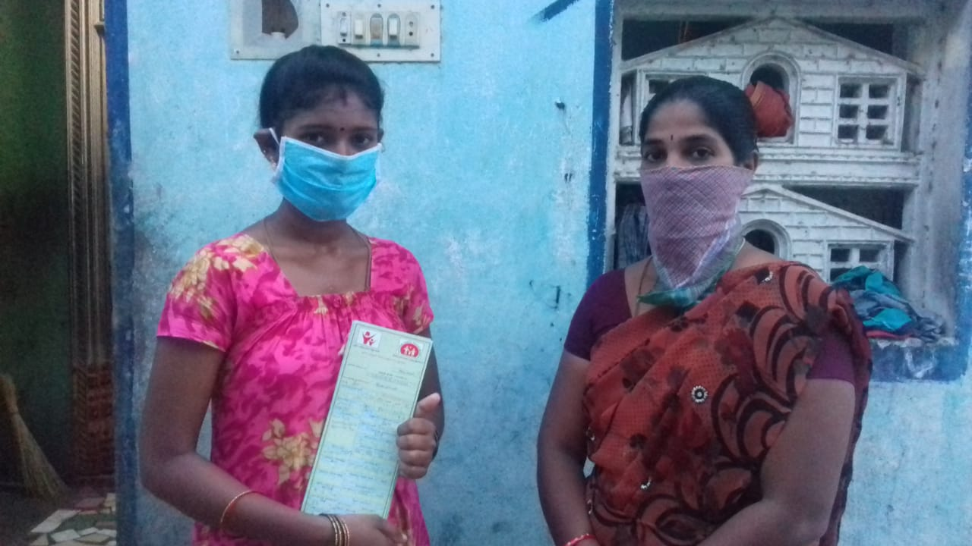
. A high risk disabled pregnant woman with seven h gravid and 8th month of gestation was assisted in availing the ANC services, and our staff accompanied her to undergo lab tests and ultrasound tests.
A woman who had a miscarriage was referred to an upgraded PHC, and they referred her to a government medical college hospital, but the patient refused to go there as she had a bad experience in using the facility; finally, she went to a private hospital and spent Rs 12,000/- for availing a D&C service.
In XX village, a heart problem woman had an unplanned pregnancy. We referred her to a private hospital for an abortion at her request. Then we provided contraceptive information and counselling to the couple, and now her husband is using a condom.
Providing mental health counselling services in the community:
Almost all the workers and youth volunteers (twenty-one persons) in our team have completed a community mental health course conducted by the Banyan Academy of Leadership in Mental Health (BALM), Chennai. With guidance from BALM’s faculty members, our team members have started providing psychosocial counselling services for persons who need assistance. Now, our team members are providing counselling services and technical information to help them deal with their fears and provide moral support. If required, we will be connecting them to BALM faculty to speak with them over the phone and provide necessary support and guidance.
Provided-going support to women survivors of intimate partner violence who are part of our VAW prevention and support programme:
RUWSEC has had a Community-based Prevention of VAW programme (PoVAW) since 1998, wherein community support groups are trained to prevent and provide support to women experiencing intimate partner violence (and other forms of domestic violence). This is complemented by counselling and health services offered by RUWSEC’s clinic and support group activities, and referral to legal recourse. Realising that the lock-down situation creates additional risks for women experiencing violence within their home, our PoVAW team members maintained regular contact with the community support groups, encouraging them to act pro-actively in diffusing tensions and preventing violence within the home. PoVAW team members were also in touch with women who have recently sought help to ensure they are kept safe and assured them of support in case of any problems.
In E…. village, a man attempted to attack his wife with a steel rod. She was protected with the timely intervention of a committee member in the town and assisted her in registering a police complaint.
In another village, a pregnant woman with mental health problem was provided three levels of counselling; a local volunteer, senior co-coordinator and doctor, and she is under constant follow up, and the local volunteer is observing her closely.
Awareness Campaign to Prevent Violence’s Against Women
Every year to observe violence against women, weekly campaigns are conducted in the project villages. This year, the campaign was completed in 5 project villages: Echankarunai, Mullikulathur, Kamarajar Nagar, Edaiaathur and Suradimangalam. In all these villages chart display was held and bit notice on prevention of violence against women was given to all the households. Towards the end, a session on violence that happens to women, sexual violence’s against women, and solving mechanisms were presented. One hundred sixty women took part in this campaign.
Reflections of RUWSEC’s Community health workers and Volunteers about their community work
When I called a woman over the phone to inquire about her health condition and ensure her medication for her reproductive tract infection, she told me that all the private hospitals were closed on the day. Still, luckily RUWSEC clinic was opened, and I sought treatment there. The lady doctor was amiable and clarified my doubts. Otherwise, my health condition would have deteriorated more. Further, they gave me detailed information about the Coronavirus and supplied free face masks - Community Health Worker
I would like to share one heartfelt moment in my life; when we distributed food materials to an elderly couple living in a hut in my village, the woman held my hand. She wept out of happiness, saying my relative’s dint support even the government and us dint provide an old-age pension. We mostly ate the foodstuff our neighbours gave, and a few of them gave what was left in their homes after feeding their family/ residual foods. In such a situation, now we get food materials to cook our fresh food – Youth Volunteer
There was a long crowd in the public distribution system/ ration shop, and the salesman was unable to control the group; on hearing the news, I immediately rushed there and regulated the group by putting round marks on the floor and asking them to stand on it one behind the other giving enough space and to maintain social distancing. During their waiting time, I gave a short talk on the importance of keeping social distance and using personal hygienic measures to protect them from Coronavirus- Youth Volunteer
  - CENTRALISED TRAINING AND MEETINGS ON SRHR:
Youth Leadership training programme
Starting from 2013, RUWSEC has been conducting a youth leadership training programme for young men and women aged below 30 years as young leaders in the community. With an objective that the trained people would contribute to social change in the community, take up leadership initiative in their villages and act as change agents and serve the community. The seventh batch of training was conducted for the young people in the financial year, and it is a certificate course. The youth training could not be undertaken; it started to commence only in December. The six days training was conducted during December - March. The topics covered through the sessions include functioning of the reproductive organs, contraceptive methods and pre and postnatal care, Relationship and gender-based violence against women. Each session had a group discussion, question and answer session, video display and experience sharing; 18 youth volunteers attended this training programme. Finally, certificates were distributed to the participants
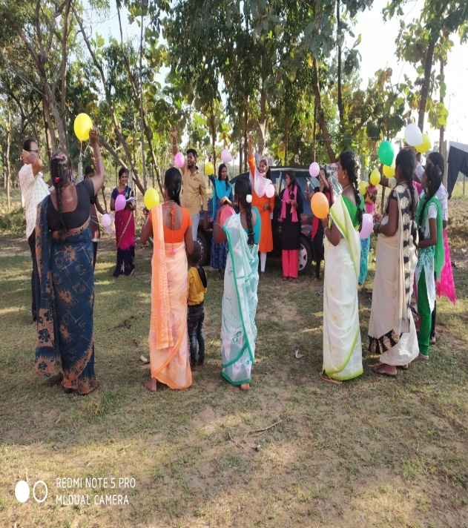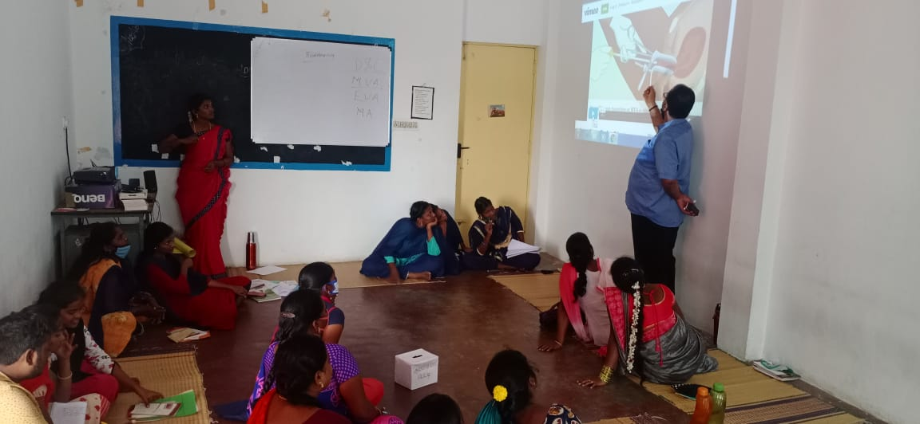
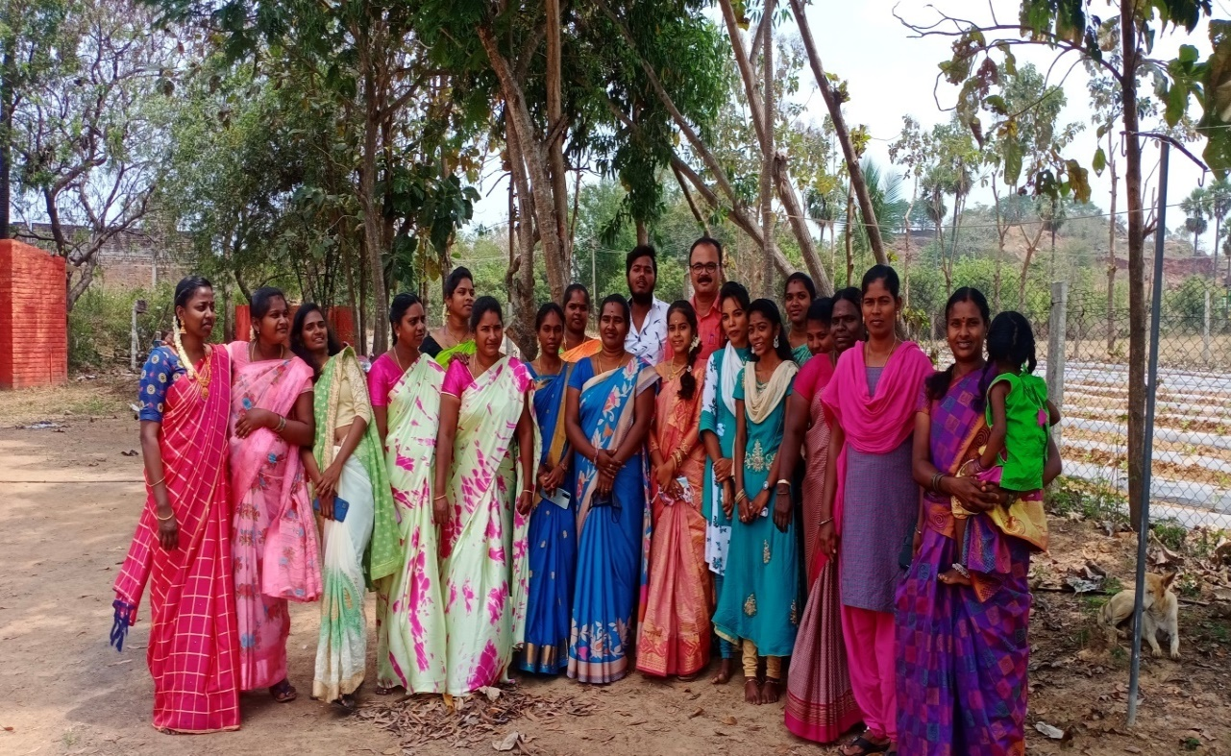
Seventh Batch Youth Leadership Trainings programme (2019-2021) Group Photo
The training sessions were more participatory and full of games and exercises; each session's learning would ever remain green/fresh forever in my memories.
The information shared, and the materials provided on reproductive health are beneficial.
Special meeting for newly married couples and Pregnant Women
A special workshop for newly married couples on gender and SRHR was organised in March 2021, and 10 teams participated. Likewise, a workshop for pregnant women was conducted in the PHC. A video telecasted in the Mega TV Channel by a doctor was shared with pregnant women accessing Nerumbur PHC. The video was on care during the first three months of pregnancy, problems faced by women during pregnancy, reasons for high or low levels of amniotic fluid were explained by a doctor this was telecasted for the pregnant women for better understanding and about the importance of care during pregnancy 45 women benefitted out of this event.

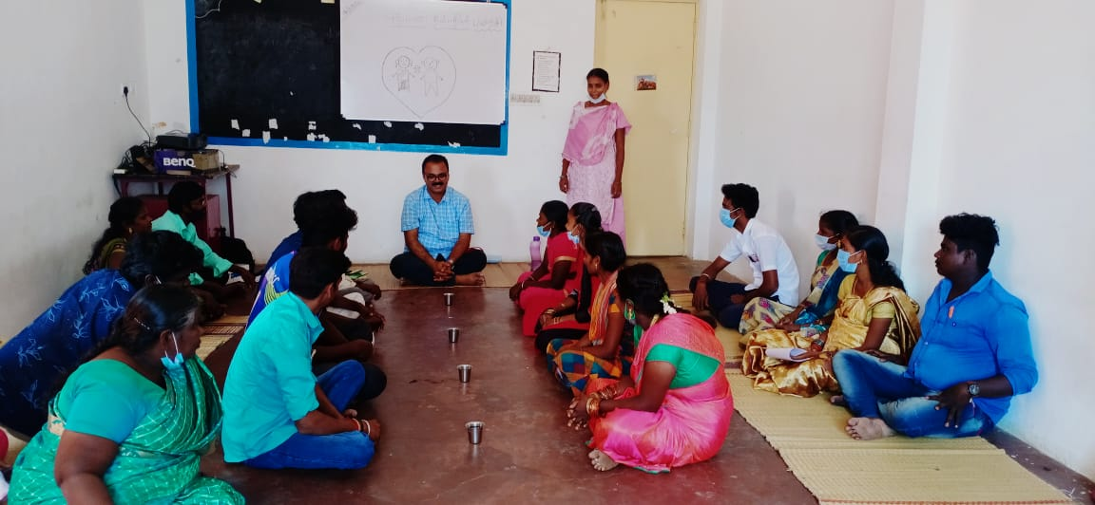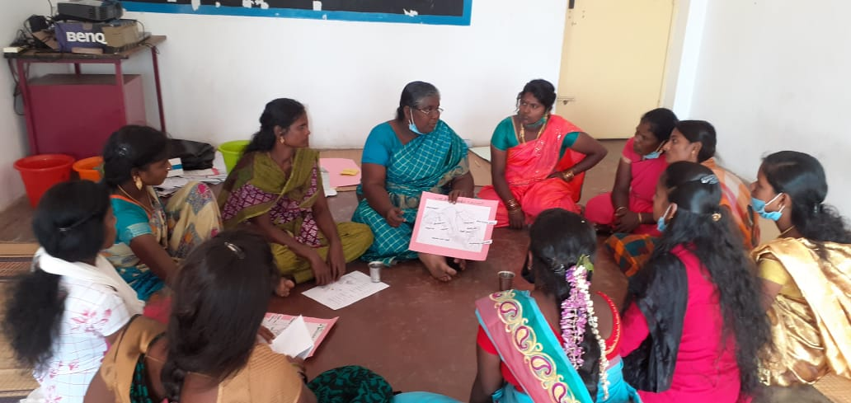
Staff Capacity Building Training: Regular capacity building training for the staff was conducted, both internal and external resource persons were invited to facilitate the sessions. A Q& A session with a senior endocrinologist and a public health specialist was conducted in March 2021. Another critical point is that five staff and ten youth volunteers completed a six-month diploma in community mental health run by Banyan Academy of Mental Health, Kovalam, Chennai
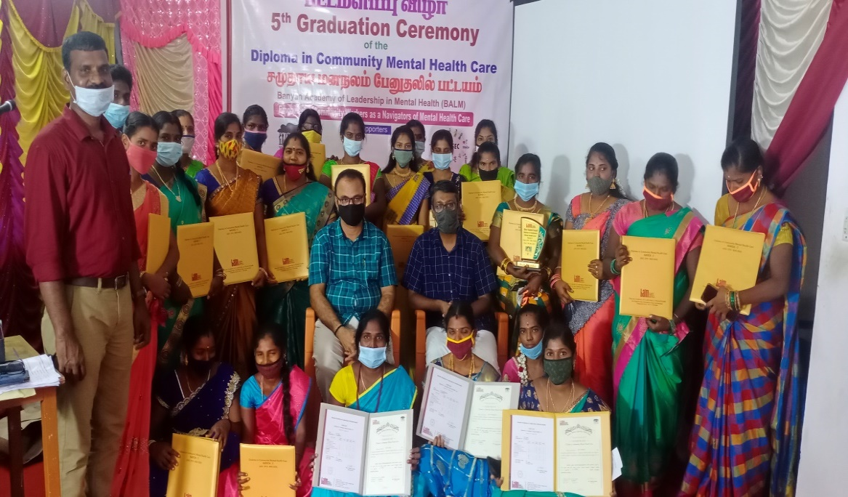
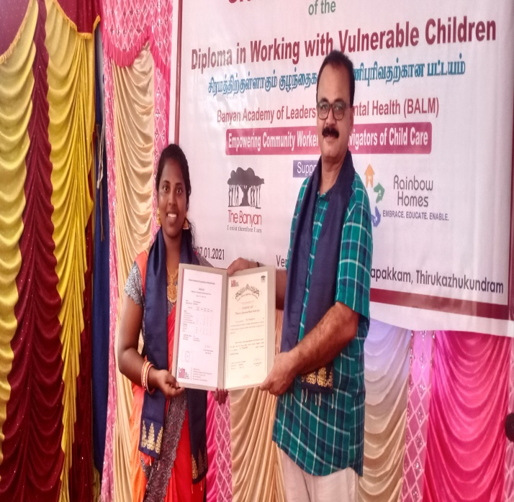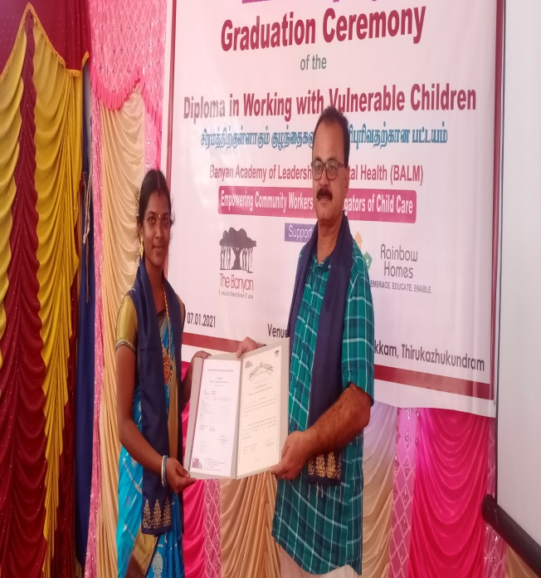
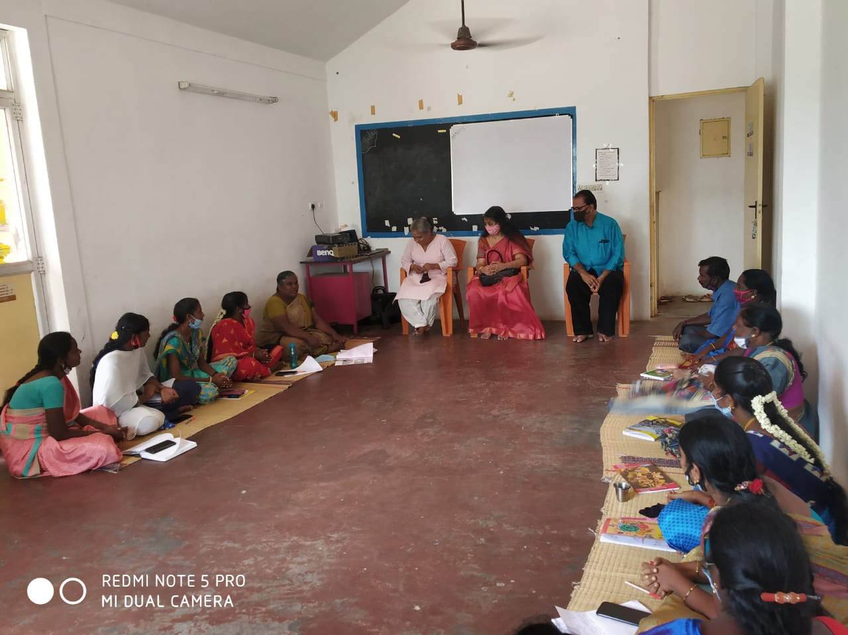
STRATEGY 3 PROVISION OF HEALTH CARE SERVICES
We continued to provide our outpatient health care services but limited the days of services. As the RUWSEC clinic functioned on Thursday and Sunday in April and May, people from the nearby villages accessed the clinical benefits and got medicines for their health problems. Counselling was also provided for pregnant women, women who breastfeed their children, women having reproductive health problems and women using contraceptives. Additionally, they were also provided inputs about the pandemic and the importance of being safe, following hygienic practices, and wearing masks.
RUWSEC clinic carters to outpatient services for the people in the villages of Thirukazhukundram. During the lockdown from March 23rd to September 2020, the clinic functioned only for a limited number of days.
During the lockdown period, Siddha treatment services were offered on Wednesday, Homeopathy and Allopathic services were provided on Thursday, Allopathic services were provided on Sunday, and the timings were from 9 AM to 2 PM. All the people coming to the clinic were given ‘Kaba Sura Kudineer’. To stress social distancing, circles were drawn, patients were asked to follow a queue and tokens were given. After a temperature check, villagers were asked to consult the doctor, and wearing masks were mandatory. People who did not wear masks while coming to the clinic were given masks free of cost. After the free supplies got over, acts were given to self-help groups at the expense of Rs.10/- per mask 100 mask worth Rs.1000 was given to self-help groups.
From April to June 2020 Dr Savithiri Constant Doctor) provided allopathic treatment services in the clinic. Due to the lack of bus facility and panic in people’s minds about Corona, people were thankful to RUWSEC for providing treatment in the close vicinity by maintaining social distancing, wearing masks and washing hands regularly. Patients who needed follow-up treatment for BP and sugar were asked to have medicines and utilise the follow-up services via phone call. People from the project villages who could not come to the clinic to get drugs were given drugs, and it was distributed with the help of the staff and volunteers so that there was no break in the treatment.
To provide counselling services for the patients, four RUWSEC senior coordinators took turns coming to the clinic and providing counselling services for the patients. When the relaxation was announced on Tuesdays, the Siddha treatment services were provided till 4 PM. From August 2020, Dr Vijay (Regular consultant) started to provide allopathic treatment services on Sunday.
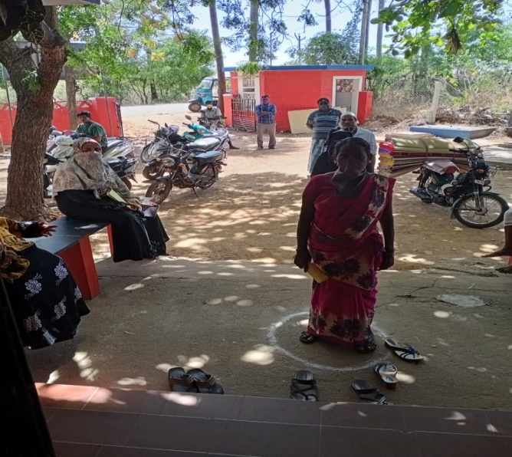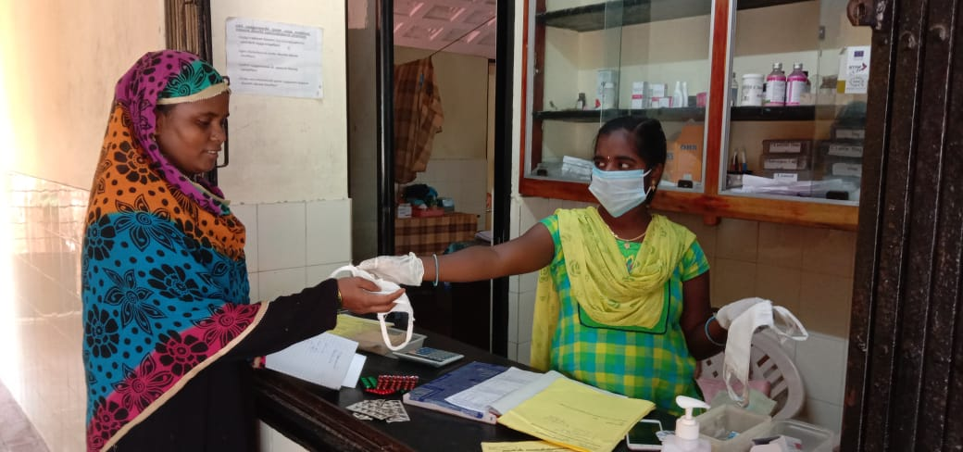
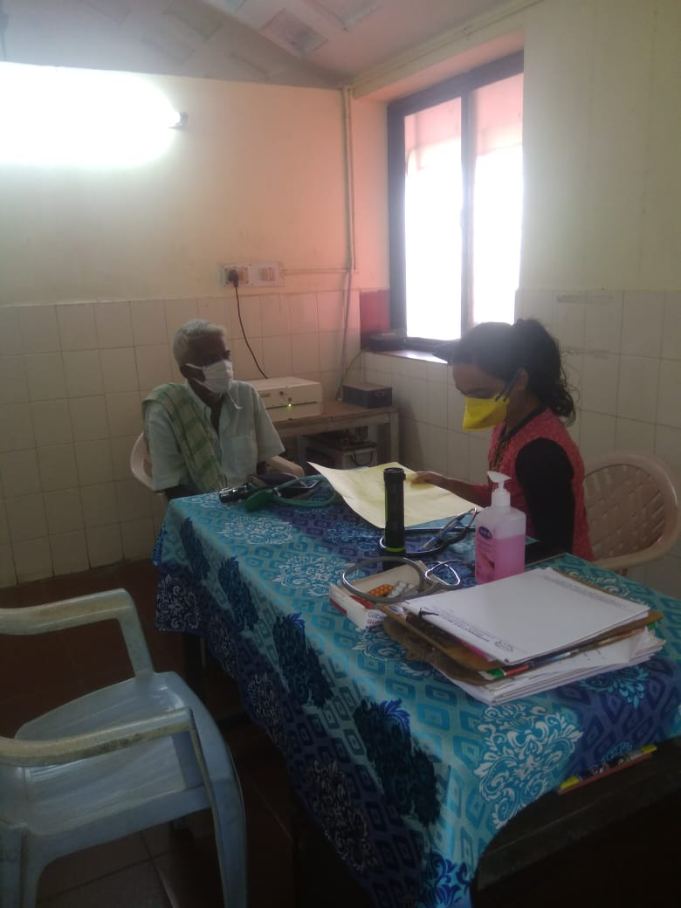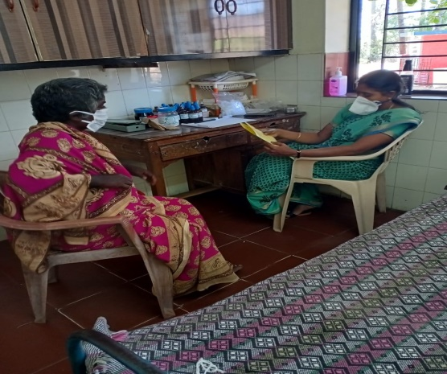
During the one year, over 30 persons with cold and cough symptoms of COVID 19 were referred to the nearby Nerumbur PHC and Thirukalukundram CHC, and they took the Corona test results were negative.
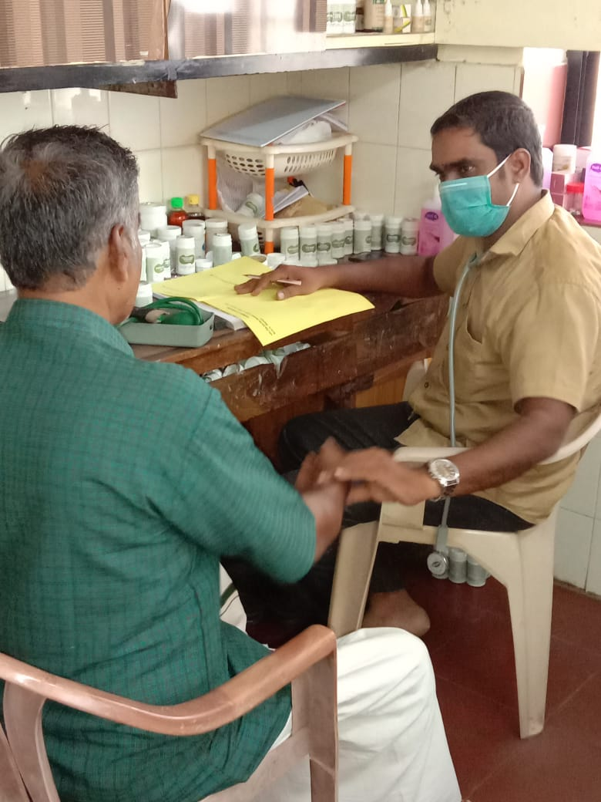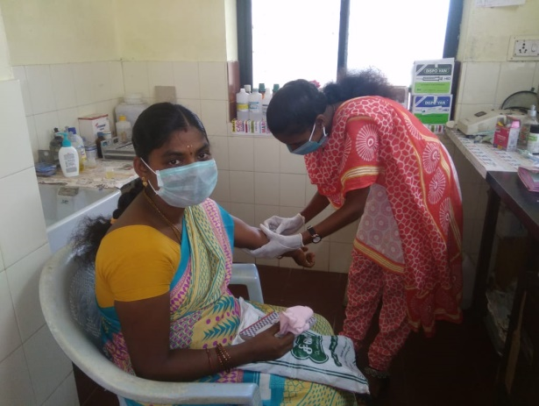
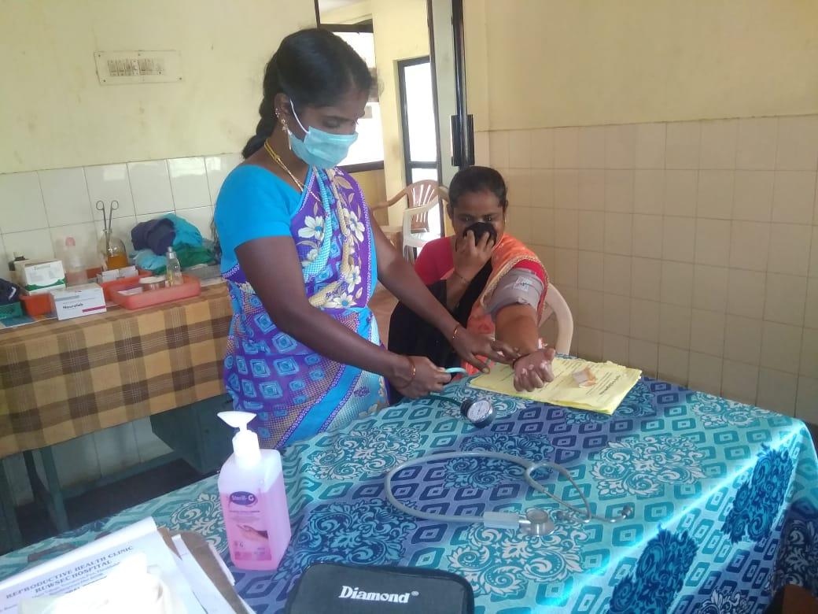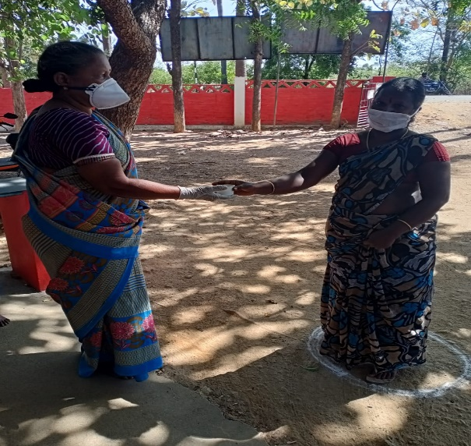

Table 1 RUWSEC Clinic Users (April 2020 – March 2021)
Month | Allopathy |  |  |  | Siddha |  |  |  | Homoeopathy
 | Male | Female | Children | Total | Male | Female | Children | Total | Male | Female | Children | Total
April 2020 | 59 | 98 | 1 | 158 | - | - | - | - | - | - | - | -
May | 104 | 202 | 1 | 307 | 40 | 65 | 2 | 107 | 3 | 15 | - | 18
June | 101 | 169 | 1 | 271 | 126 | 143 | 3 | 272 | 12 | 35 | 1 | 48
July | 72 | 149 | - | 221 | 124 | 157 | - | 311 | 24 | 54 | 2 | 80
August | 93 | 107 | - | 200 | 125 | 210 | 11 | 346 | 24 | 51 | - | 75
September | 103 | 214 | 1 | 318 | 200 | 298 | 4 | 502 | 15 | 38 | - | 53
October | 81 | 155 | 3 | 239 | 191 | 275 | 5 | 471 | 28 | 66 | 2 | 96
November | 113 | 233 | 0 | 346 | 99 | 212 | 10 | 321 | 11 | 18 | - | 29
December | 102 | 230 | 10 | 288 | 149 | 305 | 13 | 497 | 23 | 64 | 1 | 88
January 2021 | 112 | 227 | 4 | 343 | 114 | 178 | 4 | 296 | 16 | 43 | 2 | 61
February | 126 | 265 | 3 | 394 | 160 | 220 | 3 | 383 | 22 | 48 | 3 | 73
March2021 | 91 | 211 | 2 | 304 | 194 | 299 | 7 | 500 | 28 | 56 | 1 | 85
Total | 1157 | 2260 | 26 | 3389 | 1522 | 2362 | 62 | 4006 | 206 | 488 | 12 | 706
Allopathy: 3389 Siddha: 4006 Homeopathy: 706, Overall Total: 8101

It is seen from table – 1 that due to lockdown, we only ran Allopathic OP in April 2020, then from May, we provided all the three systems; Allopathy and Homeopathy OP weekly one day, Siddha two days a week, Ortho and Psychiatric services one day in a month. The average caseload ranges between 60- 120 per day for Allopathy and Siddha, 25- 30 for Homeopathy.
Seven hundred thirty-six persons availed our specialised counselling services; 107 women had reproductive health problems, and around 400 were NCD patients.

Table: 2 Beneficiaries of RUWSEC Laboratory Service (April 2020 - March 2021)
Month | BY SEX |  | Total | TEST |  |  |  |  |  |  |  |  |  |  | Total tests
 | Male | Female |  | HB | Blood Sugar | Blood Group | ANC | HBSAG | HIV | VDRL | Thyroid | Urine Alb | Urine Pregnancy | Other tests (Urine Creatine, bilirubin etc.)
April | 14 | 48 | 62 | 33 | 22 | 6 | 42 | 10 | 5 | 3 | 0 | 32 | 0 | 1 | 154
May | 29 | 109 | 138 | 52 | 75 | 15 | 65 | 21 | 11 | 2 | 0 | 35 | 3 | 4 | 283
June | 27 | 93 | 120 | 51 | 57 | 5 | 54 | 4 | 7 | 2 | 0 | 31 | 2 | 3 | 216
July | 34 | 88 | 122 | 44 | 66 | 13 | 43 | 6 | 6 | 2 | 0 | 55 | 0 | 20 | 255
August | 29 | 87 | 116 | 39 | 66 | 10 | 33 | 4 | 1 | 0 | 0 | 25 | 1 | 5 | 184
Sept | 41 | 99 | 140 | 35 | 89 | 14 | 0 | 5 | 3 | 2 | 0 | 21 | 1 | 2 | 172
October | 33 | 64 | 97 | 18 | 64 | 10 | 9 | 2 | 5 | 1 | 9 | 14 | 1 | 10 | 143
November | 18 | 54 | 72 | 2 | 58 | 2 | 3 | 0 | 0 | 0 | 3 | 1 | 2 | 4 | 75
December | 31 | 92 | 123 | 12 | 75 | 6 | 22 | 5 | 1 | 0 | 24 | 6 | 6 | 7 | 164
January | 18 | 64 | 82 | 11 | 48 | 0 | 15 | 4 | 1 | 1 | 16 | 6 | 3 | 4 | 109
February | 37 | 80 | 117 | 11 | 69 | 8 | 19 | 11 | 1 | 1 | 19 | 4 | 4 | 6 | 153
March | 37 | 75 | 112 | 11 | 72 | 7 | 0 | 9 | 1 | 0 | 14 | 4 | 2 | 16 | 136
Total | 348 | 953 | 1301 | 319 | 761 | 96 | 305 | 81 | 42 | 14 | 85 | 234 | 25 | 82 | 2044

During April- August, almost all the laboratories, including the laboratory in the nearby PHCs in our area, were closed due to Covid. Still, we continued our services, and during that period, many pregnant women accessed our lab services. Monthly, 62- 140 patients used our laboratory services.
Free medicines are given to very poor and single patients (widows, aged, and person don’t have family support). During the last year, 97 persons were provided free medicines, of which 85 were regular and NCD patients (April 2020-March 2021).
Two patients with TB symptoms were identified, referred to Thirukazhukundrum GH, and followed up.
Many patients don’t wear face masks as they believe that it won’t spread in our community. Only persons who travelled outside the state/country and urban areas have the chance. So, we routinely educate and compel them to wear the face mask and practice personal hygienic measures.
Overall, many patients highly appreciated RUWSEC clinic services, saying that most of the private hospitals and clinics in the area were closed in April. Government facilities also didn’t provide clinical services, but RUWSE Clinic was open and provided services, especially allopathic doctor services, were highly appreciated.
Counselling for Diabetic patients in RUWSEC clinic
As a part of creating awareness, diabetic patients accessing RUWSEC clinical services were provided counselling for two Sunday’s a month. During this period, four such meetings were conducted wherein inputs were given on healthy food practices, and the importance of tests and treatment were shared. Questions related to care regarding diabetes were answered, and charts were used to explain the care and healthy practices. 58 diabetic patients benefitted out of these counselling services
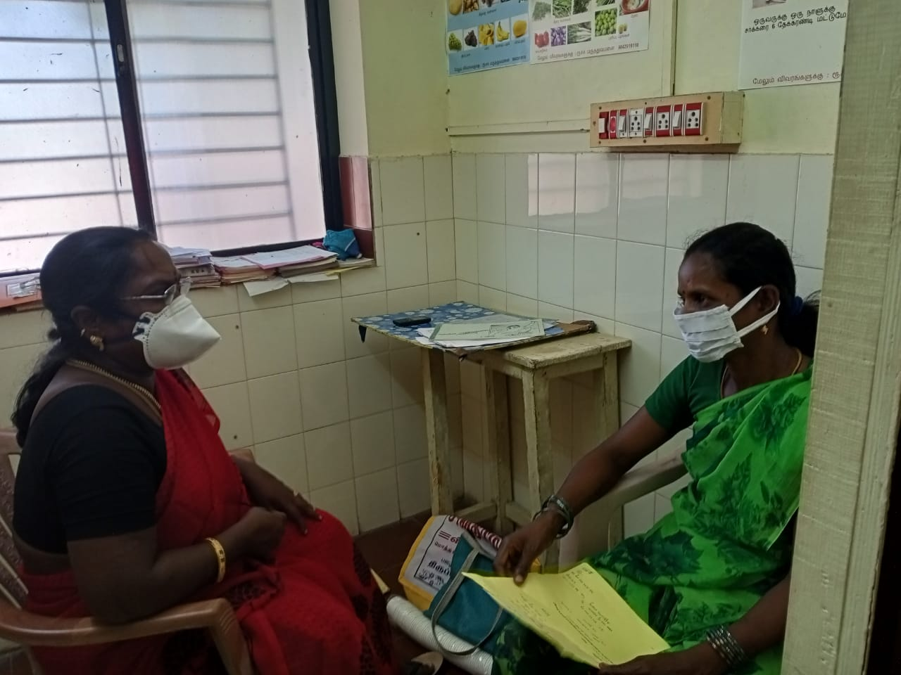
Staff from RUWSEC take turns and provide counselling services for patients accessing RUWSEC clinic for blood pressure, anaemia, reproductive health problems and mental health concerns 109 patients benefitted from these counselling services and 37 pamphlets were distributed during these counselling sessions.
Counselling services at Nerumbur PHC
In our project villages, most people access Nerumbur PHC for health problems like blood pressure, diabetic care, reproductive health problems and pregnancy care. Counselling services are provided with every Friday by the staff or coordinators in RUWSEC, wherein attention is provided on prevention and the importance of taking treatment for health problems. Pamphlets are also distributed for the needy to understand health problems better. One hundred sixty villagers benefitted from the counselling services.
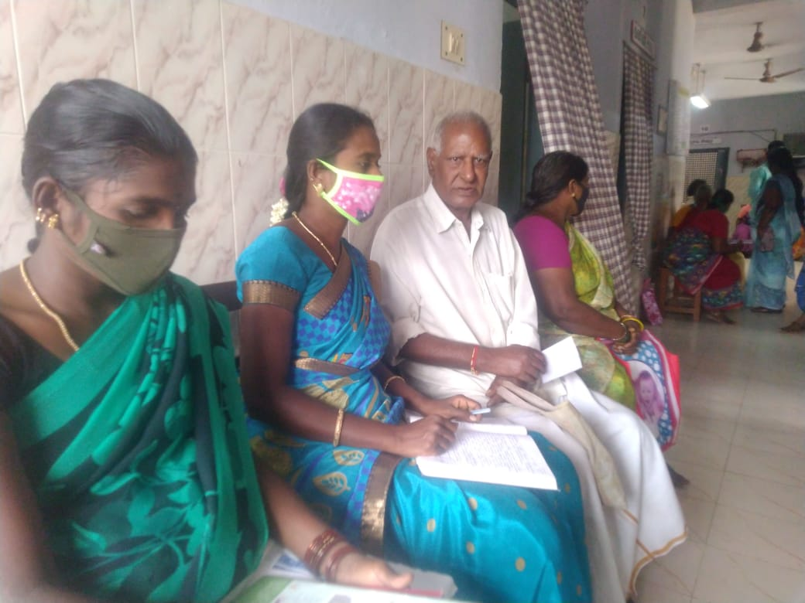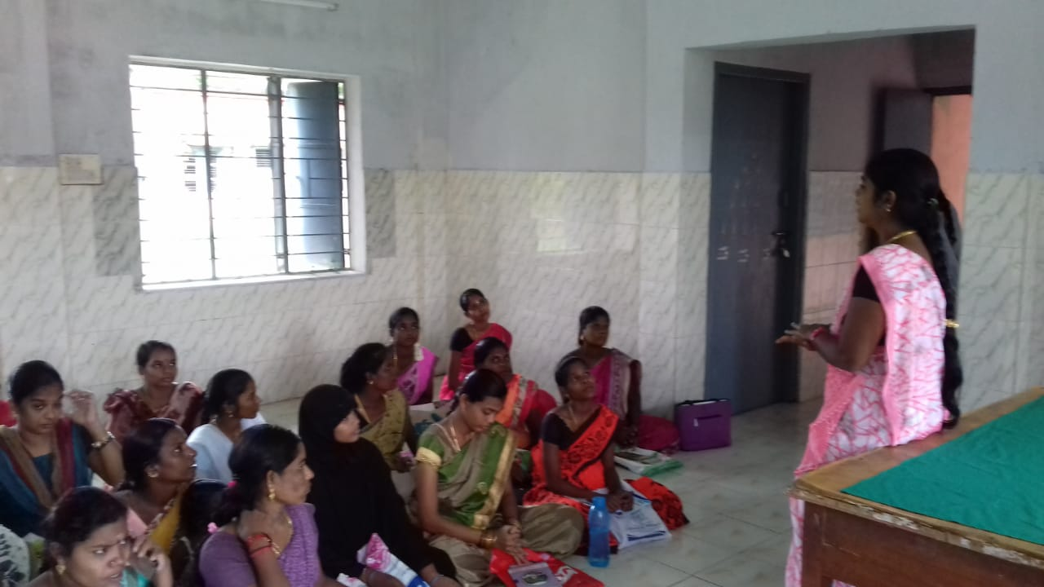
On Tuesday, counselling services are provided for women, especially pregnant women and other reproductive health problems. Pregnant women are provided counselling on a healthy diet, especially iron-rich food, why they should have food substitutes, accessing monthly check-up services, the importance of breastfeeding, pre and postnatal care, using contraceptives, and delivery care.
An annual diabetes screening camp was conducted in Jan 2021 with the support of Kaarunya trust, and around 100 patients benefited from the centre. More details about the camp are provided at the end of the report as annexure -1
STRATEGY – 3 AND 4: RESEARCH, PUBLICATION AND ADVOCACY ACTIVITIES.
Between April 2020 and March 2021, we did two qualitative research studies on women’s SRHR. The first one is on the reproductive life histories of Dalit women, and the second one is on problems and difficulties in access to safe abortion services during Covid 19 lockdown in Tamil Nadu. The data analysis and reporting of the first study were completed, and now the final report was submitted for peer review. The first draft of the information and a presentation of the findings with the technical advisory team members of CommonHealth were done in June 2020. Copy of the presentation slides is attached in annexure 2. In the second study, the field data collection and analysis have been completed, and reporting is in progress.
A research study to find whether women can access safe abortion services during the Covid pandemic was conducted in the project villages collaborating with Common Health. Details about the research and the data collection process were explained to the research team members via conference call. These meetings were conducted about four times with the team members. In-depth interviews were planned with 15 respondents. It was decided to collect details from women who accessed abortion services, ICDS staff, NGO staff, ANM, women using contraceptives, recently delivered women and doctors. 13 respondents were interviewed in September. Two respondents were interviewed in October 2020. The process of data collection and reporting got completed.
The two research publications were come out in the year: 1) The impact of demonetisation on the utilisation of hospital services, patient outcomes and finances: a multicentre observational study from India- published in BMJ Global Health Journal
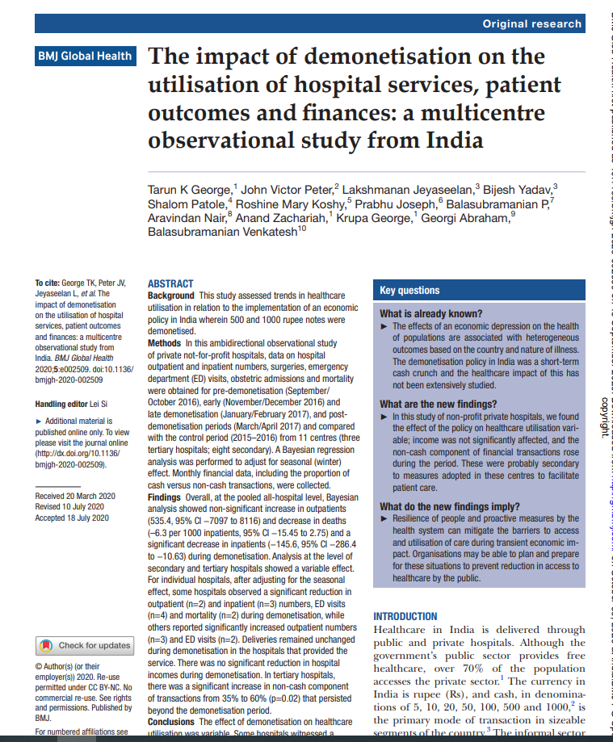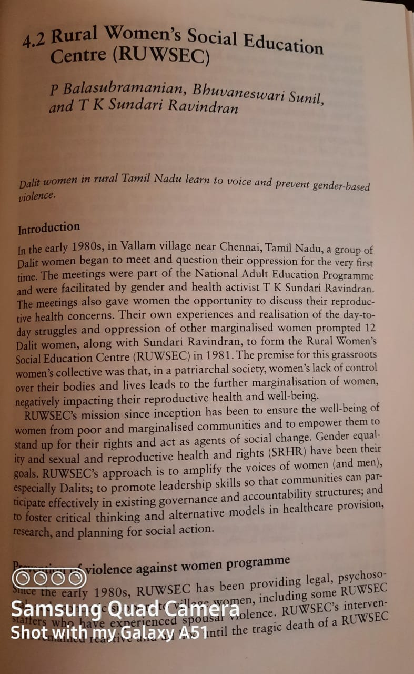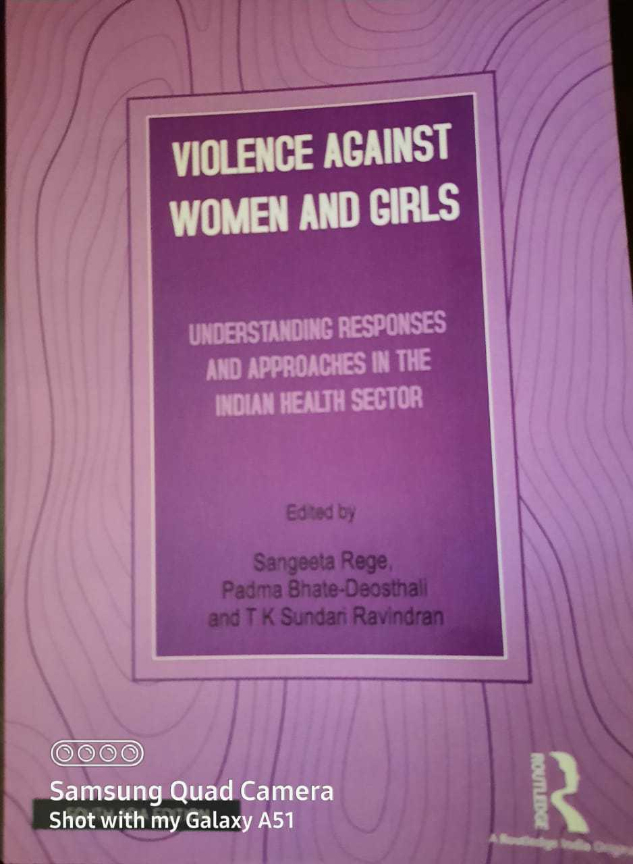
2) Prevention of Violence against Women: THE RUWSEC MODEL – edited volume on violence against women and girls – by Rutledge publishers New Delhi
Campaigns on Safe abortion as a woman right – International safe abortion day
On September 28th 2020, an awareness campaign on abortion as a woman right was conducted in 11 project villages with the support of Common Health. The event had a quiz session, an awareness session on safe abortion and sharing experiences in these villages. In these villages, married women with children, pregnant women, breastfeeding mothers, and women who had not undergone tubectomy.
In three villages, namely Andimadam, Pandur, and Suradimangalam, unmarried young women participated in the event. In Kunnavakkam village, the campaign was conducted in the ICDS centre. All the women in the village who are benefitted from the ICDS centre also participated.
The event spread over for two hours. All the participants were asked to follow social distancing, wear masks and use sanitiser. A total of 197 women took part in the campaign; all the participants were given masks and asked to hand sanitise before entering the meeting place.
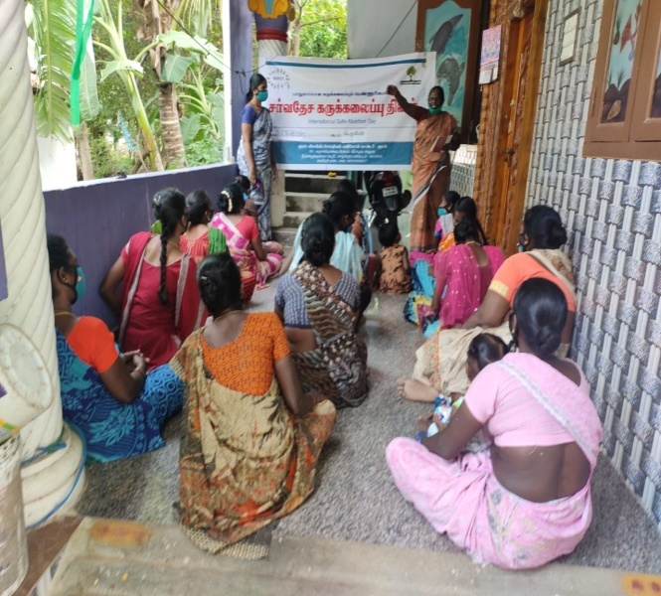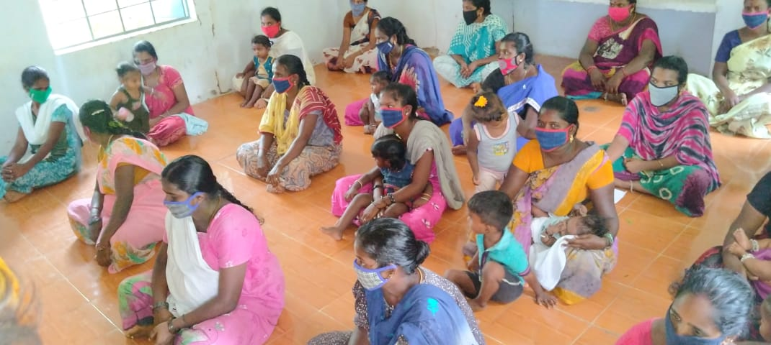
Reflections of the participants
We thought that abortions would be done in the hospital. After attending this campaign, we learned that only registered medical practitioners could perform an abortion.
We were under the opinion that abortion is a ‘sin’, but now we realise that if a woman needs abortion services, she has the right to have an abortion.
We learned that women should not go to a medical shop and get medicine for abortion. They should consult a registered doctor and then only access the abortion service.
Diabetes awareness campaign on World Diabetes Day
Every year 14th November is observed as World Diabetes Day; to mark the occasion, an awareness camp was conducted in Karumarapakkam and Nerumbur PHC on 23rd and 27th November. During the event, a chart display, awareness skit, poem narrating and special talks were given, and around 80 diabetic patients from the villages took part in the camp. The nurses and doctors also addressed the villagers and shared inputs about how diabetic patients should care for themselves. Gifts were given to nurses and doctors as a token of goodwill. All the participants were given masks, and the event took place by following social distancing and wearing masks.
International women’s day celebrations
International women’s day was celebrated at RUWSEC on 8th March 2021; around 125 women from our project villages actively participated in various events organised on the day. There were cultural shows, talk shows and competitions, and the winners of the events were awarded gifts and appreciation.
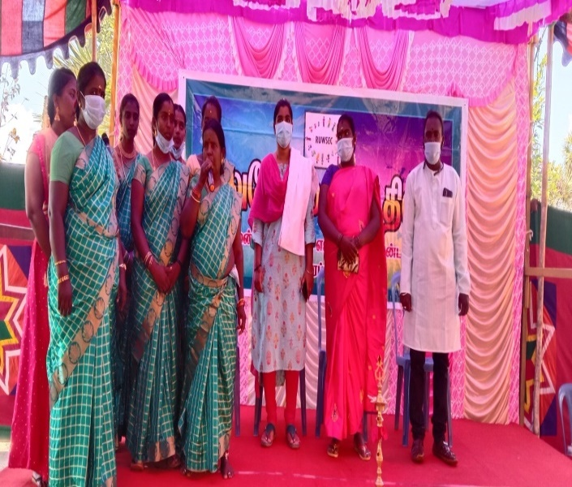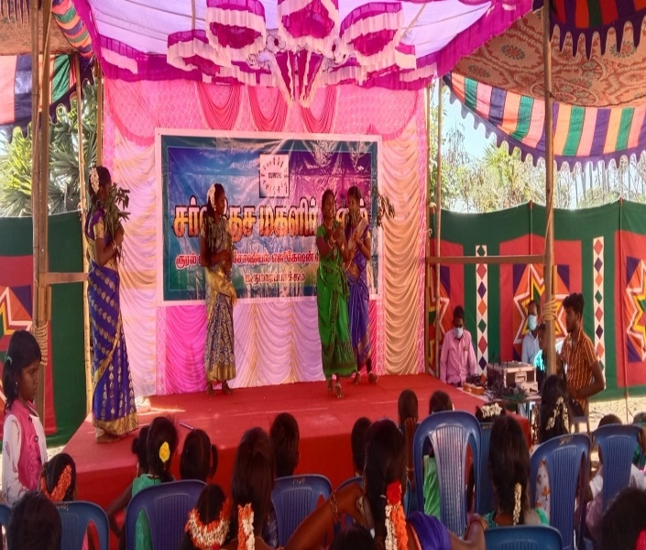
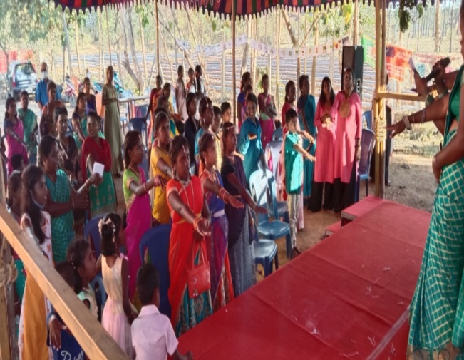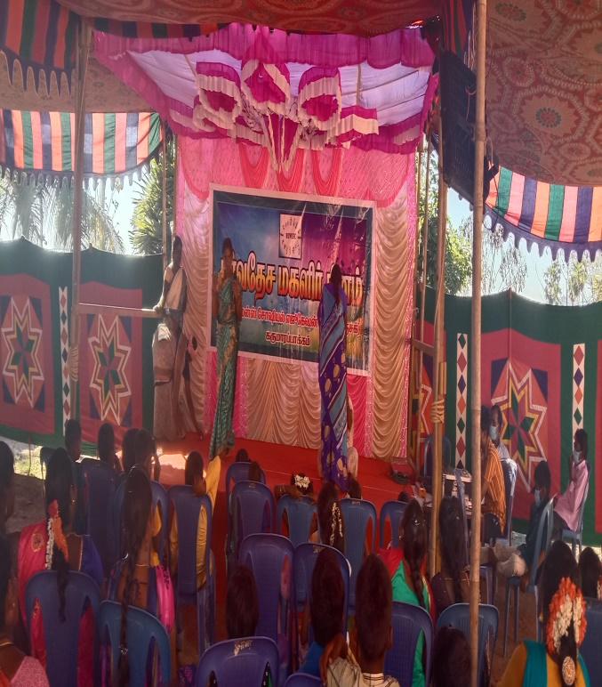
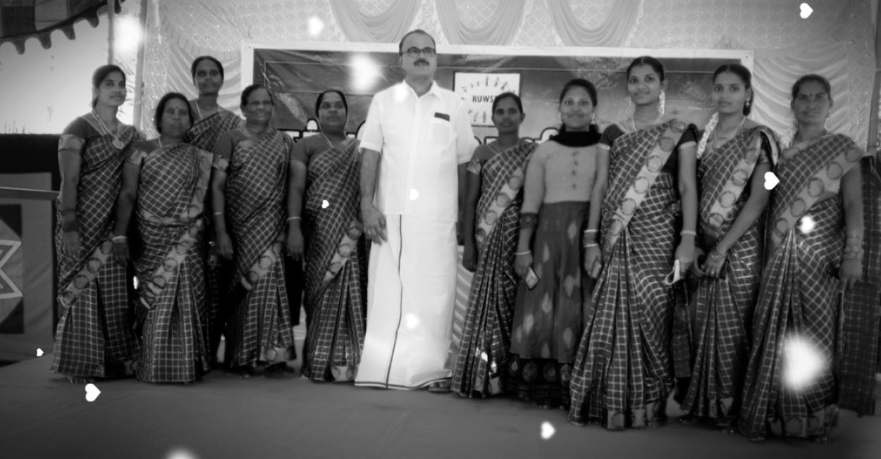

We were fortunate to receive contributions and donations from our friends and well-wishers of RUWSEC (Ms Annette Christine Kuesel, France Ms Anna Sehara Dean and Esther Odile Bettiol Switzerland, Mrs TK Sundari Ravindran, Mr Ravindaran, Dr Vijay Prasad, Dr Bhuvaneswari Dr Sowmiya Sampath) and a few other foundations (ARROW Malaysia, LG Foundation, Chennai and Kaarunya Foundation Chennai) to carry out COVID 19 relief activities. We also received contributions from many individuals in Chengalpattu District to organise international women’s day celebrations. Kaarunya Trust, Chennai, also supported conducting an annual health camp for poor diabetes patients. CWDR, Chennai, assisted us in facilitating workshops for adolescent girls. We would also like to thank Kath- the UK for sending baby-knit wares.
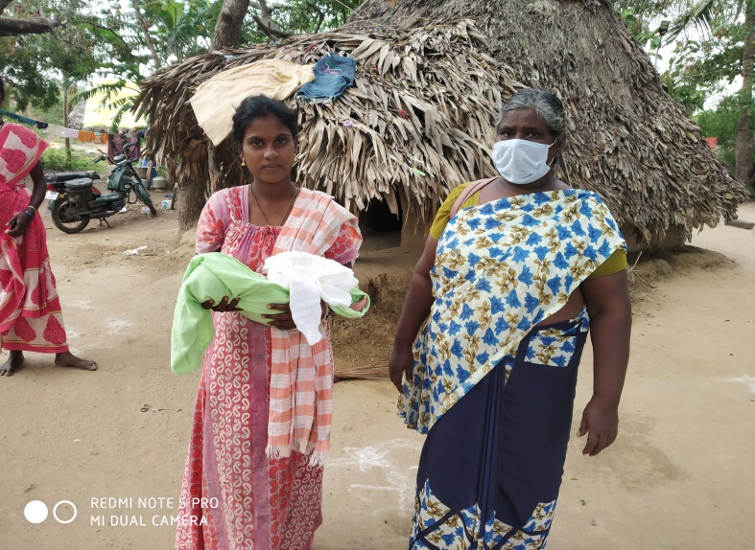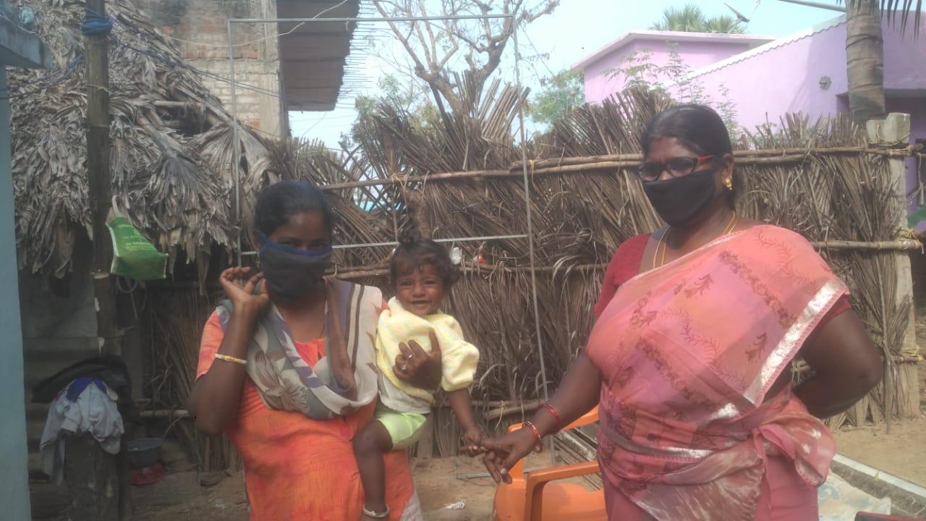

All our routine SRHR activities and major field activities were carried out to support the interest amount earned from the CORPUS fund that we received from the Ford Foundation in the year 2000. Thanks to all our donors and supporters.
------------------------------------------------------------------------------------------------------
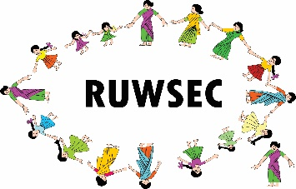Rural Women’s Social Education Centre (RUWSEC)
61 Karumarapakkam, Veerapuram Post, Thirukazhukundram,
Chengalpattu District, Tamil Nadu, India 60109
Phone: 044- 29542751, Mobile 9655168627 and 9842919110
E-mail: ruwsec.tn@gmail.com; Website: www.ruwsec.org

